Project-1

1.Write a Simple HTML program for displaying “Hello World!”

<!DOCTYPE html>

<html>

<head>

<title>Hello World Page</title>

</head>

<body>

<h1>Hello World!</h1>

</body>

</html>

Output

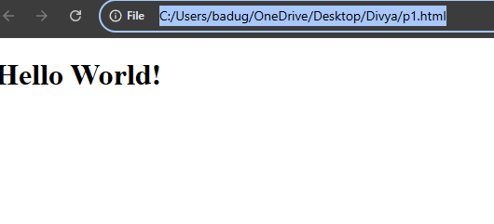

Project-2

Design a web page of displaying “Hello World!” by using Heading Tag

<!DOCTYPE html>

<html>

<head>

<title>Hello World Page</title>

</head>

<body>

<!-- Displaying Hello World using a heading tag -->

<h1>Hello World!</h1>

</body>

</html>

Output:

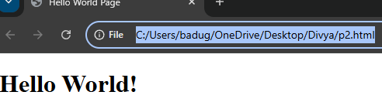

Project-3

Design a web page by demonstrating the usage of Paragraph Tag

<!DOCTYPE html>

<html lang="en">

<head>

<meta charset="UTF-8">

<meta name="viewport" content="width=device-width, initial-scale=1.0">

<title>Paragraph Tag Example</title>

</head>

<body>

<h1>Welcome to My Web Page!</h1>

<p>This is a paragraph that demonstrates the use of the <code>&lt;p&gt;</code> (paragraph) tag. Paragraph tags are used to enclose a block of text, separating it from other elements, and creating a readable format on the webpage.</p>

<p>The <code>&lt;p&gt;</code> tag automatically adds space before and after the paragraph, making the text look nicely spaced. It is one of the most commonly used tags when structuring content on a webpage.</p>

<p>HTML elements are fundamental to building a website. This is just an example of how you can structure your content effectively using paragraph tags.</p>

</body>

</html>

Output:

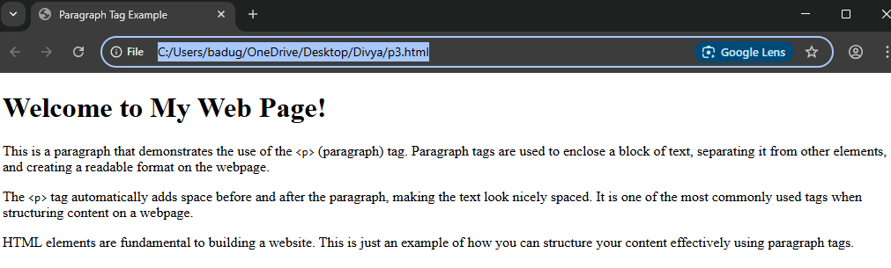

Project-4

Design a web page by demonstrating the usage of HTML lists

<!DOCTYPE html>

<html lang="en">

<head>

<meta charset="UTF-8">

<meta name="viewport" content="width=device-width, initial-scale=1.0">

<title>HTML List Example</title>

</head>

<body>

<h1>HTML List Types</h1>

<!-- Unordered List (Bulleted List) -->

<h2>Unordered List (Bulleted List)</h2>

<ul>

<li>Apple</li>

<li>Banana</li>

<li>Cherry</li>

<li>Date</li>

</ul>

<!-- Ordered List (Numbered List) -->

<h2>Ordered List (Numbered List)</h2>

<ol>

<li>Wake up</li>

<li>Brush your teeth</li>

<li>Have breakfast</li>

<li>Go to work/school</li>

</ol>

<!-- Description List -->

<h2>Description List</h2>

<dl>

<dt>HTML</dt>

<dd>HyperText Markup Language, the standard language for documents designed to be displayed in a web browser.</dd>

<dt>CSS</dt>

<dd>Cascading Style Sheets, a language used to describe the presentation of a document written in HTML or XML.</dd>

<dt>JavaScript</dt>

<dd>A programming language that enables interactive web pages.</dd>

</dl>

</body>

</html>

Output:

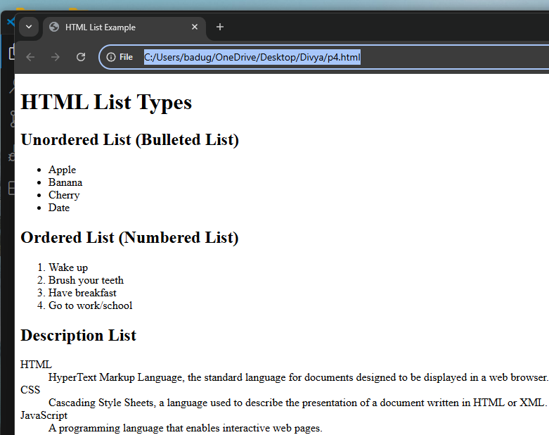

Project-5

Design a web page by demonstrating the usage of HTML list type attribute – “A”

<!DOCTYPE html>

<html lang="en">

<head>

<meta charset="UTF-8">

<meta name="viewport" content="width=device-width, initial-scale=1.0">

<title>HTML List Type Attribute: A</title>

</head>

<body>

<h1>HTML Ordered List with Type "A"</h1>

<p>The following list uses the <code>type="A"</code> attribute to display uppercase alphabetical numbering for the list items.</p>

<!-- Ordered List with Type "A" (Uppercase letters) -->

<ol type="A">

<li>Apple</li>

<li>Banana</li>

<li>Cherry</li>

<li>Date</li>

</ol>

</body>

</html>

Output:

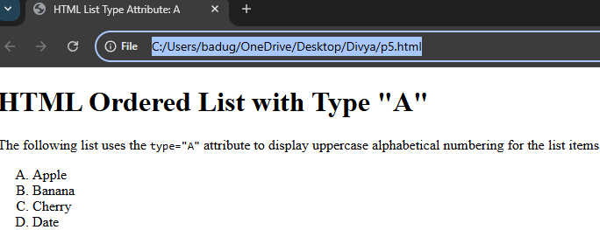

Project-6

Design a web page by demonstrating the usage of HTML list type attribute – “a”

<!DOCTYPE html>

<html lang="en">

<head>

<meta charset="UTF-8">

<meta name="viewport" content="width=device-width, initial-scale=1.0">

<title>HTML List Type Attribute: a</title>

</head>

<body>

<h1>HTML Ordered List with Type "a"</h1>

<p>The following list uses the <code>type="a"</code> attribute to display lowercase alphabetical numbering for the list items.</p>

<!-- Ordered List with Type "a" (Lowercase letters) -->

<ol type="a">

<li>Apples</li>

<li>Bananas</li>

<li>Cherries</li>

<li>Dates</li>

</ol>

</body>

</html>

Output:

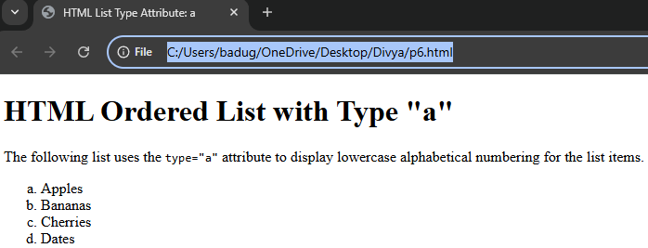

Project-7

Design a web page by demonstrating the usage of HTML list type attribute – “I”

<!DOCTYPE html>

<html lang="en">

<head>

<meta charset="UTF-8">

<meta name="viewport" content="width=device-width, initial-scale=1.0">

<title>HTML List Type Attribute: I</title>

</head>

<body>

<h1>HTML Ordered List with Type "I"</h1>

<p>The following list uses the <code>type="I"</code> attribute to display uppercase Roman numerals for the list items.</p>

<!-- Ordered List with Type "I" (Uppercase Roman Numerals) -->

<ol type="I">

<li>Introduction</li>

<li>Chapter One: Basics</li>

<li>Chapter Two: Advanced Concepts</li>

<li>Conclusion</li>

</ol>

</body>

</html>

Output:

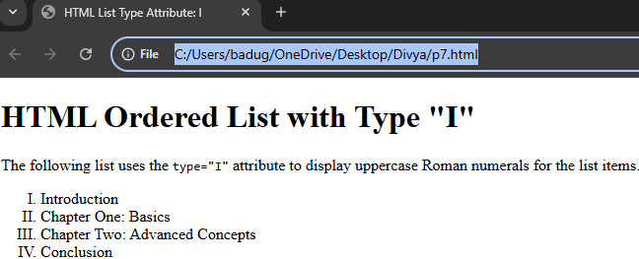

Project-8

Design a web page by demonstrating the usage of HTML list type attribute – “i”

<!DOCTYPE html>

<html lang="en">

<head>

<meta charset="UTF-8">

<meta name="viewport" content="width=device-width, initial-scale=1.0">

<title>HTML List Type Attribute: i</title>

</head>

<body>

<h1>HTML Ordered List with Type "i"</h1>

<p>The following list uses the <code>type="i"</code> attribute to display lowercase Roman numerals for the list items.</p>

<!-- Ordered List with Type "i" (Lowercase Roman Numerals) -->

<ol type="i">

<li>Introduction</li>

<li>Overview of the Project</li>

<li>Implementation Details</li>

<li>Conclusion and Future Work</li>

</ol>

</body>

</html>

Output:

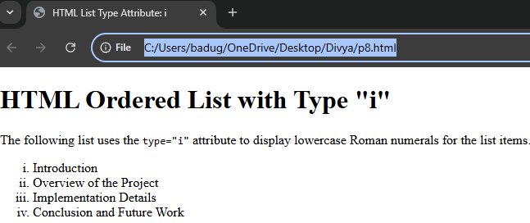

Project-9

Design a web page by demonstrating the usage of HTML list with start attribute

<!DOCTYPE html>

<html lang="en">

<head>

<meta charset="UTF-8">

<title>HTML List with Start Attribute</title>

<style>

body {

font-family: Arial, sans-serif;

margin: 30px;

background-color: #f9f9f9;

}

h1 {

color: #333;

}

section {

background-color: #fff;

padding: 20px;

border-radius: 8px;

box-shadow: 0 0 10px rgba(0,0,0,0.1);

}

</style>

</head>

<body>

<section>

<h1>HTML List with Start Attribute</h1>

<p>The <code>start</code> attribute in an ordered list allows you to specify the starting number. Here's an example:</p>

<h2>Part 1</h2>

<ol>

<li>Introduction to HTML</li>

<li>HTML Elements</li>

<li>HTML Attributes</li>

</ol>

<h2>Part 2 (Starting from 4)</h2>

<ol start="4">

<li>HTML Lists</li>

<li>HTML Forms</li>

<li>HTML Tables</li>

</ol>

</section>

</body>

</html>

Output:

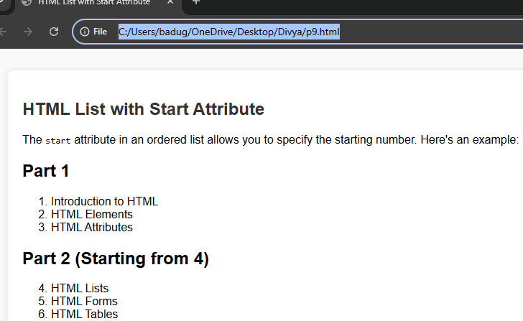

Project-10

Design a web page by demonstrating the usage of HTML list type attribute – “square”

<!DOCTYPE html>

<html lang="en">

<head>

<meta charset="UTF-8">

<title>HTML List with Type Attribute – Square</title>

<style>

body {

font-family: Arial, sans-serif;

margin: 30px;

background-color: #eef2f3;

}

h1 {

color: #2c3e50;

}

section {

background-color: #ffffff;

padding: 20px;

border-radius: 8px;

max-width: 600px;

box-shadow: 0 0 8px rgba(0, 0, 0, 0.1);

}

ul {

margin-top: 10px;

}

</style>

</head>

<body>

<section>

<h1>HTML List with <code>type="square"</code></h1>

<p>The <code>type</code> attribute in an unordered list allows you to change the bullet style. Below is an example using <code>type="square"</code>:</p>

<ul type="square">

<li>HTML Basics</li>

<li>CSS Styling</li>

<li>JavaScript Essentials</li>

<li>Responsive Design</li>

</ul>

<p>Other options for the <code>type</code> attribute include <code>disc</code> (default) and <code>circle</code>.</p>

</section>

</body>

</html>

Output:

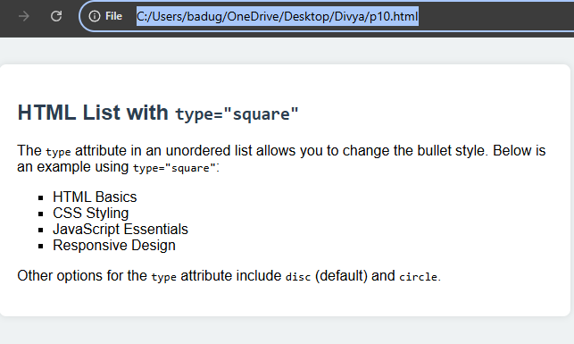

Project-11

. Design a web page by demonstrating the usage of HTML list type attribute – “circle”

<!DOCTYPE html>

<html lang="en">

<head>

<meta charset="UTF-8">

<title>HTML List with Type Attribute – Circle</title>

<style>

body {

font-family: Verdana, sans-serif;

margin: 40px;

background-color: #f0f8ff;

}

section {

background-color: #ffffff;

border-radius: 10px;

padding: 25px;

box-shadow: 0 0 10px rgba(0,0,0,0.1);

max-width: 600px;

}

h1 {

color: #333366;

}

ul {

margin-top: 15px;

}

</style>

</head>

<body>

<section>

<h1>HTML List with <code>type="circle"</code></h1>

<p>The <code>type</code> attribute in an unordered list specifies the bullet style. Here's how <code>type="circle"</code> works:</p>

<ul type="circle">

<li>Introduction to Web Development</li>

<li>HTML Structure</li>

<li>Working with CSS</li>

<li>JavaScript Basics</li>

</ul>

<p>Other list bullet styles include <code>disc</code> (default) and <code>square</code>.</p>

</section>

</body>

</html>

Output:

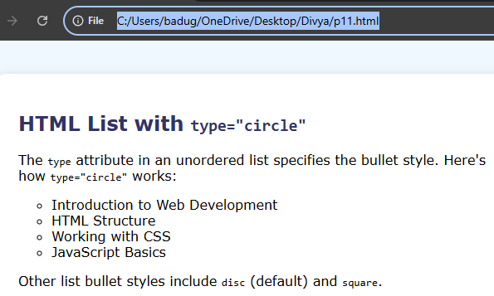

Project-12

Design a web page by demonstrating the usage of HTML list type attribute – “disc”

<!DOCTYPE html>

<html lang="en">

<head>

<meta charset="UTF-8">

<title>HTML List with Type Attribute – Disc</title>

<style>

body {

font-family: 'Segoe UI', Tahoma, Geneva, Verdana, sans-serif;

margin: 40px;

background-color: #f3f4f6;

}

section {

background-color: #ffffff;

border-radius: 12px;

padding: 30px;

box-shadow: 0 4px 12px rgba(0,0,0,0.1);

max-width: 600px;

}

h1 {

color: #2c3e50;

font-size: 28px;

}

ul {

margin-top: 15px;

padding-left: 20px;

}

</style>

</head>

<body>

<section>

<h1>HTML List with <code>type="disc"</code></h1>

<p>The <code>type</code> attribute in an unordered list defines the bullet style. The default bullet style is <code>disc</code>, but let's demonstrate it explicitly:</p>

<ul type="disc">

<li>Introduction to HTML</li>

<li>Learning CSS Basics</li>

<li>JavaScript Fundamentals</li>

<li>Understanding the DOM</li>

</ul>

<p>Other bullet styles include <code>circle</code> and <code>square</code>.</p>

</section>

</body>

</html>

Output:

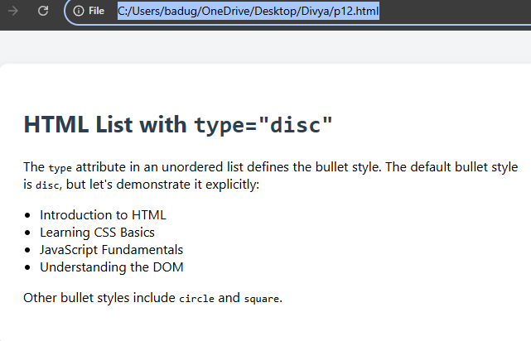

Project-13

Design a web page by demonstrating the usage of HTML list type attribute – “none”

<!DOCTYPE html>

<html lang="en">

<head>

<meta charset="UTF-8">

<title>HTML List with Type Attribute – None</title>

<style>

body {

font-family: Arial, sans-serif;

margin: 40px;

background-color: #f4f6f9;

}

section {

background-color: #ffffff;

border-radius: 12px;

padding: 30px;

box-shadow: 0 4px 10px rgba(0,0,0,0.1);

max-width: 650px;

}

h1 {

color: #2c3e50;

font-size: 28px;

}

ul {

margin-top: 20px;

padding-left: 20px;

}

</style>

</head>

<body>

<section>

<h1>HTML List with <code>type="none"</code></h1>

<p>The <code>type="none"</code> attribute in an unordered list removes the default bullet points, making it a **bullet-less list**:</p>

<ul type="none">

<li>Introduction to Web Development</li>

<li>HTML Basics</li>

<li>CSS Styling</li>

<li>JavaScript Programming</li>

</ul>

<p>For modern web design, it is recommended to use CSS to remove the bullets for better flexibility and HTML5 compliance.</p>

</section>

</body>

</html>

Output:

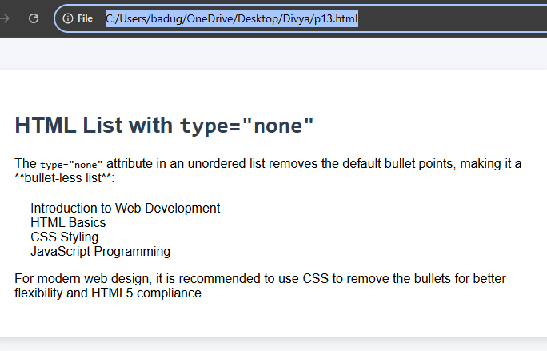

Project-14

Design a web page by demonstrating the usage of Nested list in HTML

<!DOCTYPE html>

<html lang="en">

<head>

<meta charset="UTF-8">

<meta name="viewport" content="width=device-width, initial-scale=1.0">

<title>Nested List Example</title>

<style>

body {

font-family: Arial, sans-serif;

background-color: #f4f4f9;

margin: 0;

padding: 20px;

}

h1 {

color: #333;

text-align: center;

}

.list-container {

background-color: #fff;

padding: 20px;

border-radius: 8px;

box-shadow: 0 0 10px rgba(0, 0, 0, 0.1);

}

ul {

list-style-type: none;

padding-left: 20px;

}

li {

margin: 8px 0;

font-size: 18px;

}

li > ul {

margin-top: 10px;

list-style-type: circle;

}

li > ul > li {

font-size: 16px;

}

</style>

</head>

<body>

<h1>Nested List Example</h1>

<div class="list-container">

<ul>

<li>Home</li>

<li>About Us</li>

<li>Services

<ul>

<li>Web Development</li>

<li>App Development

<ul>

<li>Android</li>

<li>iOS</li>

</ul>

</li>

<li>Graphic Design</li>

</ul>

</li>

<li>Portfolio</li>

<li>Contact</li>

</ul>

</div>

</body>

</html>

Output:

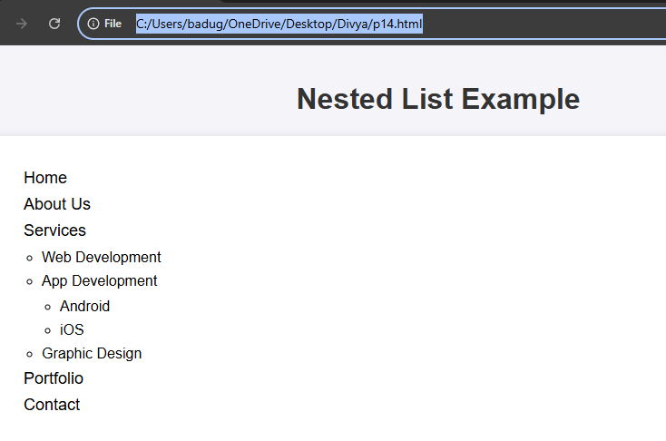

Project-15

Design a web page by demonstrating the usage of HTML Table tags.

<!DOCTYPE html>

<html lang="en">

<head>

<meta charset="UTF-8">

<meta name="viewport" content="width=device-width, initial-scale=1.0">

<title>HTML Table Example</title>

<style>

body {

font-family: Arial, sans-serif;

background-color: #f4f4f9;

margin: 0;

padding: 20px;

}

h1 {

color: #333;

text-align: center;

}

.table-container {

margin: 20px auto;

width: 80%;

background-color: #fff;

padding: 20px;

border-radius: 8px;

box-shadow: 0 0 15px rgba(0, 0, 0, 0.1);

}

table {

width: 100%;

border-collapse: collapse;

}

th, td {

padding: 10px;

text-align: left;

border: 1px solid #ddd;

}

th {

background-color: #4CAF50;

color: white;

}

tr:nth-child(even) {

background-color: #f2f2f2;

}

tr:hover {

background-color: #ddd;

}

</style>

</head>

<body>

<h1>Student Data Table</h1>

<div class="table-container">

<table>

<thead>

<tr>

<th>Student ID</th>

<th>Name</th>

<th>Age</th>

<th>Grade</th>

<th>City</th>

</tr>

</thead>

<tbody>

<tr>

<td>101</td>

<td>John Doe</td>

<td>20</td>

<td>A</td>

<td>New York</td>

</tr>

<tr>

<td>102</td>

<td>Jane Smith</td>

<td>22</td>

<td>B</td>

<td>Los Angeles</td>

</tr>

<tr>

<td>103</td>

<td>Sam Brown</td>

<td>21</td>

<td>A</td>

<td>Chicago</td>

</tr>

<tr>

<td>104</td>

<td>Emily Davis</td>

<td>23</td>

<td>C</td>

<td>Miami</td>

</tr>

</tbody>

</table>

</div>

</body>

</html>

Output:

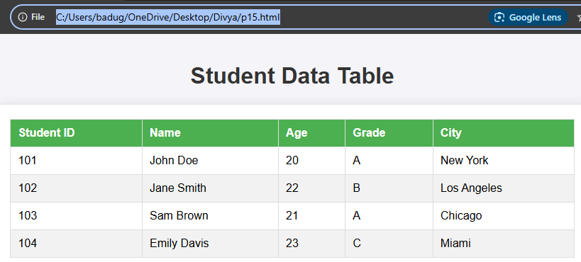

Project-16

Design a web page demonstrating the usage of HTML Image Tag

<!DOCTYPE html>

<html lang="en">

<head>

<meta charset="UTF-8">

<meta name="viewport" content="width=device-width, initial-scale=1.0">

<title>HTML Image Tag Example</title>

<style>

body {

font-family: Arial, sans-serif;

background-color: #f4f4f9;

margin: 0;

padding: 20px;

text-align: center;

}

h1 {

color: #333;

}

.image-gallery {

display: flex;

justify-content: center;

gap: 20px;

flex-wrap: wrap;

}

.image-container {

width: 300px;

margin-bottom: 20px;

border-radius: 8px;

overflow: hidden;

box-shadow: 0 4px 10px rgba(0, 0, 0, 0.1);

}

.image-container img {

width: 100%;

height: auto;

transition: transform 0.3s ease-in-out;

}

.image-container img:hover {

transform: scale(1.05);

}

.caption {

padding: 10px;

background-color: #fff;

color: #555;

font-size: 16px;

text-align: center;

}

</style>

</head>

<body>

<h1>Image Gallery Example</h1>

<div class="image-gallery">

<!-- Image 1 -->

<div class="image-container">

<img src="https://via.placeholder.com/300" alt="Placeholder Image 1">

<div class="caption">Beautiful Landscape 1</div>

</div>

<!-- Image 2 -->

<div class="image-container">

<img src="https://via.placeholder.com/300" alt="Placeholder Image 2">

<div class="caption">Beautiful Landscape 2</div>

</div>

<!-- Image 3 -->

<div class="image-container">

<img src="https://via.placeholder.com/300" alt="Placeholder Image 3">

<div class="caption">Beautiful Landscape 3</div>

</div>

<!-- Image 4 -->

<div class="image-container">

<img src="https://via.placeholder.com/300" alt="Placeholder Image 4">

<div class="caption">Beautiful Landscape 4</div>

</div>

</div>

</body>

</html>

Output:

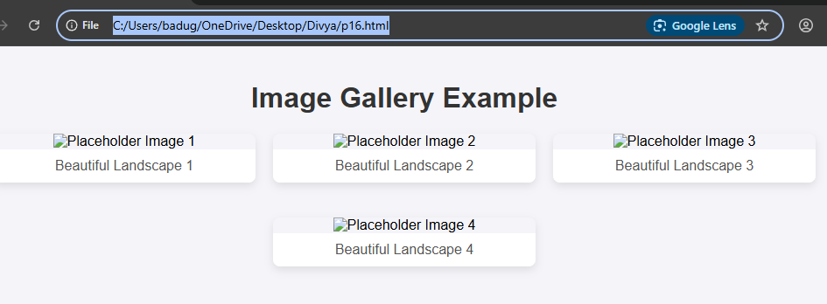

Project-17

Design a web page by demonstrating the usage of HTML Video Tag

<!DOCTYPE html>

<html lang="en">

<head>

<meta charset="UTF-8">

<meta name="viewport" content="width=device-width, initial-scale=1.0">

<title>HTML Video Tag Example</title>

<style>

body {

font-family: Arial, sans-serif;

background-color: #f4f4f9;

margin: 0;

padding: 20px;

text-align: center;

}

h1 {

color: #333;

}

.video-container {

margin-top: 20px;

max-width: 800px;

margin-left: auto;

margin-right: auto;

background-color: #fff;

padding: 20px;

border-radius: 8px;

box-shadow: 0 4px 15px rgba(0, 0, 0, 0.1);

}

video {

width: 100%;

height: auto;

border-radius: 8px;

}

.caption {

margin-top: 10px;

font-size: 16px;

color: #555;

}

</style>

</head>

<body>

<h1>HTML Video Tag Example</h1>

<div class="video-container">

<video controls>

<!-- Video source for modern browsers -->

<source src="https://www.w3schools.com/html/mov_bbb.mp4" type="video/mp4">

<!-- Fallback for browsers that do not support MP4 -->

<source src="https://www.w3schools.com/html/movie.ogg" type="video/ogg">

Your browser does not support the video tag.

</video>

<div class="caption">

<p>Sample Video - HTML5 Video Tag Demonstration</p>

</div>

</div>

</body>

</html>

Output:

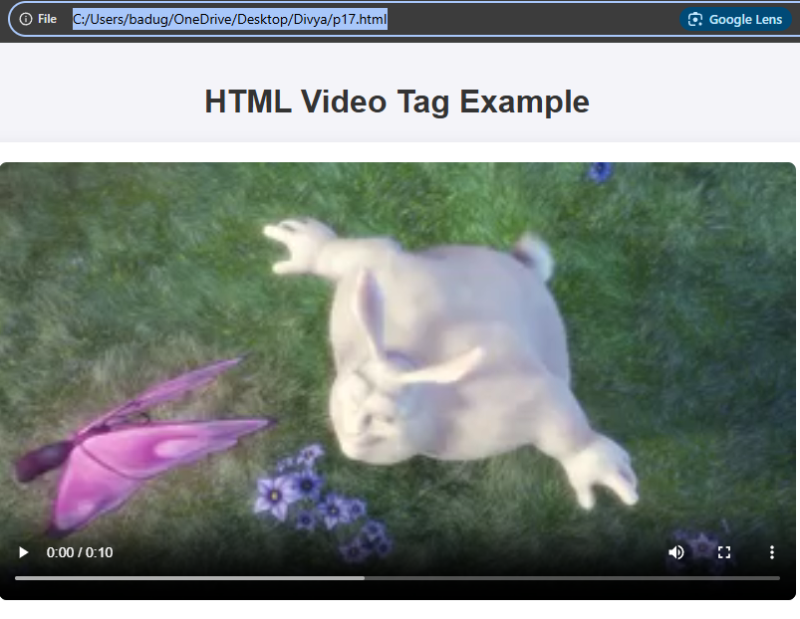

Project-18

Design a web page by demonstrating the usage of HTML Audio Tag

<!DOCTYPE html>

<html lang="en">

<head>

<meta charset="UTF-8">

<meta name="viewport" content="width=device-width, initial-scale=1.0">

<title>HTML Audio Tag Example</title>

<style>

body {

font-family: Arial, sans-serif;

background-color: #f4f4f9;

margin: 0;

padding: 20px;

text-align: center;

}

h1 {

color: #333;

}

.audio-container {

margin-top: 20px;

max-width: 600px;

margin-left: auto;

margin-right: auto;

background-color: #fff;

padding: 20px;

border-radius: 8px;

box-shadow: 0 4px 15px rgba(0, 0, 0, 0.1);

}

audio {

width: 100%;

margin-top: 10px;

}

.caption {

margin-top: 10px;

font-size: 16px;

color: #555;

}

</style>

</head>

<body>

<h1>HTML Audio Tag Example</h1>

<div class="audio-container">

<!-- Audio element with controls -->

<audio controls>

<!-- Audio source for modern browsers -->

<source src="https://www.soundhelix.com/examples/mp3/SoundHelix-Song-1.mp3" type="audio/mpeg">

<!-- Fallback for browsers that do not support MP3 -->

<source src="https://www.soundhelix.com/examples/mp3/SoundHelix-Song-1.ogg" type="audio/ogg">

Your browser does not support the audio tag.

</audio>

<div class="caption">

<p>Enjoy this sample audio! (MP3 & OGG supported)</p>

</div>

</div>

</body>

</html>

Output:

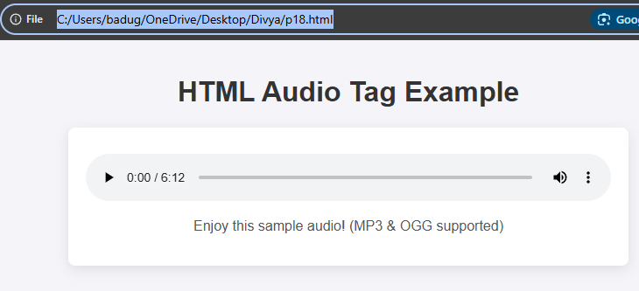

Project-19

Design a web page by demonstrating the usage of Div Tag

<!DOCTYPE html>

<html lang="en">

<head>

<meta charset="UTF-8">

<meta name="viewport" content="width=device-width, initial-scale=1.0">

<title>HTML Div Tag Example</title>

<style>

body {

font-family: Arial, sans-serif;

margin: 0;

padding: 20px;

background-color: #f4f4f9;

}

h1 {

text-align: center;

color: #333;

}

.container {

max-width: 1200px;

margin: 0 auto;

padding: 20px;

background-color: #fff;

box-shadow: 0 0 10px rgba(0, 0, 0, 0.1);

border-radius: 8px;

}

.header, .footer {

background-color: #333;

color: #fff;

padding: 20px;

text-align: center;

border-radius: 8px;

}

.content {

display: flex;

justify-content: space-between;

gap: 20px;

}

.content > div {

flex: 1;

background-color: #e4e4e4;

padding: 20px;

border-radius: 8px;

}

.content div h2 {

color: #333;

}

.sidebar {

background-color: #ccc;

}

.main {

background-color: #ddd;

}

.footer {

margin-top: 20px;

}

</style>

</head>

<body>

<h1>HTML Div Tag Example</h1>

<div class="container">

<!-- Header Section -->

<div class="header">

Output:

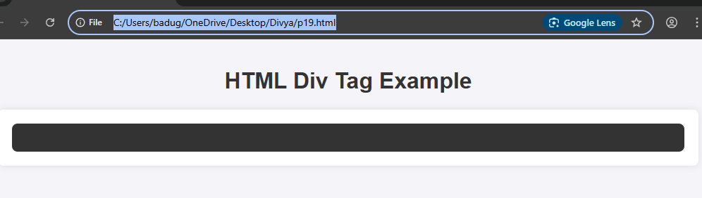

Project-20

Design a web page by demonstrating the usage of HTML Marquee Tag.

<!DOCTYPE html>

<html lang="en">

<head>

<meta charset="UTF-8">

<meta name="viewport" content="width=device-width, initial-scale=1.0">

<title>HTML Marquee Tag Example</title>

<style>

body {

font-family: Arial, sans-serif;

background-color: #f4f4f9;

margin: 0;

padding: 20px;

text-align: center;

}

h1 {

color: #333;

}

.marquee-container {

background-color: #fff;

padding: 20px;

border-radius: 8px;

box-shadow: 0 0 15px rgba(0, 0, 0, 0.1);

margin-bottom: 30px;

}

.marquee-container h2 {

margin: 0;

color: #333;

}

</style>

</head>

<body>

<h1>HTML Marquee Tag Demonstration</h1>

<div class="marquee-container">

<h2>Scrolling Text (Default Direction)</h2>

<marquee>This is a scrolling text using the Marquee tag!</marquee>

</div>

<div class="marquee-container">

<h2>Scrolling Text (Right to Left)</h2>

<marquee direction="right">This text scrolls from right to left.</marquee>

</div>

<div class="marquee-container">

<h2>Scrolling Text (Left to Right)</h2>

<marquee direction="left">This text scrolls from left to right.</marquee>

</div>

<div class="marquee-container">

<h2>Scrolling Text (With Speed Control)</h2>

<marquee scrollamount="10">This text scrolls with a custom speed. You can adjust the value of scrollamount.</marquee>

</div>

<div class="marquee-container

Output:

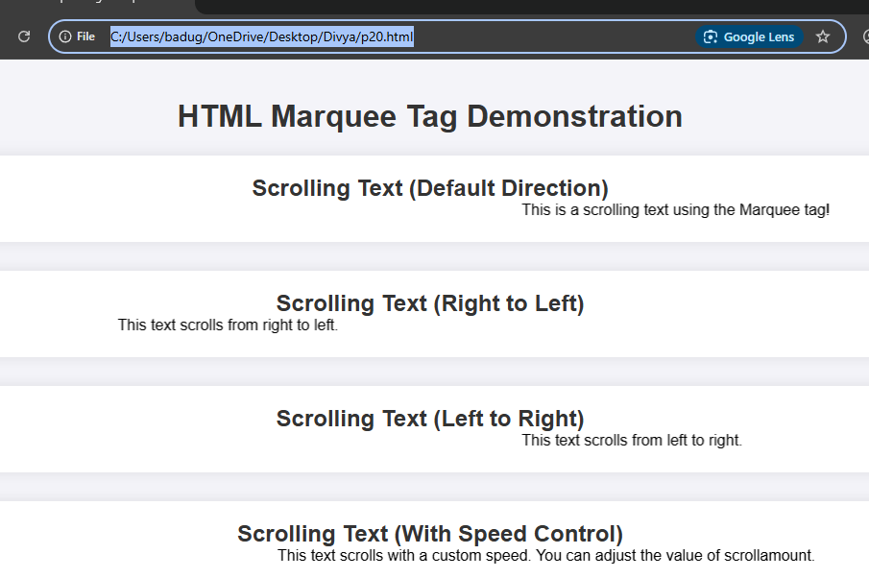

Project-21

Design a web page by demonstrating the usage of HTML Marquee Tag with image

<!DOCTYPE html>

<html lang="en">

<head>

<meta charset="UTF-8">

<meta name="viewport" content="width=device-width, initial-scale=1.0">

<title>HTML Marquee Tag with Image</title>

<style>

body {

font-family: Arial, sans-serif;

background-color: #f4f4f9;

margin: 0;

padding: 20px;

text-align: center;

}

h1 {

color: #333;

}

.marquee-container {

background-color: #fff;

padding: 20px;

border-radius: 8px;

box-shadow: 0 0 15px rgba(0, 0, 0, 0.1);

margin-bottom: 30px;

}

.marquee-container h2 {

margin: 0;

color: #333;

}

.marquee {

width: 100%;

overflow: hidden;

white-space: nowrap;

}

img {

height: 100px;

margin-right: 30px;

}

</style>

</head>

<body>

<h1>HTML Marquee Tag with Image Example</h1>

<div class="marquee-container">

<h2>Scrolling Image from Left to Right</h2>

<marquee direction="left">

<img src="https://via.placeholder.com/150" alt="Image 1">

<img src="https://via.placeholder.com/150" alt="Image 2">

<img src="https://via.placeholder.com/150" alt="Image 3">

<img src="https://via.placeholder.com/150" alt="Image 4">

</marquee>

</div>

<div class="marquee-container">

<h2>Scrolling Image from Right to Left</h2>

<marquee direction="right">

<img src="https://via.placeholder.com/150" alt="Image 1">

<img src="https://via.placeholder.com/150" alt="Image 2">

<img src="https://via.placeholder.com/150" alt="Image 3">

<img src="https://via.placeholder.com/150" alt="Image 4">

</marq

Output:

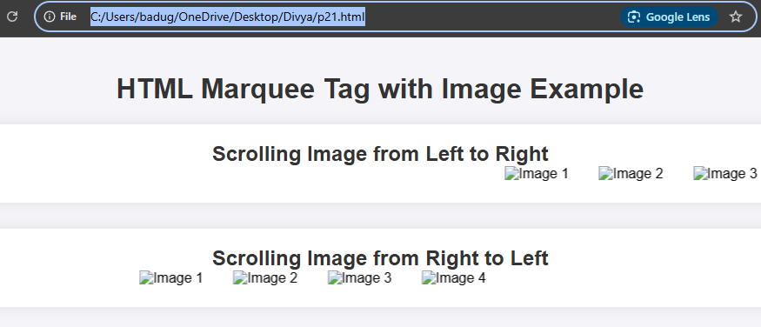

Project-22

Design a web page by demonstrating the usage of HTML background attribute

<!DOCTYPE html>

<html lang="en">

<head>

<meta charset="UTF-8">

<meta name="viewport" content="width=device-width, initial-scale=1.0">

<title>HTML Background Attribute Example</title>

<style>

body {

font-family: Arial, sans-serif;

margin: 0;

padding: 20px;

text-align: center;

}

h1 {

color: #333;

}

.container {

background-color: #f0f0f0;

padding: 20px;

border-radius: 8px;

box-shadow: 0 0 10px rgba(0, 0, 0, 0.1);

margin-top: 30px;

}

</style>

</head>

<body>

<h1>HTML Background Attribute Example</h1>

<!-- Using HTML Background Attribute -->

<div class="container" background="https://via.placeholder.com/800x300.png?text=Background+Image">

<h2>This div has a background image set with the HTML 'background' attribute.</h2>

<p>Notice that this approach is outdated, and using CSS is recommended instead.</p>

</div>

<div class="container" style="background-color: lightblue;">

<h2>This div has a background color set using the HTML 'background-color' attribute.</h2>

</div>

<div class="container" style="background-color: lightgray; padding: 40px;">

<h2>This is a modern, responsive background with CSS styling.</h2>

</div>

</body>

</html>

Output:

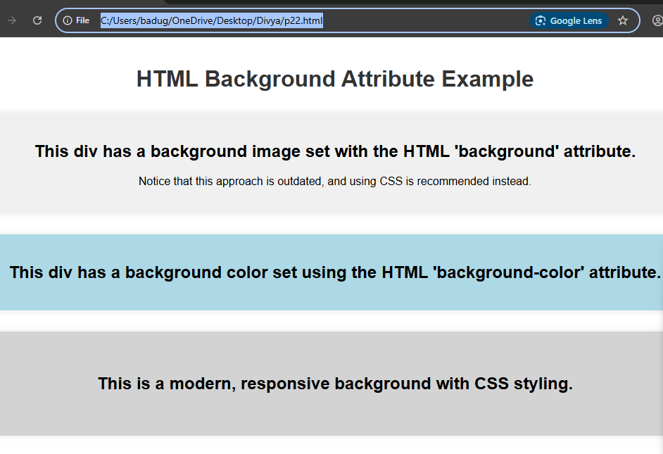

Project-23

Design a webpage to open an external link

<!DOCTYPE html>

<html lang="en">

<head>

<meta charset="UTF-8">

<meta name="viewport" content="width=device-width, initial-scale=1.0">

<title>Open External Link Example</title>

<style>

body {

font-family: Arial, sans-serif;

background-color: #f0f0f9;

text-align: center;

padding: 50px;

}

h1 {

color: #333;

}

.link-container {

background-color: #ffffff;

padding: 30px;

margin-top: 20px;

border-radius: 8px;

box-shadow: 0 0 10px rgba(0

output:

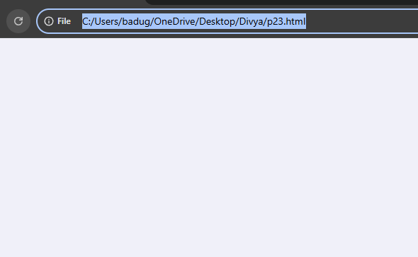

Project-24

Design a webpage to open a mailto link

<!DOCTYPE html>

<html lang="en">

<head>

<meta charset="UTF-8">

<meta name="viewport" content="width=device-width, initial-scale=1.0">

<title>Mailto Link Example</title>

<style>

body {

font-family: Arial, sans-serif;

background-color: #f7f7f7;

text-align: center;

padding: 50px;

}

h1 {

color: #333;

}

.link-container {

background-color: #ffffff;

padding: 30px;

margin-top: 20px;

border-radius: 8px;

box-shadow: 0 0 10px rgba(0, 0, 0, 0.1);

}

.link-container a {

color: #0066cc;

font-size: 18px;

text-decoration: none;

font-weight: bold;

}

.link-container a:hover {

text-decoration: underline;

}

</style>

</head>

<body>

<h1>Contact Us</h1>

<p>If you have any questions, feel free to email us:</p>

<div class="link-container">

<a href="mailto:someone@example.com?subject=Hello&body=I%20would%20like%20more%20information." target="_blank">

Send us an Email

</a>

</div>

</body>

</html>

Output:

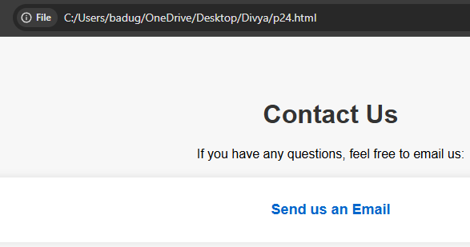

Project-25

Design a webpage to open a phone number link

<!DOCTYPE html>

<html lang="en">

<head>

<meta charset="UTF-8">

<meta name="viewport" content="width=device-width, initial-scale=1.0">

<title>Phone Number Link Example</title>

<style>

body {

font-family: Arial, sans-serif;

background-color: #f0f0f9;

text-align: center;

padding: 50px;

}

h1 {

color: #333;

}

.link-container {

background-color: #ffffff;

padding: 30px;

margin-top: 20px;

border-radius: 8px;

box-shadow: 0 0 10px rgba(0, 0, 0, 0.1);

}

.link-container a {

color: #0066cc;

font-size: 18px;

text-decoration: none;

font-weight: bold;

}

.link-container a:hover {

text-decoration: underline;

}

</style>

</head>

<body>

<h1>Contact Us by Phone</h1>

<p>If you'd like to speak with us directly, click the link below to call:</p>

<div class="link-container">

<a href="tel:+1234567890">

Call us at +1 (234) 567-890

</a>

</div>

</body>

</html>

Output:

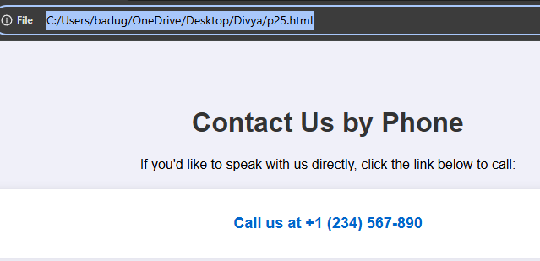

Project-26

Design a webpage to open a section on the same page using links

<!DOCTYPE html>

<html lang="en">

<head>

<meta charset="UTF-8">

<meta name="viewport" content="width=device-width, initial-scale=1.0">

<title>Anchor Links Example</title>

<style>

body {

font-family: Arial, sans-serif;

background-color: #f4f4f9;

margin: 0;

padding: 0;

}

header {

background-color: #4CAF50;

color: white;

padding: 15px;

text-align: center;

}

nav {

background-color: #333;

padding: 10px;

}

nav a {

color: white;

text-decoration: none;

margin: 0 15px;

font-size: 18px;

}

nav a:hover {

text-decoration: underline;

}

section {

padding: 50px;

margin: 20px 0;

border-radius: 8px;

background-color: #fff;

box-shadow: 0 0 15px rgba(0, 0, 0, 0.1);

}

.section-title {

color: #333;

}

</style>

</head>

<body>

<!-- Header with navigation links -->

<header>

<h1>Anchor Links Navigation</h1>

<p>Click on the links below to jump to the corresponding section.</p>

</header>

<!-- Navigation bar with links to different sections -->

<nav>

<a href="#section1">Section 1</a>

<a href="#section2">Section 2</a>

<a href="#section3">Section 3</a>

</nav>

<!-- Content sections with IDs -->

<section id="section1">

<h2 class="section-title">Section 1: Introduction</h2>

<p>This is the first section. You can add any content here, such as text, images, or videos. Clicking the link in the navigation bar above will bring you to this section.</p>

</section>

<section id="section2">

<h2 class="section-title">Section 2: Features</h2>

<p>This is the second section, where you can describe the features of your product or service. Clicking the link in the navigation bar will smoothly scroll you down to this section.</p>

</section>

<section id="section3">

<h2 class="section-title">Section 3: Contact</h2>

<p>This is the final section. You can include a contact form or any other information here. Clicking the link above will bring you to this section of the page.</p>

</section>

</body>

</html>

Output:

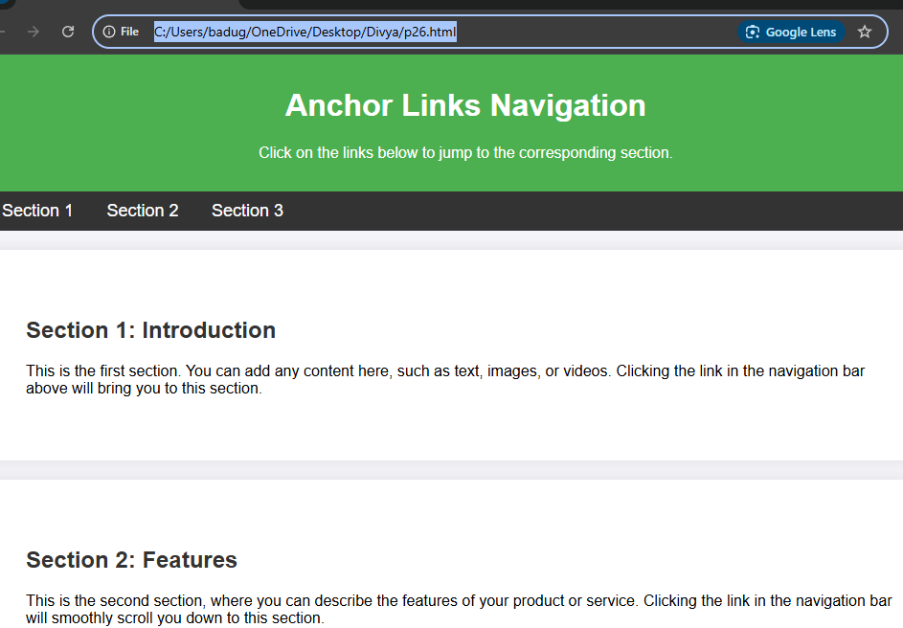

Project-27

Create a web page demonstrating the use of the **(bold) tag.**

<!DOCTYPE html>

<html lang="en">

<head>

<meta charset="UTF-8">

<meta name="viewport" content="width=device-width, initial-scale=1.0">

<title>Bold Tag Example</title>

<style>

body {

font-family: Arial, sans-serif;

background-color: #f7f7f7;

margin: 0;

padding: 20px;

text-align: center;

}

h1 {

color: #333;

}

p {

color: #555;

font-size: 18px;

line-height: 1.6;

}

.example {

background-color: #fff;

padding: 20px;

margin-top: 20px;

border-radius: 8px;

box-shadow: 0 0 10px rgba(0, 0, 0, 0.1);

}

</style>

</head>

<body>

<h1>Demonstrating the Use of the &lt;b&gt; (Bold) Tag</h1>

<div class="example">

<p><b>This text is bold using the &lt;b&gt; tag.</b></p>

<p>Here is a <b>bold sentence</b> within a paragraph to highlight important information.</p>

</div>

<p>The <b>&lt;b&gt;</b> tag makes text bold, but it does not convey any semantic meaning. It is often used for styling text without implying importance.</p>

</body>

</html>

Output:

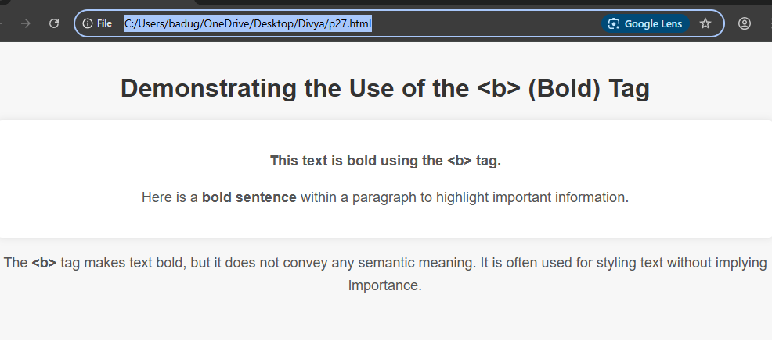

Project-28

Create a web page demonstrating the use of the **tag.**

<!DOCTYPE html>

<html lang="en">

<head>

<meta charset="UTF-8">

<meta name="viewport" content="width=device-width, initial-scale=1.0">

<title>Strong Tag Example</title>

<style>

body {

font-family: Arial, sans-serif;

background-color: #f4f4f9;

padding: 20px;

text-align: center;

}

h1 {

color: #333;

}

p {

color: #555;

font-size: 18px;

line-height: 1.6;

}

.example {

background-color: #fff;

padding: 20px;

margin-top: 20px;

border-radius: 8px;

box-shadow: 0 0 10px rgba(0, 0, 0, 0.1);

}

</style>

</head>

<body>

<h1>Demonstrating the Use of the &lt;strong&gt; Tag</h1>

<div class="example">

<p>The <strong>&lt;strong&gt;</strong> tag is used to indicate that text is of strong importance or significance.</p>

<p><strong>Warning!</strong> This action cannot be undone.</p>

<p>This is an example of text that <strong>emphasizes</strong> important information for the user.</p>

</div>

<p>Using the <strong>&lt;strong&gt;</strong> tag not only makes the text bold but also adds semantic meaning. It is often used for important instructions, warnings, or any content that needs to stand out.</p>

</body>

</html>

Output:

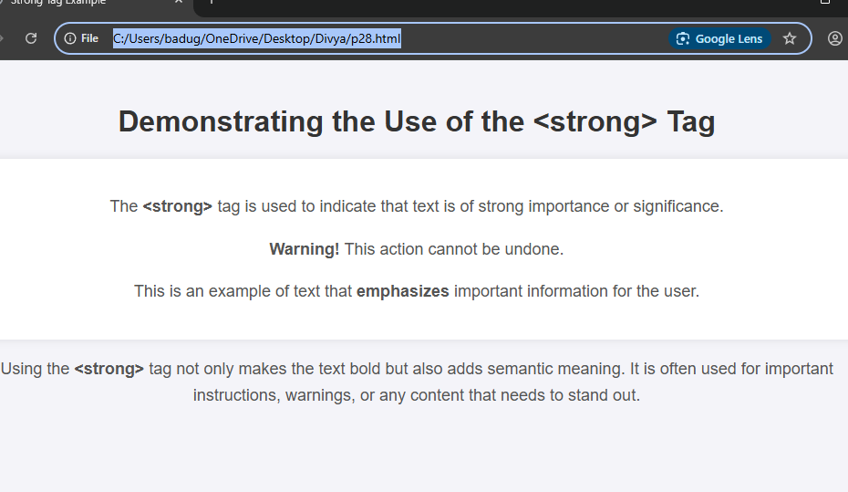

Project-29

Create a web page demonstrating the use of the *tag*

<!DOCTYPE html>

<html lang="en">

<head>

<meta charset="UTF-8">

<meta name="viewport" content="width=device-width, initial-scale=1.0">

<title>Italic Tag Example</title>

<style>

body {

font-family: Arial, sans-serif;

background-color: #f4f4f9;

padding: 20px;

text-align: center;

}

h1 {

color: #333;

}

p {

color: #555;

font-size: 18px;

line-height: 1.6;

}

.example {

background-color: #fff;

padding: 20px;

margin-top: 20px;

border-radius: 8px;

box-shadow: 0 0 10px rgba(0, 0, 0, 0.1);

}

</style>

</head>

<body>

<h1>Demonstrating the Use of the &lt;i&gt; Tag</h1>

<div class="example">

<p>The <i>&lt;i&gt;</i> tag is used to indicate text that should be displayed in italics.</p>

<p>For example, the word <i>bonjour</i> is French for "hello".</p>

<p>The book <i>The Great Gatsby</i> is a classic of American literature.</p>

<p>In programming, <i>Python</i> is one of the most popular languages.</p>

</div>

<p>Using the <i>&lt;i&gt;</i> tag generally makes text italic, but it can also indicate that the text is different in meaning, such as for foreign words, technical terms, or titles.</p>

</body>

</html>

Output:

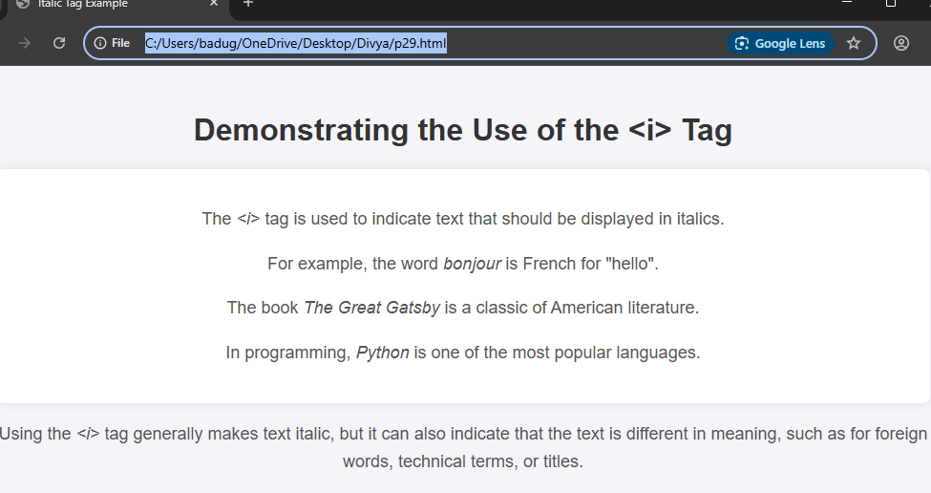

Project-30

Create a web page demonstrating the use of the tag.

<!DOCTYPE html>

<html lang="en">

<head>

<meta charset="UTF-8">

<meta name="viewport" content="width=device-width, initial-scale=1.0">

<title>Emphasis Tag Example</title>

<style>

body {

font-family: Arial, sans-serif;

background-color: #f4f4f9;

padding: 20px;

text-align: center;

}

h1 {

color: #333;

}

p {

color: #555;

font-size: 18px;

line-height: 1.6;

}

.example {

background-color: #fff;

padding: 20px;

margin-top: 20px;

border-radius: 8px;

box-s

output:

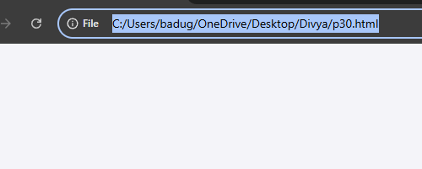

Project-31

Create a web page demonstrating the use of the tag.

<!DOCTYPE html>

<html lang="en">

<head>

<meta charset="UTF-8">

<meta name="viewport" content="width=device-width, initial-scale=1.0">

<title>Using the &lt;u&gt; Tag</title>

<style>

body {

font-family: Arial, sans-serif;

line-height: 1.6;

}

h1 {

color: #333;

}

p {

font-size: 18px;

}

.example {

font-size: 20px;

color: #555;

}

.note {

color: #e74c3c;

font-weight: bold;

}

</style>

</head>

<body>

<h1>Demonstrating the &lt;u&gt; Tag</h1>

<p>The <u>&lt;u&gt;</u> tag in HTML is used to underline text. Here's an example:</p>

<div class="example">

<p>This is <u>underlined text</u> using the <code>&lt;u&gt;</code> tag.</p>

</div>

<p class="note">Note: The <u>&lt;u&gt;</u> tag is typically used to indicate emphasis or highlight specific content in a webpage.</p>

</body>

</html>

Output:

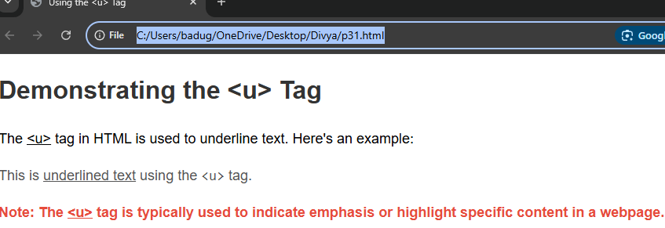

Project-32

Create a web page demonstrating the use of the and tags.

<!DOCTYPE html>

<html lang="en">

<head>

<meta charset="UTF-8">

<meta name="viewport" content="width=device-width, initial-scale=1.0">

<title>Using the &lt;mark&gt; and &lt;small&gt; Tags</title>

<style>

body {

font-family: Arial, sans-serif;

line-height: 1.6;

}

h1 {

color: #333;

}

p {

font-size: 18px;

}

.highlight {

font-size: 20px;

color: #555;

}

.note {

color: #e74c3c;

font-weight: bold;

}

.highlight-mark {

background-color: yellow; /* Highlight text with yellow */

}

.highlight-small {

font-size: 14px; /* Make the small text appear smaller */

color: #666;

}

</style>

</head>

<body>

<h1>Demonstrating the &lt;mark&gt; and &lt;small&gt; Tags</h1>

<p>The <u>&lt;mark&gt;</u> tag is used to highlight parts of text, while the <u>&lt;small&gt;</u> tag is used to display text in a smaller font.</p>

<div class="highlight">

<p>Here is an example of highlighted text using the <mark class="highlight-mark">mark tag</mark>.</p>

<p>Here's an example of smaller text using the <small class="highlight-small">small tag</small>.</p>

</div>

<p class="note">Note: The <u>&lt;mark&gt;</u> tag highlights text, typically for emphasis or to indicate a search match, and the <u>&lt;small&gt;</u> tag reduces the text size for side notes or fine print.</p>

</body>

</html>

Output:

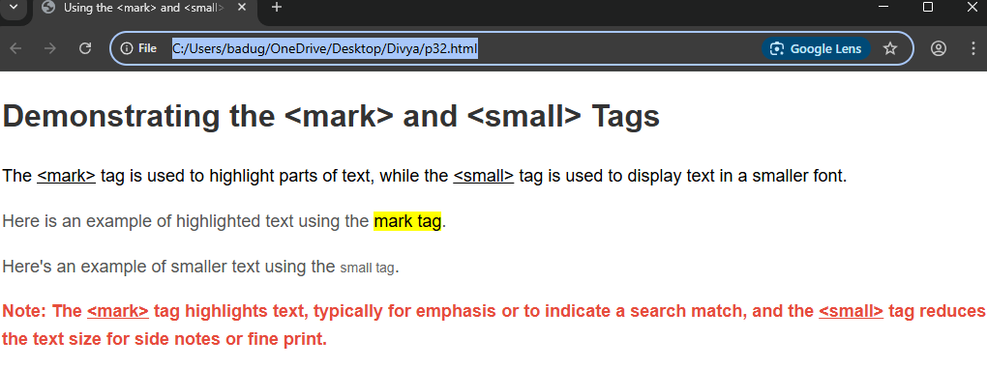

Project-33

Design a web page by demonstrating the usage of Form Tag

<!DOCTYPE html>

<html lang="en">

<head>

<meta charset="UTF-8">

<meta name="viewport" content="width=device-width, initial-scale=1.0">

<title>Form Tag Example</title>

<style>

body {

font-family: Arial, sans-serif;

margin: 0;

padding: 20px;

background-color: #f4f4f4;

}

h1 {

text-align: center;

color: #333;

}

.form-container {

max-width: 600px;

margin: 0 auto;

padding: 20px;

background-color: #fff;

border-radius: 8px;

box-shadow: 0 4px 8px rgba(0, 0, 0, 0.1);

}

label {

display: block;

font-size: 16px;

margin-bottom: 5px;

}

input[type="text"],

input[type="email"],

input[type="password"],

select,

textarea {

width: 100%;

padding: 10px;

margin-bottom: 15px;

border: 1px solid #ccc;

border-radius: 4px;

font-size: 14px;

}

input[type="radio"],

input[type="checkbox"] {

margin-right: 5px;

}

button {

padding: 12px 20px;

background-color: #4CAF50;

color: white;

border: none;

border-radius: 4px;

font-size: 16px;

cursor: pointer;

width: 100%;

}

button:hover {

background-color: #45a049;

}

.note {

color: #777;

font-size: 12px;

text-align: center;

}

.required {

color: red;

}

</style>

</head>

<body>

<h1>Contact Us</h1>

<div class="form-container">

<form action="#" method="post">

<!-- Name Field -->

<label for="name">Full Name <span class="required">*</span></label>

<input type="text" id="name" name="name" placeholder="Your full name" required>

<!-- Email Field -->

<label for="email">Email <span class="required">*</span></label>

<input type="email" id="email" name="email" placeholder="Your email address" required>

<!-- Password Field -->

<label for="password">Password <span class="required">*</span></label>

<input type="password" id="password" name="password" placeholder="Choose a password" required>

<!-- Gender Selection -->

<label>Gender</label>

<input type="radio" id="male" name="gender" value="male">

<label for="male">Male</label>

<input type="radio" id="female" n

Output:

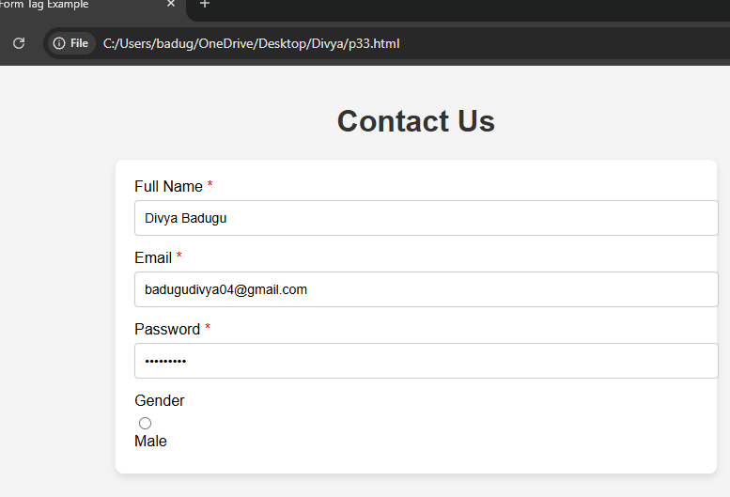

Project-34

Design a web page by demonstrating the usage of Radio Button

<!DOCTYPE html>

<html lang="en">

<head>

<meta charset="UTF-8">

<meta name="viewport" content="width=device-width, initial-scale=1.0">

<title>Radio Button Demo</title>

<style>

body {

font-family: Arial, sans-serif;

background-color: #f4f4f4;

margin: 0;

padding: 20px;

}

h1 {

text-align: center;

color: #333;

}

.form-container {

max-width: 500px;

margin: 0 auto;

background-color: white;

padding: 20px;

border-radius: 8px;

box-shadow: 0 4px 8px rgba(0, 0, 0, 0.1);

}

label {

font-size: 16px;

margin-right: 10px;

}

.radio-group {

margin-bottom: 15px;

}

input[type="radio"] {

margin-right: 10px;

}

.submit-btn {

width: 100%;

padding: 12px 20px;

background-color: #4CAF50;

color: white;

border: none;

border-radius: 4px;

font-size: 16px;

cursor: pointer;

}

.submit-btn:hover {

background-color: #45a049;

}

.note {

font-size: 12px;

color: #777;

text-align: center;

}

</style>

</head>

<body>

<h1>Choose Your Favorite Color</h1>

<div class="form-container">

<form action="#">

<!-- Radio Button Group for Color Selection -->

<div class="radio-group">

<label for="red">Red</label>

<input type="radio" id="red" name="color" value="red">

<label for="blue">Blue</label>

<input type="radio" id="blue" name="color" value="blue">

<label for="green">Green</label>

<input type="radio" id="green" name="color" value="green">

<label for="yellow">Yellow</label>

<input type="radio" id="yellow" name="color" value="yellow">

</div>

<!-- Radio Button Group for Subscription Plan -->

<div class="radio-group">

<label for="basic">Basic Plan</label>

<input type="radio" id="basic" name="plan" value="basic">

<label for="premium">Premium Plan</label>

<input type="radio" id="premium" name="plan" value="premium">

<label for="vip">VIP Plan</label>

<input type="radio" id="vip" name="plan" value="vip">

</div>

<!-- Submit Button -->

<button type="submit" class="submit-btn">Submit</button>

</form>

<p class="note">Note: You can only select one option in each group.</p>

</div>

</body>

</html>

Output:

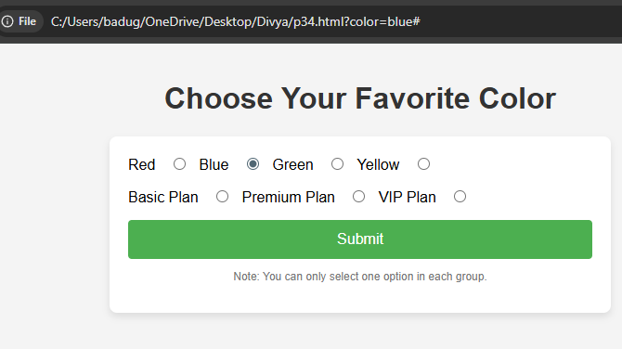

Project-35

Design a web page by demonstrating the usage of Check Box

<!DOCTYPE html>

<html lang="en">

<head>

<meta charset="UTF-8">

<meta name="viewport" content="width=device-width, initial-scale=1.0">

<title>Checkbox Demo</title>

<style>

body {

font-family: Arial, sans-serif;

background-color: #f4f4f4;

margin: 0;

padding: 20px;

}

h1 {

text-align: center;

color: #333;

}

.form-container {

max-width: 500px;

margin: 0 auto;

background-color: white;

padding: 20px;

border-radius: 8px;

box-shadow: 0 4px 8px rgba(0, 0, 0, 0.1);

output:

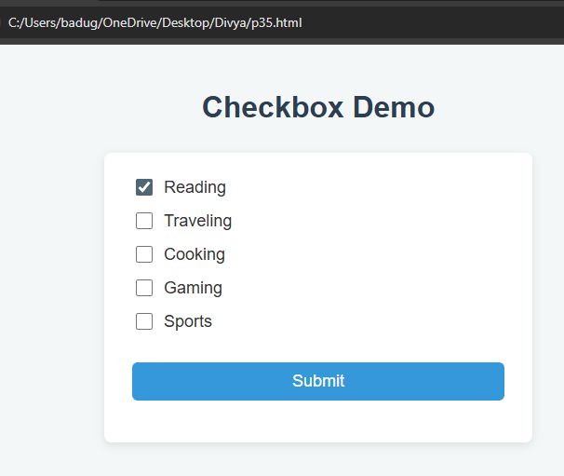

Project-36

Design a web page by demonstrating the usage of Dropdown

<!DOCTYPE html>

<html lang="en">

<head>

<meta charset="UTF-8">

<meta name="viewport" content="width=device-width, initial-scale=1.0">

<title>Dropdown Demo</title>

<style>

body {

font-family: Arial, sans-serif;

background-color: #f4f4f4;

margin: 0;

padding: 20px;

}

h1 {

text-align: center;

color: #333;

}

.form-container {

max-width: 500px;

margin: 0 auto;

background-color: white;

padding: 2

output:

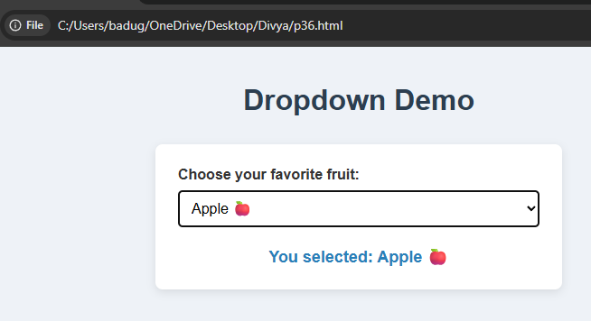

Project-37

Design a web page by demonstrating the usage of Text Area

<!DOCTYPE html>

<html lang="en">

<head>

<meta charset="UTF-8">

<meta name="viewport" content="width=device-width, initial-scale=1.0">

<title>Textarea Demo</title>

<style>

body {

font-family: Arial, sans-serif;

background-color: #f4f4f4;

margin: 0;

padding: 20px;

}

h1 {

text-align: center;

color: #333;

}

.form-container {

max-width: 600px;

margin: 0 auto;

background-color: white;

padding: 20px;

border-radius: 8px;

box-shadow: 0 4px 8px rgba(0, 0, 0, 0.1);

}

label {

font-size: 16px;

margin-bottom: 5px;

display: block;

}

textarea {

width: 100%;

height: 150px;

padding: 10px;

margin-bottom: 20px;

border: 1px solid #ccc;

border-radius: 4px;

font-size: 16px;

resize: vertical; /* Allows resizing the textarea vertically */

}

.submit-btn {

width: 100%;

padding: 12px 20px;

background-color: #4CAF50;

color: white;

border: none;

border-radius: 4px;

font-size: 16px;

cursor: pointer;

}

.submit-btn:hover {

background-color: #45a049;

}

.note {

font-size: 12px;

color: #777;

text-align: center;

}

</style>

</head>

<body>

<h1>Leave Us a Message</h1>

<div class="form-container">

<form action="#">

<!-- Textarea for Message -->

<label for="message">Your Message:</label>

<textarea id="message" name="message" placeholder="Write your message here..." required></textarea>

<!-- Submit Button -->

<button type="submit" class="submit-btn">Submit</button>

</form>

<p class="note">Note: You can type a longer message in the text area above.</p>

</div>

</body>

</html>

Output:

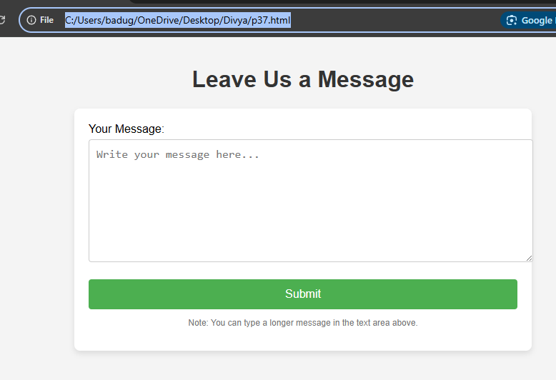

Project-38

Design a web page by demonstrating the usage of Button

<!DOCTYPE html>

<html lang="en">

<head>

<meta charset="UTF-8">

<meta name="viewport" content="width=device-width, initial-scale=1.0">

<title>Button Demo</title>

<style>

body {

font-family: Arial, sans-serif;

background-color: #f4f4f4;

margin: 0;

padding: 20px;

}

h1 {

text-align: center;

color: #333;

}

.form-container {

max-width: 600px;

margin: 0 auto;

background-color: white;

padding: 20px;

border-radius: 8px;

box-shadow: 0 4px 8px rgba(0, 0, 0, 0.1);

}

.button-container {

display: flex;

justify-content: space-between;

gap: 20px;

margin-bottom: 20px;

}

button {

padding: 12px 20px;

font-size: 16px;

border-radius: 4px;

border: none;

}

.submit-btn {

background-color: #4CAF50;

color: white;

}

.submit-btn:hover {

background-color: #45a049;

}

.reset-btn {

background-color: #f44336;

color: white;

}

.reset-btn:hover {

background-color: #e53935;

}

.alert-btn {

background-color: #2196F3;

color: white;

}

.alert-btn:hover {

background-color: #1976D2;

}

.note {

font-size: 14px;

color: #777;

text-align: center;

}

</style>

</head>

<body>

<h1>Button Demonstration</h1>

<div class="form-container">

<form action="#">

<!-- Button Container -->

<div class="button-container">

<!-- Submit Button -->

<button type="submit" class="submit-btn">Submit</button>

<!-- Reset Button -->

<button type="reset" class="reset-btn">Reset</button>

</div>

<!-- Alert Button -->

<button type="button" class="alert-btn" onclick="showAlert()">Click Me for Alert</button>

</form>

<p class="note">Note: Click the "Click Me for Alert" button to see an alert in action.</p>

</div>

<script>

// JavaScript function to show an alert

function showAlert() {

alert("Hello! You clicked the button.");

}

</script>

</body>

</html>

Output:

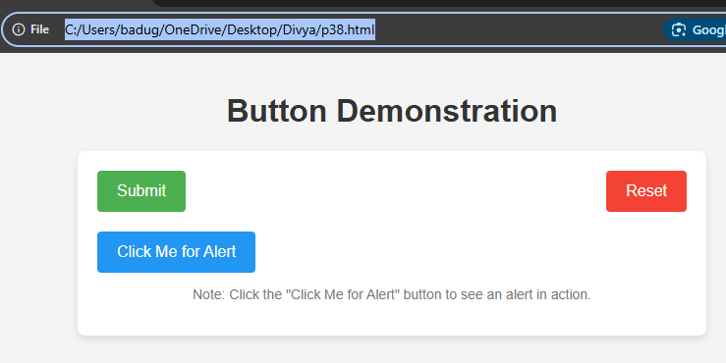

Project-39

Design a web page demonstrating the usage of the ‘’ tag

<!DOCTYPE html>

<html lang="en">

<head>

<meta charset="UTF-8">

<meta name="viewport" content="width=device-width, initial-scale=1.0">

<title>Superscript Demo</title>

<style>

body {

font-family: Arial, sans-serif;

background-color: #f4f4f4;

margin: 0;

padding: 20px;

}

h1 {

text-align: center;

color: #333;

}

.content {

max-width: 600px;

margin: 0 auto;

background-color: white;

padding: 20px;

border-radius: 8px;

box-shadow: 0 4px 8px rgba(0, 0, 0, 0.1);

}

p {

font-size: 18px;

line-height: 1.6;

}

.example {

background-color: #f9f9f9;

border-left: 4px solid #4CAF50;

padding-left: 20px;

margin-bottom: 20px;

}

.note {

font-size: 14px;

color: #777;

text-align: center;

}

</style>

</head>

<body>

<h1>Using the `<sup>` Tag</h1>

<div class="content">

<p>The `<sup>` tag is used to display superscript text. Superscript text is usually smaller than normal text and appea

Output:

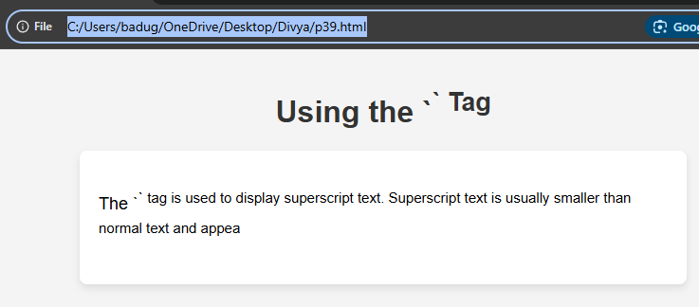

Project-40

Design a web page demonstrating the usage of the tag

<html lang="en">

<head>

    <meta charset="UTF-8">

    <meta name="viewport" content="width=device-width, initial-scale=1.0">

    <title>Subscript Demo</title>

    <style>

        body {

            font-family: Arial, sans-serif;

            background-color: #f4f4f4;

            margin: 0;

            padding: 20px;

        }

        h1 {

            text-align: center;

            color: #333;

        }

        .content {

            max-width: 600px;

            margin: 0 auto;

            background-color: white;

            padding: 20px;

            border-radius: 8px;

<

output:

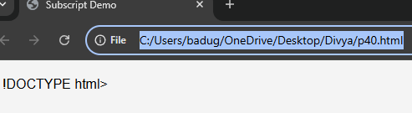

Project-41

Design a web page demonstrating the usage of the

<!DOCTYPE html>

<html lang="en">

<head>

<meta charset="UTF-8">

<meta name="viewport" content="width=device-width, initial-scale=1.0">

<title>Deleted Text (Strikethrough) Demo</title>

<style>

body {

font-family: Arial, sans-serif;

background-color: #f4f4f4;

margin: 0;

padding: 20px;

}

h1 {

text-align: center;

color: #333;

}

.content {

max-width: 600px;

margin: 0 auto;

background-color: white;

padding: 20px;

border-radius: 8px;

box-shadow: 0 4px 8px rgba(0, 0, 0, 0.1);

}

p {

font-size: 18px;

line-height: 1.6;

}

.example {

background-color: #f9f9f9;

border-left: 4px solid #4CAF50;

padding-left: 20px;

margin-bottom: 20px;

}

.note {

font-size: 14px;

color: #777;

text-align: center;

}

</style>

</head>

<body>

<h1>Using the `<del>` Tag</h1>

<div class="content">

<p>The `<del>` tag is used to represent deleted text. The text inside the `<del>` tag is displayed with a strikethrough, indicating that it has been removed or is no longer valid.</p>

<div class="example">

<p>Example 1: Correction in a Document</p>

<p>In a document, if there is a correction, the old version might be crossed out, like this: <strong>Original: <del>Apple</del> Orange</strong>. Here, the word "Apple" is deleted, and "Orange" is the new term.</p>

</div>

<div class="example">

<p>Example 2: Removed Item from List</p>

<p>Sometimes, products or items might be removed from a list. For example: <strong>Item 1: <del>Old Phone Model</del> New Phone Model</strong>.</p>

</div>

<div class="example">

<p>Example 3: Changed Information</p>

<p>For instance, if a scheduled event gets canceled, we might show: <strong>Event Date: <del>March 15</del> April 10</strong>, showing the previous date was removed and replaced with a new one.</p>

</div>

<p class="note">Note: The `<del>` tag is important for maintaining the integrity of the content, especially when displaying revisions, changes, or corrections in documents.</p>

</div>

</body>

</html>

Output:

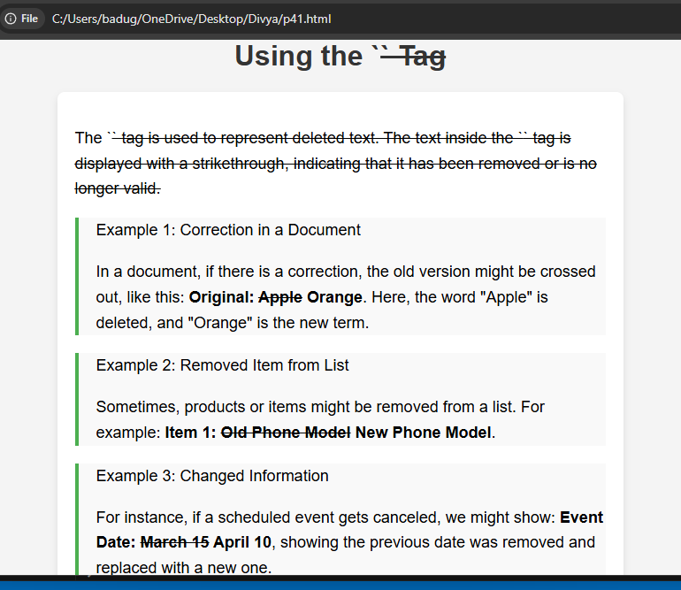

Project-42

Design a web page demonstrating the usage of the tag

<!DOCTYPE html>

<html lang="en">

<head>

<meta charset="UTF-8" />

<meta name="viewport" content="width=device-width, initial-scale=1" />

<title>Inserted Text (&lt;ins&gt;) Demo</title>

<style>

body {

font-family: Arial, sans-serif;

background-color: #f9f9f9;

margin: 0;

padding: 20px;

}

h1 {

text-align: center;

color: #333;

}

.content {

max-width: 600px;

margin: 0 auto;

background-color: #fff

output:

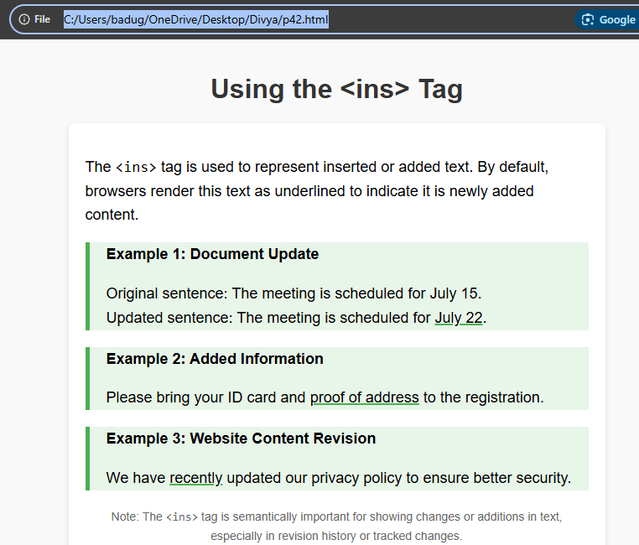

Project-43

Design a web page demonstrating the usage of the tag

<!DOCTYPE html>

<html lang="en">

<head>

<meta charset="UTF-8" />

<meta name="viewport" content="width=device-width, initial-scale=1" />

<title>Inline Quotation (&lt;q&gt;) Demo</title>

<style>

body {

font-family: Arial, sans-serif;

background-color: #fafafa;

margin: 0;

padding: 20px;

}

h1 {

text-align: center;

color: #222;

}

.content {

max-width: 600px;

margin: 0 auto;

background-color: #fff;

padding: 20px;

border-radius: 8px;

box-shadow: 0 3px 8px rgba(0,0,0,0.1);

}

p {

font-size: 18px;

line-height: 1.6;

color: #333;

}

.example {

background-color: #e0f7fa;

border-left: 5px solid #00796b;

padding-left: 20px;

margin-bottom: 20px;

}

.note {

font-size: 14px;

color: #666;

text-align: center;

font-style: italic;

}

</style>

</head>

<body>

<h1>Using the &lt;q&gt; Tag</h1>

<div class="content">

<p>The <code>&lt;q&gt;</code> tag is used for short inline quotations. Browsers usually add quotation marks automatically around the quoted text.</p>

<div class="example">

<p><strong>Example 1: Simple Quote</strong></p>

<p>She said, <q>Learning never exhausts the mind.</q></p>

</div>

<div class="example">

<p><strong>Example 2: Quote inside a paragraph</strong></p>

<p>One famous quote is <q>To be or not to be, that is the question.</q> from Shakespeare’s Hamlet.</p>

</div>

<div class="example">

<p><strong>Example 3: Nested Quotes</strong></p>

<p>He said, <q>I heard her say <q>practice makes perfect</q> yesterday.</q></p>

</div>

<p class="note">Note: The <code>&lt;q&gt;</code> tag automatically adds quotation marks and is ideal for short inline quotes within text.</p>

</div>

</body>

</html>

Output:

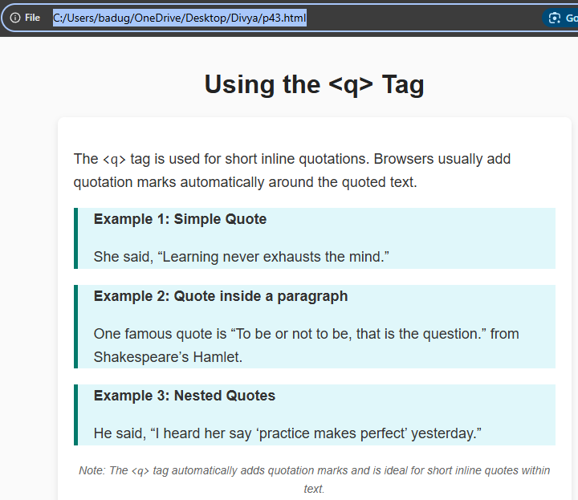

Project-44

Design a web page demonstrating the usage of the tag

<!DOCTYPE html>

<html lang="en">

<head>

<meta charset="UTF-8" />

<meta name="viewport" content="width=device-width, initial-scale=1" />

<title>Keyboard Input (&lt;kbd&gt;) Demo</title>

<style>

body {

font-family: Arial, sans-serif;

background-color: #f3f4f6;

margin: 0;

padding: 20px;

color: #333;

}

h1 {

text-align: center;

margin-bottom: 30px;

}

.content {

max-width: 600px;

margin: 0 auto;

background: white;

padding: 20px 30px;

border-radius: 8px;

box-shadow: 0 4px 10px rgba(0,0,0,0.1);

}

p {

font-size: 18px;

line-height: 1.5;

}

.example {

background-color: #e0f7fa;

border-left: 5px solid #00796b;

padding-left: 15px;

margin: 20px 0;

font-size: 18px;

}

kbd {

background-color: #ddd;

border: 1px solid #999;

border-radius: 3px;

box-shadow: inset 0 -1px 0 #bbb;

padding: 2px 6px;

font-family: monospace, monospace;

font-size: 1em;

color: #111;

}

.note {

font-size: 14px;

color: #666;

text-align: center;

font-style: italic;

margin-top: 30px;

}

</style>

</head>

<body>

<h1>Using the &lt;kbd&gt; Tag</h1>

<div class="content">

<p>The <code>&lt;kbd&gt;</code> tag is used to indicate keyboard input from the user. It is typically displayed in a monospace font with a styled background to mimic keys on a keyboard.</p>

<div class="example">

<p>Press <kbd>Ctrl</kbd> + <kbd>C</kbd> to copy the selected text.</p>

</div>

<div class="example">

<p>To save your work, press <kbd>Ctrl</kbd> + <kbd>S</kbd>.</p>

</div>

<div class="example">

<p>To open the developer tools in most browsers, press <kbd>F12</kbd> or <kbd>Ctrl</kbd> + <kbd>Shift</kbd> + <kbd>I</kbd>.</p>

</div>

<div class="example">

<p>On a Mac, press <kbd>Cmd</kbd> + <kbd>Q</kbd> to quit the application.</p>

</div>

<p class="note">Note: The <code>&lt;kbd&gt;</code> tag is helpful for documenting keyboard shortcuts and commands in a clear and semantic way.</p>

</div>

</body>

</html>

Output:

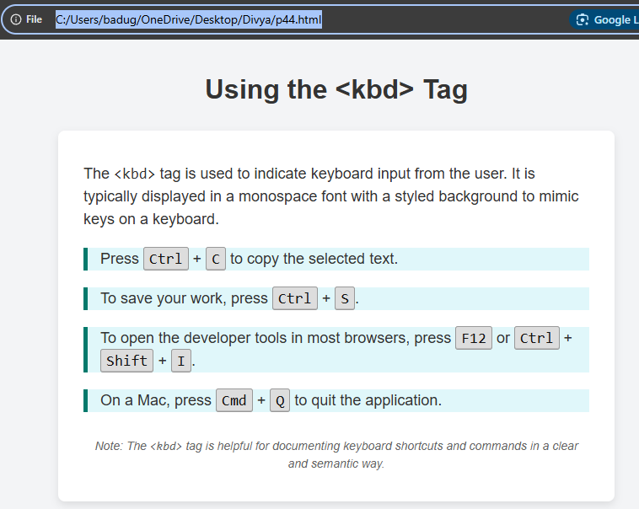

Project-45

Design a web page demonstrating the usage of the tag

<!DOCTYPE html>

<html lang="en">

<head>

<meta charset="UTF-8" />

<meta name="viewport" content="width=device-width, initial-scale=1" />

<title>Fieldset Tag Demo</title>

<style>

body {

font-family: Arial, sans-serif;

background-color: #f7f9fc;

margin: 0;

padding: 20px;

color: #333;

}

h1 {

text-align: center;

margin-bottom: 30px;

}

form {

max-width: 600px;

margin: 0 auto;

background-color: #fff;

padding: 25px;

border-radius: 8px;

box-shadow: 0 3px 10px rgba(0,0,0,0.1);

}

fieldset {

border: 2px solid #4a90e2;

border-radius: 6px;

padding: 15px 20px 20px;

margin-bottom: 20px;

}

legend {

font-weight: bold;

padding: 0 10px;

color: #4a90e2;

font-size: 1.1em;

}

label {

display: block;

margin-bottom: 8px;

font-weight: 600;

}

input[type="text"],

input[type="email"],

select {

width: 100%;

padding: 8px 10px;

margin-bottom: 15px;

border: 1px solid #ccc;

border-radius: 4px;

font-size: 16px;

box-sizing: border-box;

}

input[type="submit"] {

background-color: #4a90e2;

color: white;

border: none;

padding: 12px 25px;

border-radius: 5px;

font-size: 16px;

cursor: pointer;

transition: background-color 0.3s ease;

}

input[type="submit"]:hover {

background-color: #357ABD;

}

</style>

</head>

<body>

<h1>Using the &lt;fieldset&gt; Tag</h1>

<form>

<fieldset>

<legend>Personal Information</legend>

<label for="name">Full Name:</label>

<input type="text" id="name" name="name" placeholder="Enter your full name" required />

<label for="email">Email Address:</label>

<input type="email" id="email" name="email" placeholder="Enter your email" required />

</fieldset>

<fieldset>

<legend>Preferences</legend>

<label for="color">Favorite Color:</label>

<select id="color" name="color">

<option value="">Select a color</option>

<option value="red">Red</option>

<option value="blue">Blue</option>

<option value="green">Green</option>

<option value="yellow">Yellow</option>

</select>

<label>

<input type="checkbox" name="subscribe" /> Subscribe to newsletter

</label>

</fieldset>

<input type="submit" value="Submit" />

</form>

</body>

</html>

Output:

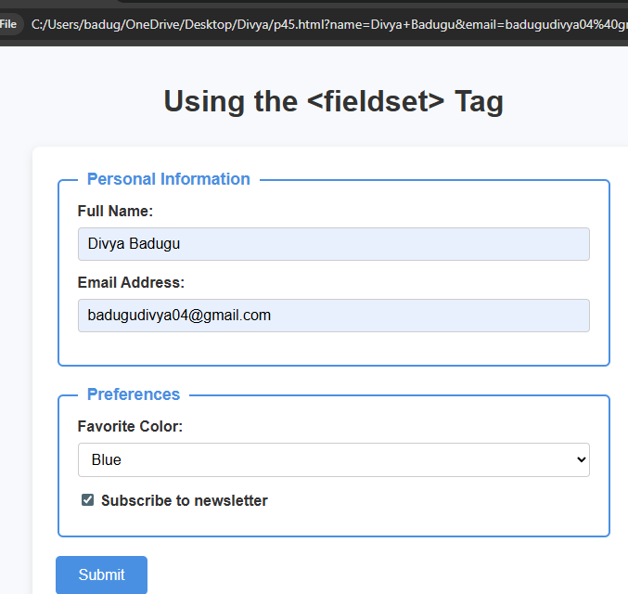

Project-46

Design a web page demonstrating the usage of the tag

<!DOCTYPE html>

<html lang="en">

<head>

<meta charset="UTF-8" />

<meta name="viewport" content="width=device-width, initial-scale=1" />

<title>Legend Tag Demo</title>

<style>

body {

font-family: Arial, sans-serif;

background-color: #f9fafb;

padding: 20px;

color: #333;

}

h1 {

text-align: center;

margin-bottom: 30px;

color: #34495e;

}

form {

max-width: 500px;

margin: 0 auto;

background-color: white;

padding: 25px;

border-radius: 8px;

box-shadow: 0 3px 8px rgba(0,0,0,0.1);

}

fieldset {

border: 2px solid #3498db;

border-radius: 6px;

padding: 15px 20px 20px;

margin-bottom: 20px;

}

legend {

font-weight: bold;

font-size: 1.2em;

color: #3498db;

padding: 0 10px;

}

label {

display: block;

margin-bottom: 10px;

font-size: 16px;

}

input[type="text"], input[type="email"] {

width: 100%;

padding: 8px 10px;

font-size: 16px;

border: 1px solid #ccc;

border-radius: 4px;

box-sizing: border-box;

margin-bottom: 15px;

}

button {

background-color: #3498db;

color: white;

border: none;

padding: 12px 20px;

font-size: 16px;

border-radius: 5px;

cursor: pointer;

transition: background-color 0.3s ease;

}

button:hover {

background-color: #2980b9;

}

</style>

</head>

<body>

<h1>Demonstrating the &lt;legend&gt; Tag</h1>

<form>

<fieldset>

<legend>Personal Details</legend>

<label for="fullname">Full Name:</label>

<input type="text" id="fullname" name="fullname" placeholder="Enter your full name" required />

<label for="email">Email Address:</label>

<input type="email" id="email" name="email" placeholder="Enter your email" required />

</fieldset>

<fieldset>

<legend>Account Settings</legend>

<label for="username">Username:</label>

<input type="text" id="username" name="username" placeholder="Choose a username" required />

</fieldset>

<button type="submit">Submit</button>

</form>

</body>

</html>

Output:

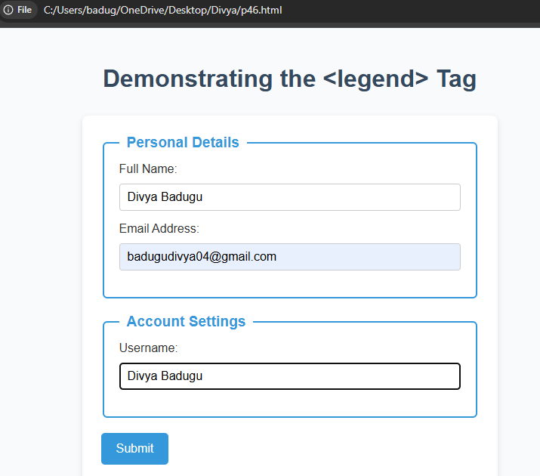

Project-47

Design a web page demonstrating the usage of the tag

<!DOCTYPE html>

<html lang="en">

<head>

<meta charset="UTF-8" />

<meta name="viewport" content="width=device-width, initial-scale=1" />

<title>Demonstrating the &lt;section&gt; Tag</title>

<style>

body {

font-family: Arial, sans-serif;

margin: 20px;

}

section {

border: 2px solid #007BFF;

padding: 15px;

margin-bottom: 20px;

border-radius: 8px;

background-color: #e6f0ff;

}

h2 {

color: #007BFF;

}

</style>

</head>

<body>

<h1>Demonstrating the &lt;section&gt; Tag</h1>

<section>

<h2>Introduction</h2>

<p>The <code>&lt;section&gt;</code> tag defines a section in a document.</p>

</section>

<section>

<h2>Usage</h2>

<p>Use the <code>&lt;section&gt;</code> element to group related content with a heading.</p>

</section>

<section>

<h2>Example</h2>

<p>This is a simple example of using multiple sections on one page.</p>

</section>

</body>

</html>

Output:

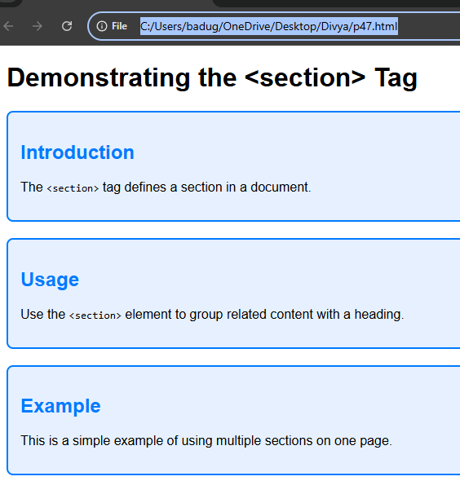

Project-48

. Design a web page demonstrating the usage of the ‘cols’ attribute in

<frameset>

<!DOCTYPE html>

<html>

<head>

<title>Demonstrating &lt;frameset&gt; with cols attribute</title>

</head>

<!-- Define a frameset with three columns -->

<frameset cols="20%, 60%, 20%">

<frame src="https://example.com" name="leftFrame" />

<frame src="https://www.wikipedia.org" name="centerFrame" />

<frame src="https://www.openai.com" name="rightFrame" />

<!-- fallback content for browsers that don't support frames -->

<noframes>

<body>

Your browser does not support frames. Please visit these sites manually:

<ul>

<li><a href="https://example.com">Example</a></li>

<li><a href="https://www.wikipedia.org">Wikipedia</a></li>

<li><a href="https://www.openai.com">OpenAI</a></li>

</ul>

</body>

</noframes>

</frameset>

</html>

Output:

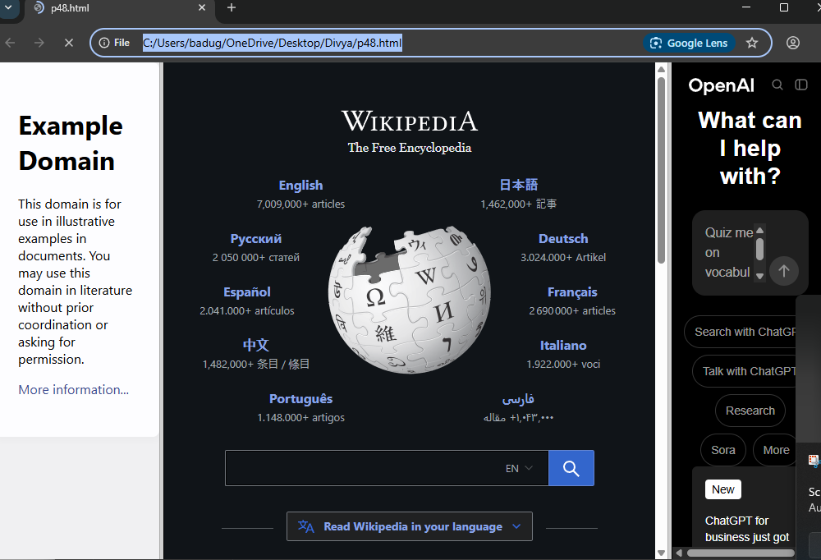

Project-49

Design a web page demonstrating the usage of the ‘rows’ attribute in

<frameset>

<!DOCTYPE html>

<html>

<head>

<title>Using &lt;frameset rows&gt;</title>

</head>

<!-- Define a frameset with 3 rows -->

<frameset rows="30%, 40%, 30%">

<frame src="https://example.com" name="topFrame" />

<frame src="https://www.wikipedia.org" name="middleFrame" />

<frame src="https://www.openai.com" name="bottomFrame" />

<!-- Fallback content if frames are not supported -->

<noframes>

<body>

<h2>Your browser does not support frames.</h2>

<p>Here are the links:</p>

<ul>

<li><a href="https://example.com">Example</a></li>

<li><a href="https://www.wikipedia.org">Wikipedia</a></li>

<li><a href="https://www.openai.com">OpenAI</a></li>

</ul>

</body>

</noframes>

</frameset>

</html>

Output:

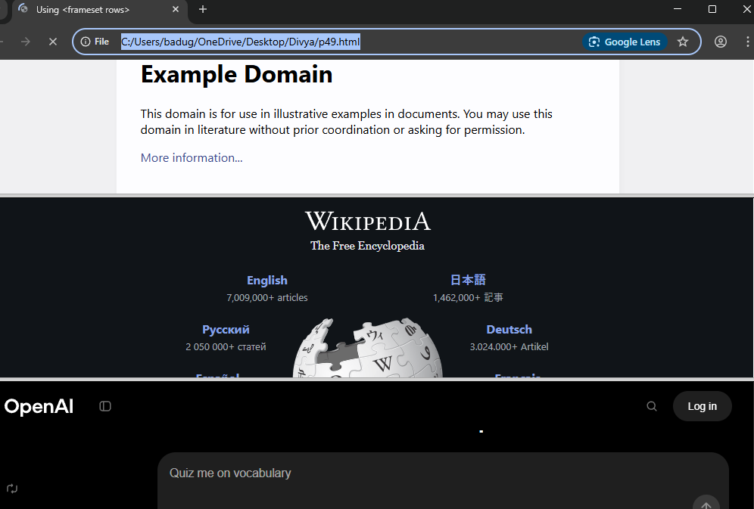

Project-50

Design a web page demonstrating the usage of the ‘frameborder’ attribute in

<frameset>

<!DOCTYPE html>

<html>

<head>

<title>Demonstrating frameborder in &lt;frameset&gt;</title>

</head>

<!-- Create a frameset with 2 columns -->

<frameset cols="50%, 50%">

<!-- Frame with border (default behavior or frameborder="1") -->

<frame src="https://example.com" name="leftFrame" frameborder="1">

<!-- Frame without border -->

<frame src="https://www.wikipedia.org" name="rightFrame" frameborder="0">

<noframes

Output:  
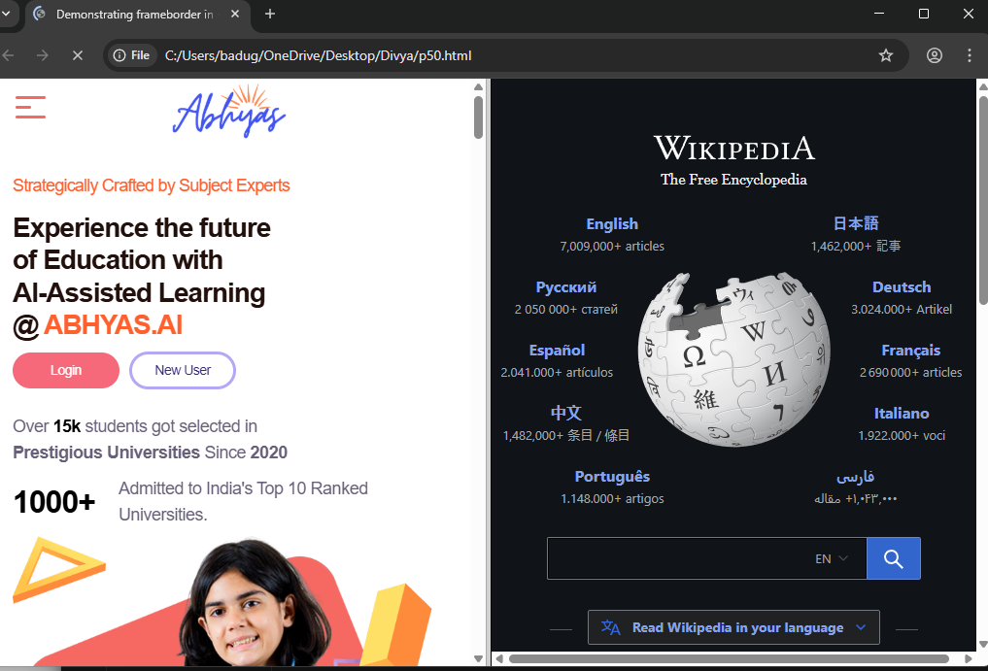

Project-51

Design a web page demonstrating the usage of the ‘border’ attribute in

<frameset>

<!DOCTYPE html>

<html>

<head>

<title>Using border in &lt;frameset&gt;</title>

</head>

<!-- Create a frameset with two columns and set border="5" -->

<frameset cols="50%, 50%" border="5">

<frame src="https://example.com" name="leftFrame" />

<frame src="https://www.wikipedia.org" name="rightFrame" />

<noframes>

<body>

<h2>Your browser does not support frames.</h2>

<p>Here are the links shown in the frames:</p>

Output:

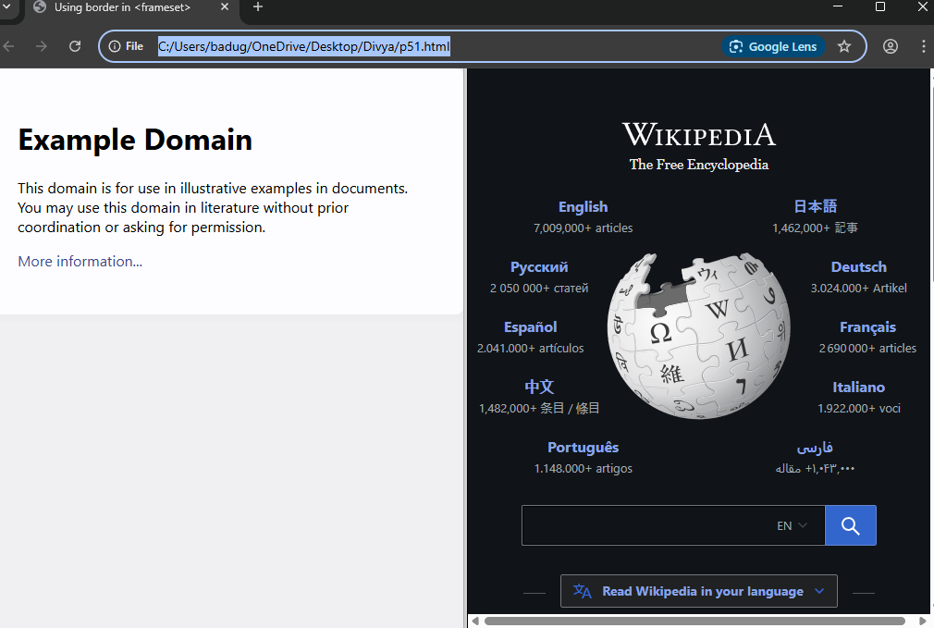

Project-52

Design a web page demonstrating the usage of the ‘noresize’ attribute in

<frame>

<!DOCTYPE html>

<html>

<head>

<title>Demonstrating noresize Attribute in &lt;frame&gt;</title>

</head>

<frameset cols="30%, 70%">

<!-- Left frame with noresize (cannot be resized) -->

<frame src="https://example.com" name="leftFrame" noresize>

<!-- Right frame resizable -->

<frame src="https://www.wikipedia.org" name="rightFrame">

<noframes>

<body>

<h2>Your browser does not support frames.</h2>

<ul>

<li><a href="https://example.com">Example Site</a></li>

<li><a href="https://www.wikipedia.org">Wikipedia</a></li>

</ul>

</body>

</noframes>

</frameset>

</html>

Output:

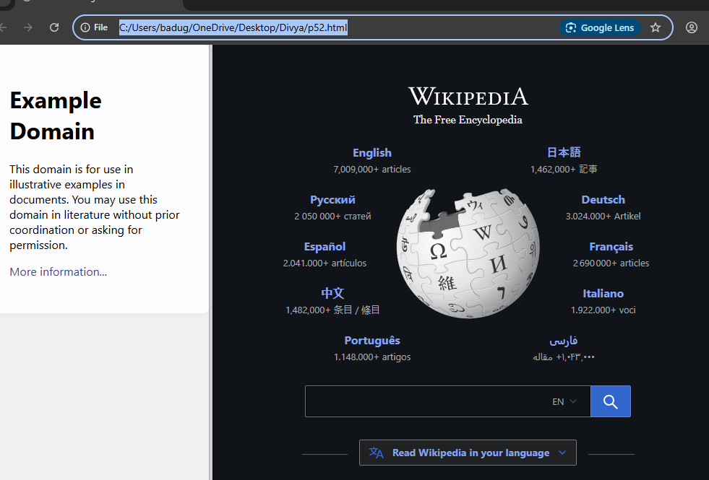

Project-53

Design a web page demonstrating the usage of the tag.

<!DOCTYPE html>

<html lang="en">

<head>

<meta charset="UTF-8" />

<meta name="viewport" content="width=device-width, initial-scale=1" />

<title>Demonstrating the &lt;header&gt; Tag</title>

<style>

body {

font-family: Arial, sans-serif;

margin: 0;

padding: 0;

}

header {

background-color: #007BFF;

color: white;

padding: 20px 40px;

text-align: center;

}

nav a {

color: white;

margin: 0 15px;

text-decoration: none;

font-weight: bold;

}

nav a:hover {

text-decoration: underline;

}

main {

padding: 20px 40px;

}

</style>

</head>

<body>

<header>

<h1>Welcome to My Website</h1>

<nav>

<a href="#home">Home</a>

<a href="#about">About</a>

<a href="#services">Services</a>

<a href="#contact">Contact</a>

</nav>

</header>

<main>

<section id="home">

<h2>Home</h2>

<p>This is the home section of the website.</p>

</section>

<section id="about">

<h2>About</h2>

<p>Learn more about us here.</p>

</section>

<section id="services">

<h2>Services</h2>

<p>Details about the services we offer.</p>

</section>

<section id="contact">

<h2>Contact</h2>

<p>How to get in touch with us.</p>

</section>

</main>

</body>

</html>

Output:

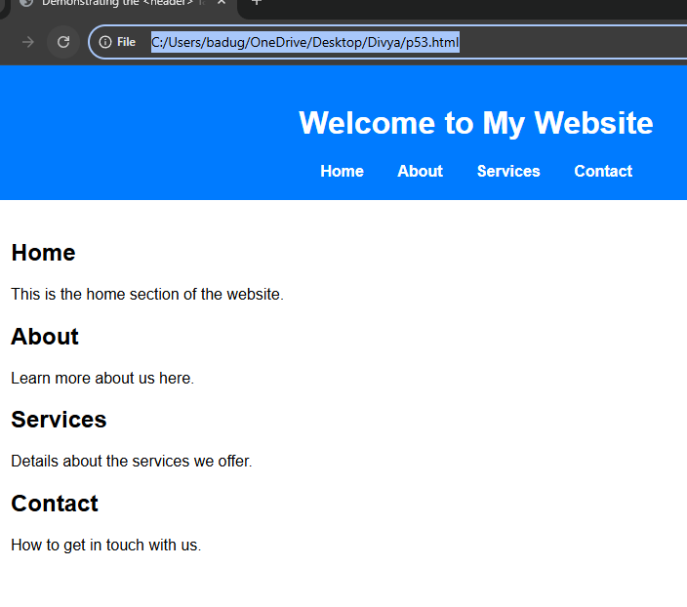

Project-54

Design a web page demonstrating the usage of the tag.

<!DOCTYPE html>

<html lang="en">

<head>

<meta charset="UTF-8" />

<meta name="viewport" content="width=device-width, initial-scale=1" />

<title>Demonstrating the &lt;nav&gt; Tag</title>

<style>

body {

font-family: Arial, sans-serif;

margin: 0;

padding: 0;

}

nav {

background-color: #333;

padding: 15px 40px;

}

nav a {

color: white;

margin-right: 20px;

text-decoration: none;

font-weight: bold;

font-size: 16px;

}

nav a:hover {

text-decoration: underline;

}

main {

padding: 20px 40px;

}

</style>

</head>

<body>

<nav>

<a href="#home">Home</a>

<a href="#about">About</a>

<a href="#blog">Blog</a>

<a href="#contact">Contact</a>

</nav>

<main>

<section id="home">

<h2>Home</h2>

<p>Welcome to our website!</p>

</section>

<section id="about">

<h2>About</h2>

<p>This section tells you about us.</p>

</section>

<section id="blog">

<h2>Blog</h2>

<p>Read our latest posts.</p>

</section>

<section id="contact">

<h2>Contact</h2>

<p>Get in touch with us.</p>

</section>

</main>

</body>

</html>

Output:

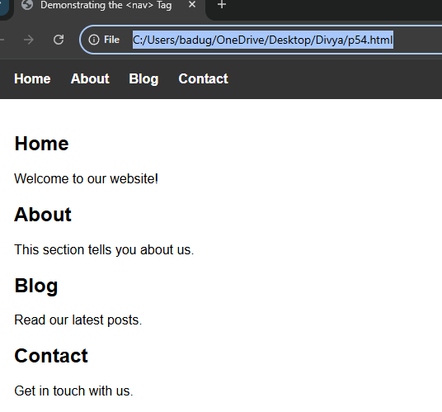

Project-55

Design a web page demonstrating the usage of the tag.

<!DOCTYPE html>

<html lang="en">

<head>

<meta charset="UTF-8" />

<meta name="viewport" content="width=device-width, initial-scale=1" />

<title>Demonstrating the &lt;main&gt; Tag</title>

<style>

body {

font-family: Arial, sans-serif;

margin: 0;

padding: 0;

}

header, footer {

background-color: #007BFF;

color: white;

padding: 15px 40px;

text-align: center;

}

main {

padding: 20px 40px;

background-color: #f9f9f9;

min-height: 300px;

}

</style>

</head>

<body>

<header>

<h1>My Website Header</h1>

</header>

<main>

<h2>Main Content Area</h2>

<p>This is where the primary content of the webpage goes.</p>

<p>The <code>&lt;main&gt;</code> element helps improve accessibility and SEO by clearly indicating the main part of the document.</p>

</main>

<footer>

<p>© 2025 My Website</p>

</footer>

</body>

</html>

Output:

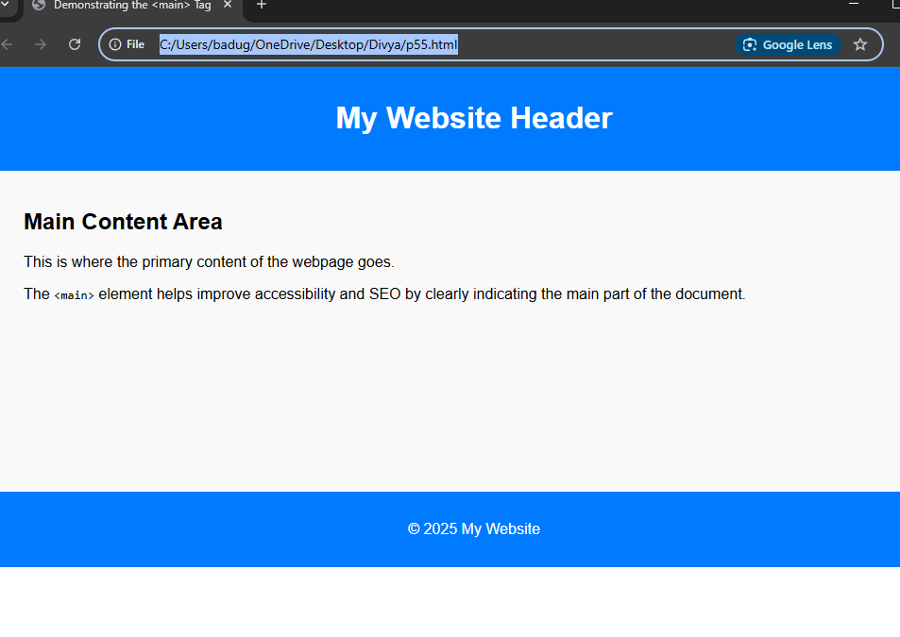

Project-56

Design a web page demonstrating the usage of the tag.

<!DOCTYPE html>

<html lang="en">

<head>

<meta charset="UTF-8" />

<meta name="viewport" content="width=device-width, initial-scale=1" />

<title>Demonstrating the &lt;article&gt; Tag</title>

<style>

body {

font-family: Arial, sans-serif;

margin: 0;

padding: 20px 40px;

background-color: #f4f4f4;

}

article {

background-color: white;

border: 1px solid #ddd;

padding: 20px;

margin-bottom: 30px;

border-radius: 8px;

box-shadow: 0 2px 5px rgba(0,0,0,0.1);

}

article h2 {

margin-top: 0;

color: #333;

}

article footer {

font-size: 0.9em;

color: #666;

margin-top: 15px;

border-top: 1px solid #eee;

padding-top: 10px;

}

</style>

</head>

<body>

<h1>Blog Posts</h1>

<article>

<h2>Understanding the &lt;article&gt; Tag</h2>

<p>The <code>&lt;article&gt;</code> tag represents a self-contained composition in a document, page, or site, such as a blog post, news story, or forum post.</p>

<p>It’s useful for structuring content and improving accessibility and SEO.</p>

<footer>Posted on July 11, 2025 by Admin</footer>

</article>

<article>

<h2>Benefits of Semantic HTML</h2>

<p>Semantic HTML tags like <code>&lt;article&gt;</code>, <code>&lt;section&gt;</code>, and <code>&lt;header&gt;</code> make your markup more meaningful and accessible.</p>

<footer>Posted on July 10, 2025 by Admin</footer>

</article>

</body>

</html>

Output:

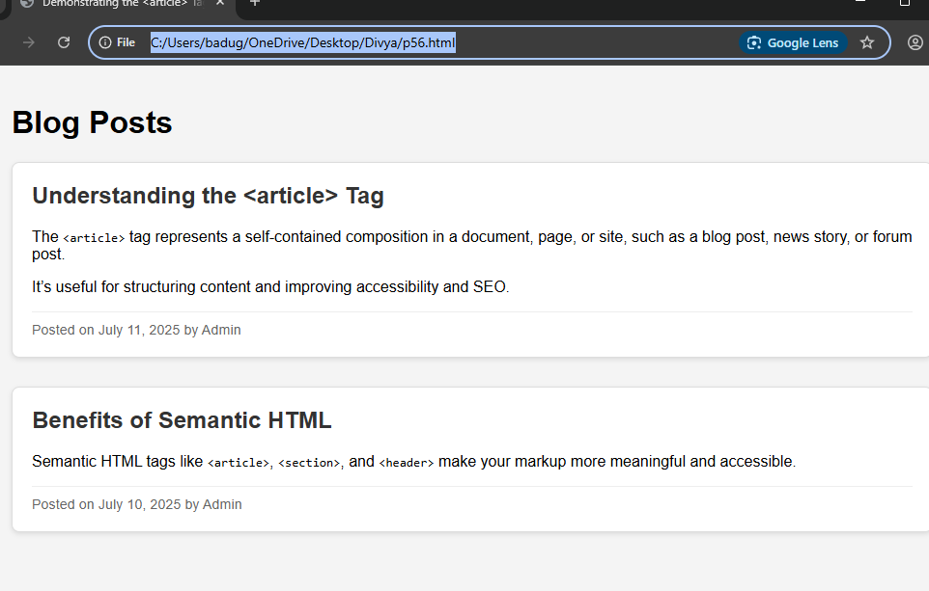

Project-57

Design a web page demonstrating the usage of the tag.

<!DOCTYPE html>

<html lang="en">

<head>

<meta charset="UTF-8" />

<meta name="viewport" content="width=device-width, initial-scale=1" />

<title>Demonstrating the &lt;section&gt; Tag</title>

<style>

body {

font-family: Arial, sans-serif;

margin: 0;

padding: 20px 40px;

background-color: #f7f7f7;

}

section {

background-color: white;

border: 1px solid #ddd;

border-radius: 6px;

padding: 20px;

margin-bottom: 25px;

box-shadow: 0 1px 4px rgba(0,0,0,0.1);

}

section h2 {

margin-top: 0;

color: #007BFF;

}

</style>

</head>

<body>

<h1>About Our Company</h1>

<section>

<h2>Our Mission</h2>

<p>We strive to deliver high-quality products that improve everyday life.</p>

</section>

<section>

<h2>Our Team</h2>

<p>Our team consists of passionate professionals dedicated to innovation.</p>

</section>

<section>

<h2>Contact Us</h2>

<p>Reach out via email or phone for more information.</p>

</section>

</body>

</html>

Output:

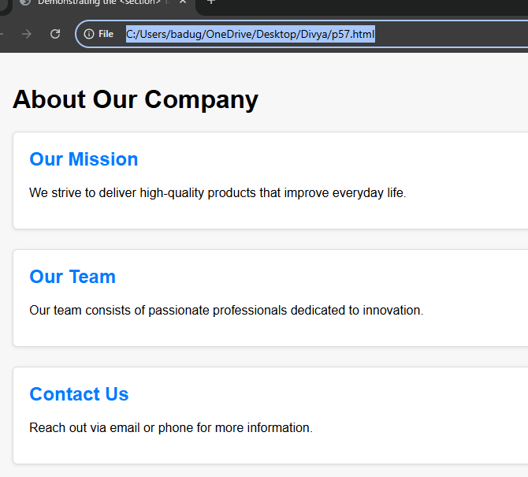

Project-58

Design a web page demonstrating the usage of the tag.

<!DOCTYPE html>

<html lang="en">

<head>

<meta charset="UTF-8" />

<meta name="viewport" content="width=device-width, initial-scale=1" />

<title>Demonstrating the &lt;aside&gt; Tag</title>

<style>

body {

font-family: Arial, sans-serif;

margin: 0;

padding: 20px 40px;

background-color: #f8f9fa;

display: flex;

max-width: 900px;

margin-left: auto;

margin-right: auto;

}

main {

flex: 3;

background-color: white;

padding: 20px;

border-radius: 6px;

box-shadow: 0 0 8px rgba(0,0,0,0.1);

}

aside {

flex: 1;

margin-left: 20px;

background-color: #e9ecef;

padding: 20px;

border-radius: 6px;

font-size: 0.9em;

color: #555;

box-shadow: 0 0 6px rgba(0,0,0,0.05);

}

h1, h2 {

color: #333;

}

p {

line-height: 1.5;

}

</style>

</head>

<body>

<main>

<h1>Understanding the &lt;aside&gt; Tag</h1>

<p>The <code>&lt;aside&gt;</code> element represents content indirectly related to the main content. It often contains sidebars, pull quotes, or related links.</p>

<p>Using <code>&lt;aside&gt;</code> helps improve semantic meaning and accessibility of your web pages.</p>

</main>

<aside>

<h2>Related Info</h2>

<p>Did you know? The <code>&lt;aside&gt;</code> tag was introduced in HTML5 to better structure web content.</p>

<p>Sidebars are commonly marked up with <code>&lt;aside&gt;</code> for clarity and accessibility.</p>

</aside>

</body>

</html>

Output:

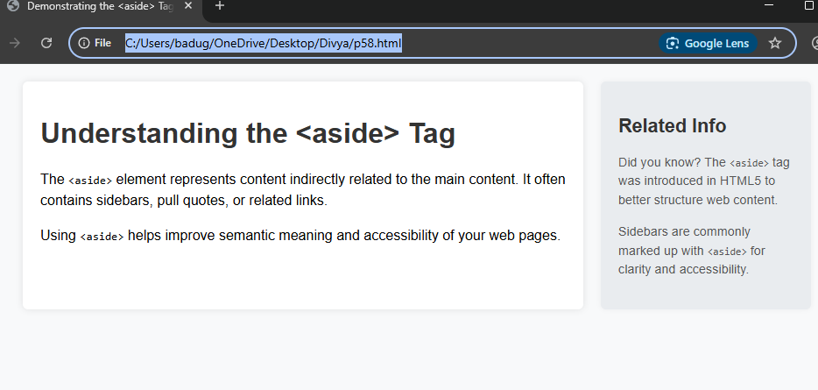

Project-59

Design a web page demonstrating the usage of the tag.

<!DOCTYPE html>

<html lang="en">

<head>

<meta charset="UTF-8" />

<meta name="viewport" content="width=device-width, initial-scale=1" />

<title>Demonstrating the &lt;footer&gt; Tag</title>

<style>

body {

font-family: Arial, sans-serif;

margin: 0;

padding: 0;

display: flex;

flex-direction: column;

min-height: 100vh;

background-color: #f4f4f4;

}

header {

background-color: #007BFF;

color: white;

padding: 20px;

text-align: center;

}

main {

flex: 1;

padding: 20px 40px;

background-color: white;

}

footer {

background-color: #222;

color: #ccc;

text-align: center;

padding: 15px 20px;

}

footer a {

color: #bbb;

margin: 0 10px;

text-decoration: none;

}

footer a:hover {

color: white;

text-decoration: underline;

}

</style>

</head>

<body>

<header>

<h1>My Personal Blog</h1>

</header>

<main>

<h2>Welcome!</h2>

<p>This is the main content of the website. Here you'll find articles, news, and updates.</p>

</main>

<footer>

<p>&copy; 2025 My Blog. All rights reserved.</p>

<p>

<a href="#">Privacy Policy</a> |

<a href="#">Terms of Service</a> |

<a href="#">Contact</a>

</p>

</footer>

</body>

</html>

Output:

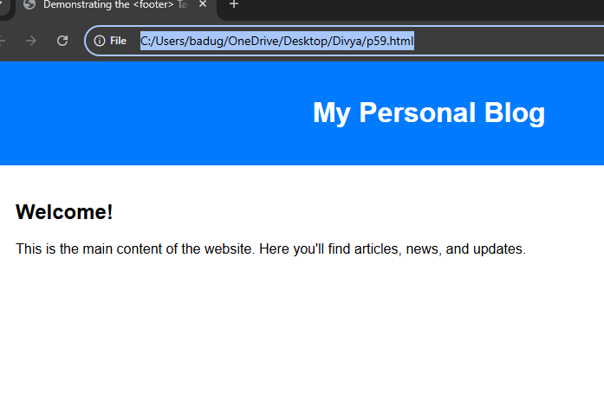

Project-60

Design a web page demonstrating the usage of the and tags<figure>and

<figcaption>tags

<!DOCTYPE html>

<html lang="en">

<head>

<meta charset="UTF-8" />

<meta name="viewport" content="width=device-width, initial-scale=1" />

<title>Demonstrating &lt;figure&gt; and &lt;figcaption&gt; Tags</title>

<style>

body {

font-family: Arial, sans-serif;

padding: 40px;

background-color: #f8f8f8;

}

h1 {

text-align: center;

color: #333;

}

figure {

margin: 20px auto;

text-align: center;

background-color: white;

padding: 20px;

border: 1px solid #ddd;

border-radius: 6px;

max-width: 500px;

box-shadow: 0 0 6px rgba(0,0,0,0.1);

}

figure img {

max-width: 100%;

height: auto;

border-radius: 4px;

}

figcaption {

margin-top: 10px;

font-style: italic;

color: #666;

}

</style>

</head>

<body>

<h1>Figure and Figcaption Example</h1>

<figure>

<img src="https://via.placeholder.com/450x250" alt="Placeholder example image">

<figcaption>Figure 1: This is a sample image with a caption using the &lt;figcaption&gt; tag.</figcaption>

</figure>

</body>

</html>

Output:

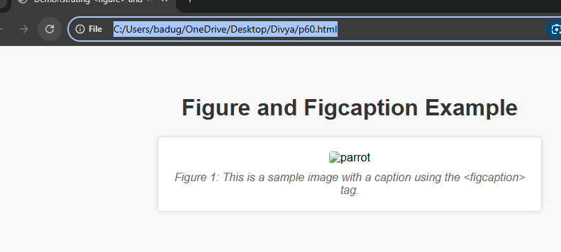

Project-61

Design a web page implementing Inline CSS

<!DOCTYPE html>

<html lang="en">

<head>

<meta charset="UTF-8">

<title>Inline CSS Example</title>

</head>

<body>

<h1 style="color: darkblue; text-align: center; font-family: Arial;">Welcome to Inline CSS Demo</h1>

<p style="font-size: 18px; color: #333; line-height: 1.6;">

This paragraph is styled using <strong>inline CSS</strong>. Inline styles are applied directly within the HTML element using the <code>style</code> attribute.

</p>

<button style="background-color: green; color: white; padding: 10px 20px; border: none; border-radius: 5px; cursor: pointer;">

Click Me

</button>

<div style="margin-top: 20px; padding: 15px; background-color: #f0f0f0; border: 1px solid #ccc;">

<h2 style="margin-top: 0; color: #444;">Inline CSS Tips</h2>

<ul>

<li style="color: #555;">Quick and easy for small styles</li>

<li style="color: #555;">Not recommended for large projects</li>

<li style="color: #555;">Hard to maintain and scale</li>

</ul>

</div>

</body>

</html>

Output:

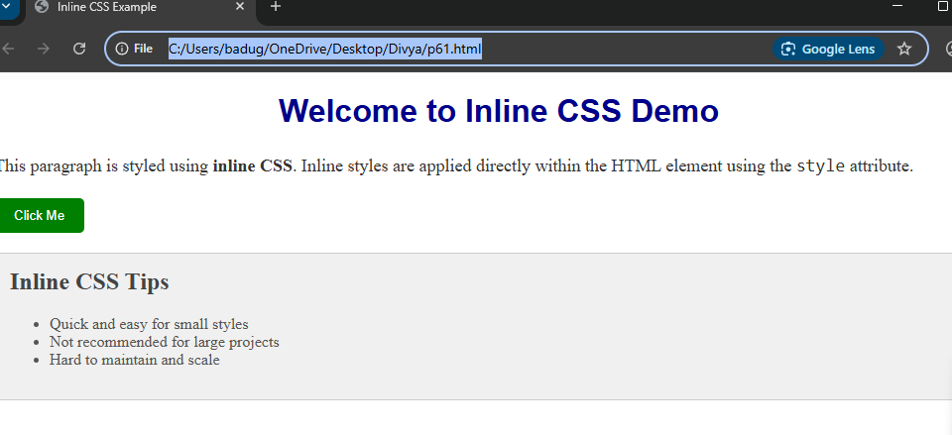

Project-62

Design a web page implementing Internal CSS

<!DOCTYPE html>

<html lang="en">

<head>

<meta charset="UTF-8">

<title>My First Styled Page</title>

<style>

body {

font-family: Arial, sans-serif;

background-color: #f2f2f2;

color: #333;

margin: 0;

padding: 0;

}

header {

background-color: #4CAF50;

color: white;

padding: 20px;

text-align: center;

}

nav {

background-color: #333;

overflow: hidden;

}

nav a {

float: left;

display: block;

color: white;

text-align: center;

padding: 14px 20px;

text-decoration: none;

}

nav a:hover {

background-color: #ddd;

color: black;

}

main {

padding: 20px;

}

footer {

background-color: #4CAF50;

color: white;

text-align: center;

padding: 10px;

position: relative;

bottom: 0;

width: 100%;

}

</style>

</head>

<body>

<header>

<h1>Welcome to My Website</h1>

<p>This page uses internal CSS for styling.</p>

</header>

<nav>

<a href="#">Home</a>

<a href="#">About</a>

<a href="#">Contact</a>

</nav>

<main>

<h2>About This Page</h2>

<p>This is a simple web page to demonstrate the use of internal CSS.</p>

</main>

<footer>

&copy; 2025 My Website

</footer>

</body>

</html>

Output:

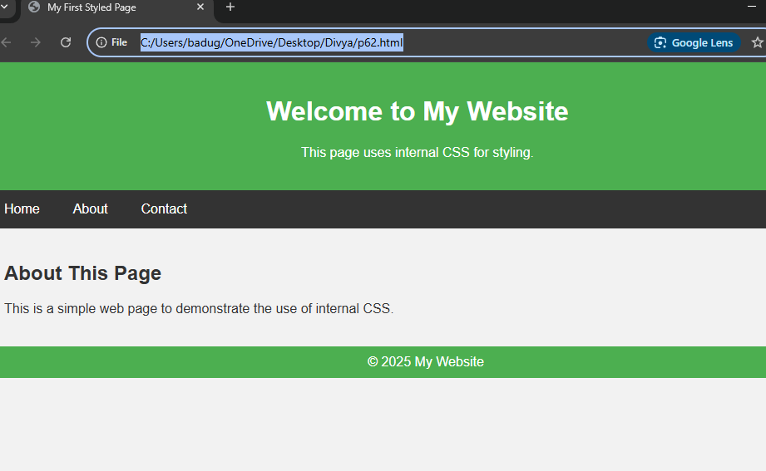

Project-63

Design a web page implementing External CSS

<!DOCTYPE html>

<html lang="en">

<head>

<meta charset="UTF-8">

<title>My Website with External CSS</title>

<link rel="stylesheet" href="style.css"> <!-- Link to external CSS -->

</head>

<body>

<header>

<h1>Welcome to My Styled Website</h1>

<p>This page uses external CSS for styling.</p>

</header>

<nav>

<a href="#">Home</a>

<a href="#">Services</a>

<a href="#">Contact</a>

</nav>

<main>

<h2>About This Site</h2>

<p>This is an example of how to use an external CSS file to style a webpage.</p>

</main>

<footer>

&copy; 2025 My Website

</footer>

</body>

</html>

Output:

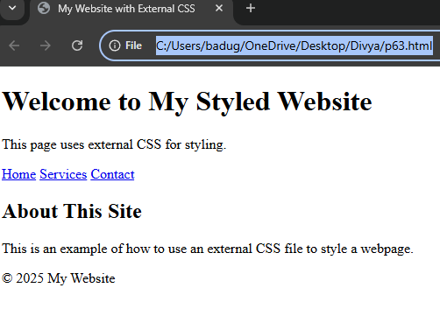

Project-64

64. Design a web page implementing the usage of CSS background property

<!DOCTYPE html>

<html lang="en">

<head>

<meta charset="UTF-8">

<title>CSS Background Property Demo</title>

<style>

body {

margin: 0;

font-family: Arial, sans-serif;

}

/* Entire body background */

body {

background-color: #e0f7fa;

}

.hero-section {

background-image: url('https://via.placeholder.com/1200x400'); /* Replace with your image URL */

background-repeat: no-repeat;

background-size: cover;

background-position: center;

height: 400px;

color: white;

text-align: center;

padding-top: 150px;

}

.content {

background-color: #ffffff;

padding: 20px;

text-align: center;

}

.pattern-box {

background-image: url('https://www.transparenttextures.com/patterns/checkered-pattern.png');

background-repeat: repeat;

background-size: auto;

padding: 40px;

margin: 20px auto;

width: 80%;

border: 1px solid #ccc;

}

.fixed-background {

background-image: url('https://via.placeholder.com/1200x800');

background-attachment: fixed;

background-size: cover;

background-position: center;

height: 300px;

color: white;

text-align: center;

padding-top: 120px;

margin-top: 40px;

}

footer {

background-color: #00796b;

color: white;

text-align: center;

padding: 15px;

}

</style>

</head>

<body>

<div class="hero-section">

<h1>CSS Background Property</h1>

<p>Using images, colors, and fixed effects</p>

</div>

<div class="content">

<h2>Section with Solid Background</h2>

<p>This section uses a solid background color.</p>

</div>

<div class="pattern-box">

<h3>Pattern Background</h3>

<p>This box uses a repeating pattern as its background image.</p>

</div>

<div class="fixed-background">

<h2>Fixed Background</h2>

<p>This background stays fixed while scrolling.</p>

</div>

<footer>

&copy; 2025 Background CSS Demo

</footer>

</body>

</html>

Output:

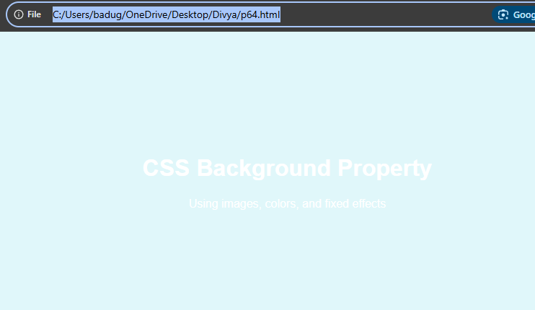

Project-65

Design a web page implementing the usage of CSS borders property

<!DOCTYPE html>

<html lang="en">

<head>

<meta charset="UTF-8">

<title>CSS Border Property Demo</title>

<style>

body {

font-family: Arial, sans-serif;

background-color: #f9f9f9;

padding: 20px;

}

h1 {

text-align: center;

color: #333;

}

.box {

margin: 20px auto;

padding: 20px;

width: 300px;

text-align: center;

background-color: #fff;

}

.solid-border {

border: 3px solid #4CAF50;

}

.dotted-border {

border: 3px dotted #FF5722;

}

.dashed-border {

border: 3px dashed #2196F3;

}

.double-border {

border: 5px double #9C27B0;

}

.rounded-border {

border: 2px solid #333;

border-radius: 15px;

}

.mixed-border {

border-top: 4px solid red;

border-right: 4px dashed green;

border-bottom: 4px dotted blue;

border-left: 4px double orange;

}

</style>

</head>

<body>

<h1>CSS Border Property Examples</h1>

<div class="box solid-border">

<p><strong>Solid Border</strong></p>

</div>

<div class="box dotted-border">

<p><strong>Dotted Border</strong></p>

</div>

<div class="box dashed-border">

<p><strong>Dashed Border</strong></p>

</div>

<div class="box double-border">

<p><strong>Double Border</strong></p>

</div>

<div class="box rounded-border">

<p><strong>Rounded Border</strong></p>

</div>

<div class="box mixed-border">

<p><strong>Mixed Border</strong></p>

</div>

</body>

</html>

Output:

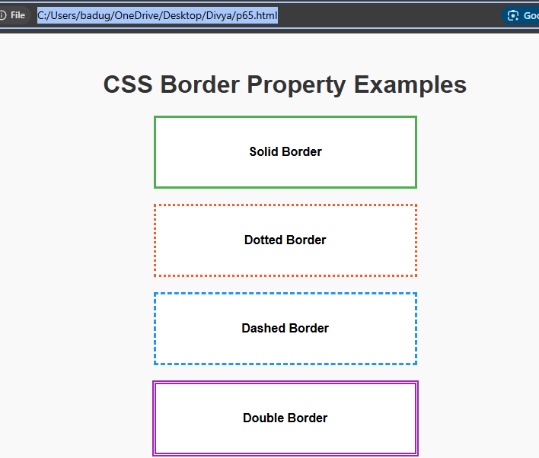

Project-66

. Design a web page implementing the usage of CSS text property

<!DOCTYPE html>

<html lang="en">

<head>

<meta charset="UTF-8">

<title>CSS Text Property Demo</title>

<style>

body {

font-family: 'Segoe UI', Tahoma, Geneva, Verdana, sans-serif;

background-color: #f4f4f4;

padding: 30px;

color: #333;

}

h1 {

text-align: center;

text-transform: uppercase;

text-shadow: 2px 2px 5px rgba(0,0,0,0.2);

color: #2c3e50;

}

.center-text {

text-align: center;

}

.right-text {

text-align: right;

}

.underline-text {

text-decoration: underline;

}

.line-through {

text-decoration: line-through;

}

.capitalize-text {

text-transform: capitalize;

}

.uppercase-text {

text-transform: uppercase;

}

.spacing {

letter-spacing: 3px;

word-spacing: 10px;

}

.line-height {

line-height: 2;

}

.rtl-text {

direction: rtl;

}

.demo-box {

background-color: #fff;

border: 1px solid #ccc;

padding: 15px;

margin-bottom: 20px;

border-radius: 5px;

}

</style>

</head>

<body>

<h1>CSS Text Properties</h1>

<div class="demo-box center-text">

<p>This paragraph is <strong>center-aligned</strong> using <code>text-align: center</code>.</p>

</div>

<div class="demo-box right-text">

<p>This paragraph is <strong>right-aligned</strong> using <code>text-align: right</code>.</p>

</div>

<div class="demo-box underline-text">

<p>This text is <strong>underlined</strong> using <code>text-decoration: underline</code>.</p>

</div>

<div class="demo-box line-through">

<p>This text has a <strong>line-through</strong> using <code>text-decoration: line-through</code>.</p>

</div>

<div class="demo-box capitalize-text">

<p>this sentence uses <strong>capitalize</strong> text-transform.</p>

</div>

<div class="demo-box uppercase-text">

<p>this sentence uses <strong>uppercase</strong> text-transform.</p>

</div>

<div class="demo-box spacing">

<p>This text has <strong>letter-spacing</strong> and <strong>word-spacing</strong>.</p>

</div>

<div class="demo-box line-height">

<p>This paragraph uses increased <strong>line-height</strong> for better readability. Lorem ipsum dolor sit amet, consectetur adipiscing elit. Integer nec odio. Praesent libero. Sed cursus ante dapibus diam.</p>

</div>

<div class="demo-box rtl-text">

<p>هذا النص يستخدم <strong>اتجاه من اليمين إلى اليسار</strong> باستخدام <code>direction: rtl</code>.</p>

</div>

</body>

</html>

Output:

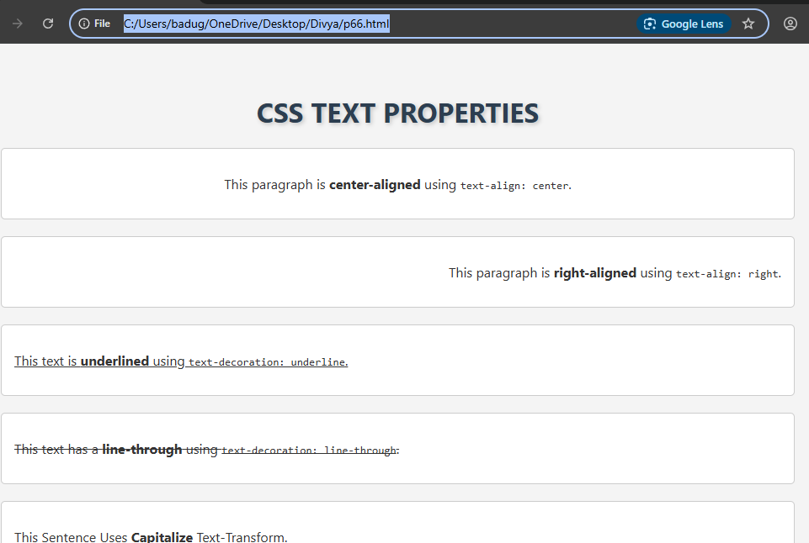

Project-67

Design a web page implementing the usage of Box Model

<!DOCTYPE html>

<html lang="en">

<head>

<meta charset="UTF-8">

<title>CSS Box Model Demo</title>

<style>

body {

font-family: Arial, sans-serif;

background-color: #f4f4f4;

padding: 40px;

}

h1 {

text-align: center;

color: #333;

}

.box {

width: 300px;

background-color: #ffffff;

color: #333;

margin: 20px auto; /* Margin: space outside the box */

padding: 20px; /* Padding: space inside the box */

border: 5px solid #4CAF50; /* Border: edge of the box */

box-shadow: 2px 2px 10px rgba(0, 0, 0, 0.1);

}

.box-info {

width: 300px;

margin: 10px auto;

background-color: #e0f7fa;

padding: 10px;

border: 1px dashed #0097a7;

font-size: 14px;

}

</style>

</head>

<body>

<h1>CSS Box Model</h1>

<div class="box">

<p>This box demonstrates the CSS box model. It has:</p>

<ul>

<li><strong>Padding</strong> around the content</li>

<li><strong>Border</strong> outside the padding</li>

<li><strong>Margin</strong> around the element</li>

</ul>

</div>

<div class="box-info">

<p><strong>Width:</strong> 300px</p>

<p><strong>Padding:</strong> 20px</p>

<p><strong>Border:</strong> 5px solid</p>

<p><strong>Margin:</strong> 20px auto</p>

<p>Total visible width = 300px + 20*2 (padding) + 5*2 (border) = <strong>350px</strong></p>

</div>

</body>

</html>

Output:

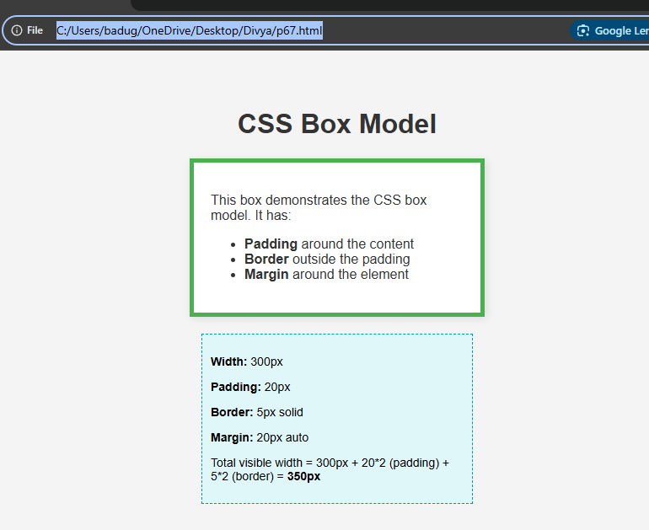

Project-68

Design a web page implementing the usage of Grid Layout

<!DOCTYPE html>

<html lang="en">

<head>

<meta charset="UTF-8" />

<meta name="viewport" content="width=device-width, initial-scale=1.0" />

<title>Grid Layout Example</title>

<style>

* {

box-sizing: border-box;

margin: 0;

padding: 0;

}

body {

font-family: Arial, sans-serif;

background-color: #f4f4f4;

}

.grid-container {

display: grid;

grid-template-areas:

"header header"

"nav nav"

"main sidebar"

"footer footer";

grid-template-columns: 2fr 1fr;

grid-template-rows: auto;

gap: 20px;

padding: 20px;

max-width: 1200px;

margin: auto;

background-color: #fff;

}

header {

grid-area: header;

background-color: #4CAF50;

padding: 20px;

color: white;

text-align: center;

}

nav {

grid-area: nav;

background-color: #333;

padding: 15px;

}

nav a {

color: white;

text-decoration: none;

margin-right: 15px;

}

main {

grid-area: main;

background-color: #e8f5e9;

padding: 20px;

}

aside {

grid-area: sidebar;

background-color: #c8e6c9;

padding: 20px;

}

footer {

grid-area: footer;

background-color: #2e7d32;

padding: 20px;

color: white;

text-align: center;

}

@media (max-width: 768px) {

.grid-container {

grid-template-areas:

"header"

"nav"

"main"

"sidebar"

"footer";

grid-template-columns: 1fr;

}

}

</style>

</head>

<body>

<div class="grid-container">

<header>

<h1>My Grid Layout Page</h1>

</header>

<nav>

<a href="#">Home</a>

<a href="#">About</a>

<a href="#">Services</a>

<a href="#">Contact</a>

</nav>

<main>

<h2>Main Content</h2>

<p>This section contains the main content of the page. Grid makes layout design easier and more responsive.</p>

</main>

<aside>

<h3>Sidebar</h3>

<p>Additional content or links can go here.</p>

</aside>

<footer>

<p>&copy; 2025 My Website</p>

</footer>

</div>

</body>

</html>

Output:

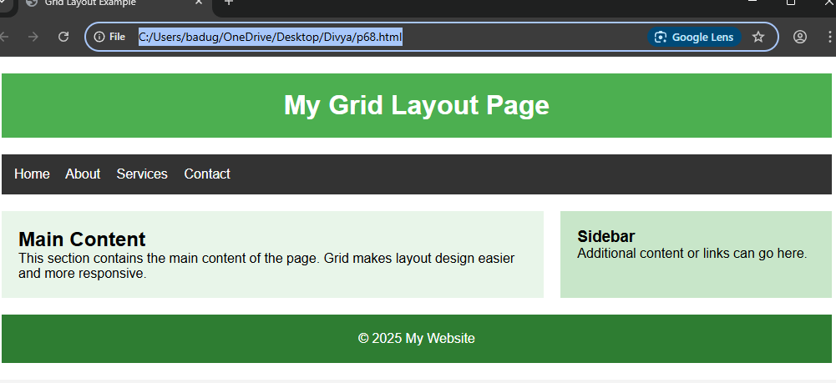

Project-69

Create a webpage that demonstrates the use of a class selector to style multiple elements

<!DOCTYPE html>

<html lang="en">

<head>

<meta charset="UTF-8" />

<meta name="viewport" content="width=device-width, initial-scale=1.0"/>

<title>Class Selector Example</title>

<style>

/* Class selector to style multiple elements */

.highlight {

background-color: #ffeb3b;

color: #333;

padding: 10px;

margin: 10px 0;

border-left: 5px solid #f57f17;

font-weight: bold;

}

</style>

</head>

<body>

<h1>Welcome to the Class Selector Demo</h1>

<p class="highlight">This paragraph uses the "highlight" class.</p>

<div class="highlight">This div also uses the "highlight" class.</div>

<p>This paragraph is not styled with the class.</p>

<section class="highlight">Even this section uses the same class to look consistent!</section>

</body>

</html>

Output:

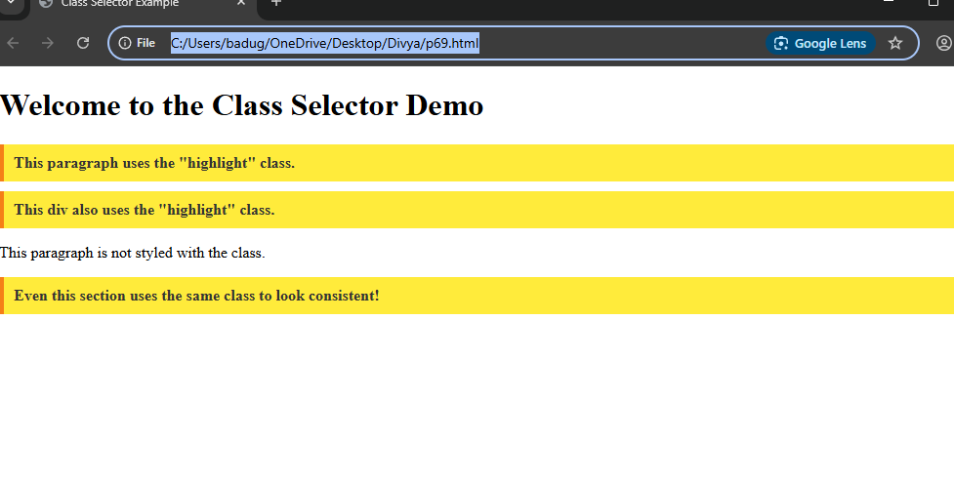

Project- 70

Create a webpage that demonstrates the use of class selectors to style multiple div elements.

<!DOCTYPE html>

<html lang="en">

<head>

<meta charset="UTF-8" />

<meta name="viewport" content="width=device-width, initial-scale=1.0" />

<title>Class Selector for Multiple Divs</title>

<style>

/* Class selector to style all div elements with class "box" */

.box {

background-color: #4CAF50; /* Green background */

color: white;

padding: 20px;

margin: 15px;

border-radius: 8px;

box-shadow: 0 4px 6px rgba(0, 0, 0, 0.1);

font-size: 16px;

text-align: center;

}

/* Additional styling for the first box */

.box:first-child {

background-color: #ff5733; /* Red background */

}

/* Additional styling for the last box */

.box:last-child {

background-color: #2980b9; /* Blue background */

}

</style>

</head>

<body>

<h1>Class Selector for Styling Multiple Divs</h1>

<!-- Multiple divs with the same class "box" -->

<div class="box">Box 1: Styled with Class "box"</div>

<div class="box">Box 2: Styled with Class "box"</div>

<div class="box">Box 3: Styled with Class "box"</div>

</body>

</html>

Output:  
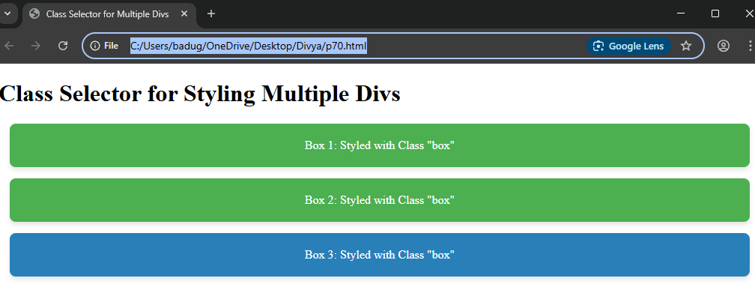

Project-71

Demonstrate the usage of the Universal Selector (*) in CSS

<!DOCTYPE html>

<html lang="en">

<head>

<meta charset="UTF-8" />

<meta name="viewport" content="width=device-width, initial-scale=1.0" />

<title>Universal Selector Example</title>

<style>

/* Universal selector that targets all elements on the page */

* {

margin: 0;

padding: 0;

box-sizing: border-box; /* Ensures padding and borders don't affect element width */

font-family: Arial, sans-serif;

}

/* Styling specific elements */

body {

background-color: #f4f4f4;

color: #333;

font-size: 16px;

}

h1 {

color: #4CAF50;

text-align: center;

margin-top: 20px;

}

p {

line-height: 1.6;

margin: 10px 20px;

}

div {

background-color: #e8f5e9;

padding: 20px;

margin: 10px;

border-radius: 8px;

box-shadow: 0 4px 6px rgba(0, 0, 0, 0.1);

}

</style>

</head>

<body>

<h1>Universal Selector Example</h1>

<div>

<p>This is a paragraph inside a div. The Universal Selector applies margin and padding reset to all elements.</p>

</div>

<div>

<p>Notice how all elements get the same base styling due to the Universal Selector!</p>

</div>

</body>

</html>

Output: 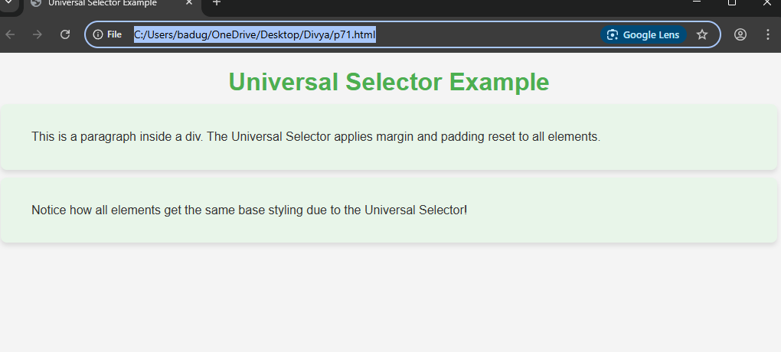

Project-72

Demonstrate the usage of the Type Selector (element) in CSS

<!DOCTYPE html>

<html lang="en">

<head>

<meta charset="UTF-8" />

<meta name="viewport" content="width=device-width, initial-scale=1.0" />

<title>Type Selector Example</title>

<style>

/* Type selector to style all <p> elements */

p {

font-size: 18px;

line-height: 1.6;

color: #333;

margin-bottom: 15px;

}

/* Type selector to style all <h1> elements */

h1 {

color: #4CAF50;

text-align: center;

font-size: 36px;

margin-top: 20px;

}

/* Type selector to style all <div> elements */

div {

background-color: #f0f8ff;

padding: 20px;

border-radius: 10px;

box-shadow: 0 4px 8px rgba(0, 0, 0, 0.1);

margin: 10px;

}

/* Style for <a> (anchor) tags inside <p> */

p a {

color: #1e88e5;

text-decoration: none;

}

p a:hover {

text-decoration: underline;

}

</style>

</head>

<body>

<h1>Type Selector in CSS</h1>

<div>

<p>This is a paragraph styled using the <code>p</code> type selector.</p>

<p>This is another paragraph. You can also add <a href="#">links</a> here.</p>

</div>

<div>

<h1>This is a heading styled using the <code>h1</code> type selector.</h1>

<p>The styling is applied automatically to all <code>&lt;p&gt;</code> elements as well.</p>

</div>

</body>

</html>

Output: 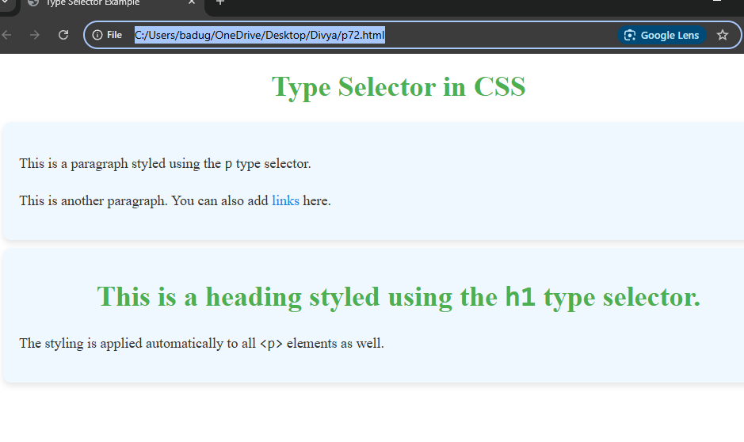

Project-73

73. Demonstrate the usage of the Class Selector (.classname) in CSS

<!DOCTYPE html>

<html lang="en">

<head>

<meta charset="UTF-8" />

<meta name="viewport" content="width=device-width, initial-scale=1.0" />

<title>Class Selector Example</title>

<style>

/* Class selector for elements with the class "box" */

.box {

background-color: #4CAF50;

color: white;

padding: 20px;

margin: 15px;

border-radius: 8px;

box-shadow: 0 4px 6px rgba(0, 0, 0, 0.1);

font-size: 16px;

text-align: center;

}

/* Class selector for elements with the class "highlight" */

.highlight {

background-color: #ffeb3b;

color: #333;

padding: 10px;

font-weight: bold;

}

/* Class selector for elements with the class "rounded" */

.rounded {

border-radius: 50px;

padding: 10px 20px;

background-color: #2980b9;

color: white;

font-size: 14px;

}

/* Styling for a <p> inside a box, to make it more distinct */

.box p {

font-size: 18px;

line-height: 1.6;

}

</style>

</head>

<body>

<h1>Class Selector Demonstration</h1>

<!-- Using the "box" class for styling -->

<div class="box">

<p>This is a box with the "box" class applied to it.</p>

</div>

<!-- Using the "highlight" class for styling -->

<div class="highlight">

<p>This box has the "highlight" class applied to it.</p>

</div>

<!-- Using the "rounded" class for styling -->

<button class="rounded">Rounded Button</button>

<!-- Multiple classes can be applied to the same element -->

<div class="box highlight">

<p>This box has both the "box" and "highlight" classes applied.</p>

</div>

</body>

</html>

Output:

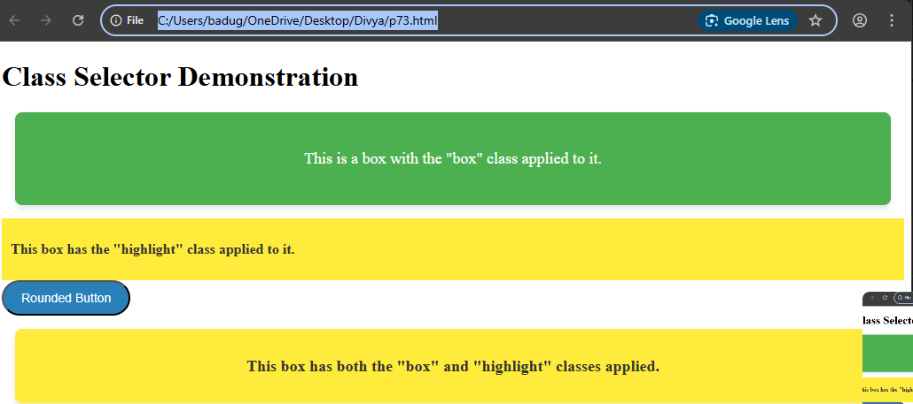

Project-74

Demonstrate the usage of the Id Selector (#id) in CSS

<!DOCTYPE html>

<html lang="en">

<head>

<meta charset="UTF-8" />

<meta name="viewport" content="width=device-width, initial-scale=1.0" />

<title>ID Selector Example</title>

<style>

/* ID selector for the element with the id "header" */

#header {

background-color: #4CAF50; /* Green background */

color: white;

text-align: center;

padding: 20px;

font-size: 36px;

font-family: Arial, sans-serif;

}

/* ID selector for the element with the id "footer" */

#footer {

background-color: #2e7d32; /* Dark Green background */

color: white;

text-align: center;

padding: 15px;

font-size: 14px;

font-family: Arial, sans-serif;

position: fixed;

bottom: 0;

width: 100%;

}

/* ID selector for the element with the id "main-content" */

#main-content {

padding: 20px;

background-color: #e8f5e9;

border-radius: 8px;

box-shadow: 0 4px 6px rgba(0, 0, 0, 0.1);

}

/* Styling for a paragraph inside the main content */

#main-content p {

font-size: 18px;

line-height: 1.6;

}

</style>

</head>

<body>

<!-- Element with the ID "header" -->

<div id="header">

<h1>Welcome to My Website</h1>

</div>

<!-- Element with the ID "main-content" -->

<div id="main-content">

<p>This is the main content of the webpage. It’s styled uniquely using the ID selector.</p>

</div>

<!-- Element with the ID "footer" -->

<div id="footer">

<p>&copy; 2025 My Website</p>

</div>

</body>

</html>

Output: 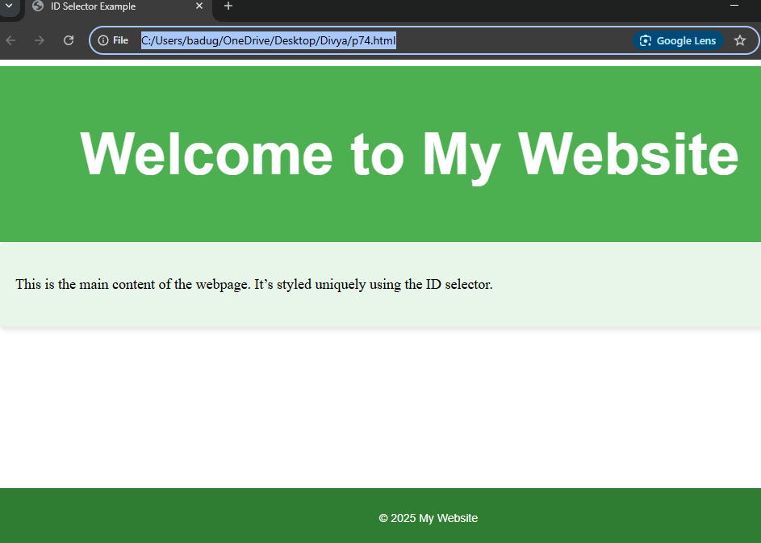

Project-75

Demonstrate the usage of `border-radius` for Rounded Corners in CSS

<!DOCTYPE html>

<html lang="en">

<head>

<meta charset="UTF-8" />

<meta name="viewport" content="width=device-width, initial-scale=1.0" />

<title>Border-Radius Example</title>

<style>

/* Style for a box with rounded corners */

.rounded-box {

width: 300px;

height: 200px;

background-color: #4CAF50;

color: white;

padding: 20px;

text-align: center;

font-size: 18px;

border-radius: 15px; /* Rounded corners */

box-shadow: 0 4px 6px rgba(0, 0, 0, 0.1);

}

/* Style for a circle using border-radius */

.circle {

width: 150px;

height: 150px;

background-color: #ff5733;

border-radius: 50%; /* Makes it a circle */

color: white;

display: flex;

justify-content: center;

align-items: center;

font-size: 20px;

}

/* Style for a button with rounded corners */

.rounded-button {

padding: 15px 30px;

background-color: #2980b9;

color: white;

font-size: 16px;

border: none;

border-radius: 25px; /* Rounded corners on button */

cursor: pointer;

transition: background-color 0.3s;

}

.rounded-button:hover {

background-color: #1e69a7;

}

</style>

</head>

<body>

<h1>CSS Border-Radius Example</h1>

<!-- Box with rounded corners -->

<div class="rounded-box">

Rounded Box

</div>

<!-- Circle using border-radius -->

<div class="circle">

Circle

</div>

<!-- Button with rounded corners -->

<button class="rounded-button">Click Me</button>

</body>

</html>

Output:

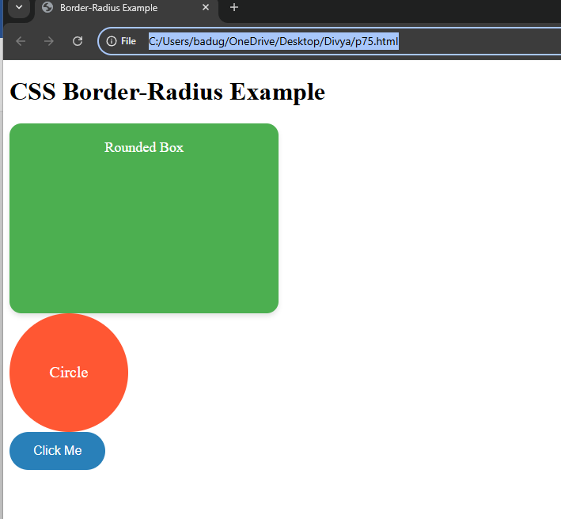

Project-76

Demonstrate the usage of `box-shadow` in CSS

<!DOCTYPE html>

<html lang="en">

<head>

<meta charset="UTF-8">

<style>

.shadow-box {

width: 200px;

height: 100px;

background-color: lightblue;

box-shadow: 10px 10px 15px rgba(0, 0, 0, 0.3);

padding: 20px;

margin: 50px;

text-align: center;

line-height: 100px;

font-weight: bold;

}

</style>

</head>

<body>

<div class="shadow-box">Box Shadow</div>

</body>

</html>

Output:

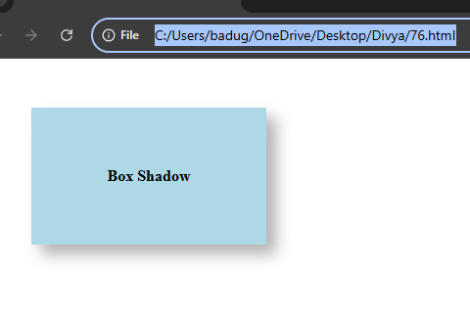

Project-77

Demonstrate the usage of `border-image` in CSS

<!DOCTYPE html>

<html lang="en">

<head>

<meta charset="UTF-8">

<title>Border Image Example</title>

<style>

.box {

width: 300px;

height: 200px;

padding: 20px;

border: 20px solid transparent; /* Required for border-image to be visible */

border-image-source: url('https://via.placeholder.com/150'); /* Border image source */

border-image-slice: 30; /* Slices the image */

border-image-repeat: round; /* Repeat the image to fit */

border-image-width: 20px;

border-image-outset: 0;

}

</style>

</head>

<body>

<div class="box">

This is a box with an image border.

</div>

</body>

</html>

Output:

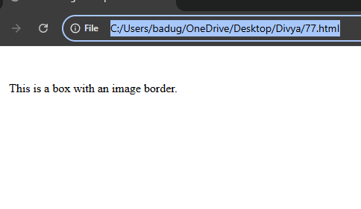

Project-78

Demonstrate how to style Table Borders using CSS

<!DOCTYPE html>

<html lang="en">

<head>

<meta charset="UTF-8">

<title>Styled Table Borders</title>

<style>

table {

width: 60%;

border-collapse: collapse; /* Ensures borders don’t double up */

margin: 20px auto;

}

th, td {

border: 2px solid #4CAF50; /* Green border */

padding: 12px;

text-align: center;

}

th {

background-color: #f2f2f2;

}

tr:nth-child(even) {

background-color: #f9f9f9;

}

tr:hover {

background-color: #e0f7fa; /* Light blue on hover */

}

</style>

</head>

<body>

<table>

<thead>

<tr>

<th>Name</th>

<th>Position</th>

<th>Location</th>

</tr>

</thead>

<tbody>

<tr>

<td>Alice</td>

<td>Developer</td>

<td>New York</td>

</tr>

<tr>

<td>Bob</td>

<td>Designer</td>

<td>London</td>

</tr>

<tr>

<td>Charlie</td>

<td>Manager</td>

<td>Berlin</td>

</tr>

</tbody>

</table>

</body>

</html>

Output:

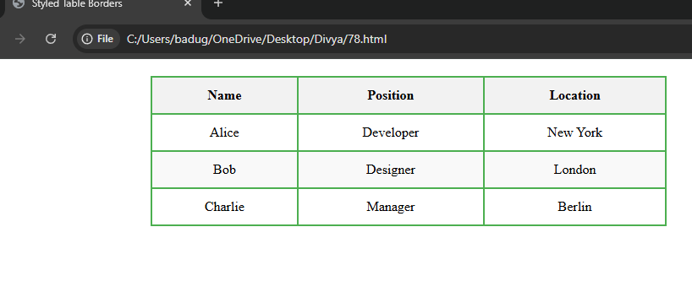

Project-79

Demonstrate the usage of the `display: block` property in CSS

<!DOCTYPE html>

<html lang="en">

<head>

<meta charset="UTF-8">

<title>Display Block Example</title>

<style>

a.block-link {

display: block;

background-color: #4CAF50;

color: white;

padding: 15px;

margin: 10px 0;

text-decoration: none;

}

a.block-link:hover {

background-color: #45a049;

}

</style>

</head>

<body> <!-- Normal inline link -->

<a href="#">This is a normal link</a>

<!-- Block-level link -->

<a href="#" class="block-link">This is a block-level link</a>

</body>

</html>

Output:

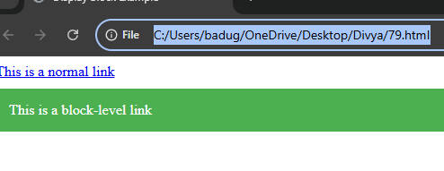

Project-80

Demonstrate the usage of the `display: inline` property in CSS

<!DOCTYPE html>

<html lang="en">

<head>

<meta charset="UTF-8">

<title>Display Inline Example</title>

<style>

div {

background-color: lightgray;

margin-bottom: 10px;

}

.box {

display: inline;

background-color: coral;

padding: 10px;

margin: 5px;

}

</style>

</head>

<body>

<div>

<span class="box">Box 1</span>

<span class="box">Box 2</span>

<span class="box">Box 3</span>

</div>

</body>

</html>

Output:

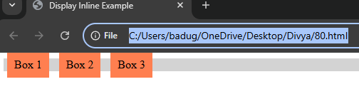

Project-81

Demonstrate the usage of the `display: inline-block` property in CSS

<!DOCTYPE html>

<html lang="en">

<head>

<meta charset="UTF-8">

<title>Display Inline-Block Example</title>

<style>

.container {

background-color: #f0f0f0;

padding: 20px;

}

.box {

display: inline-block;

width: 120px;

height: 100px;

margin: 10px;

background-color: steelblue;

color: white;

text-align: center;

line-height: 100px;

font-family: sans-serif;

border-radius: 6px;

}

</style>

</head>

<body>

<div class="container">

<div class="box">Box 1</div>

<div class="box">Box 2</div>

<div class="box">Box 3</div>

</div>

</body>

</html>

Output:

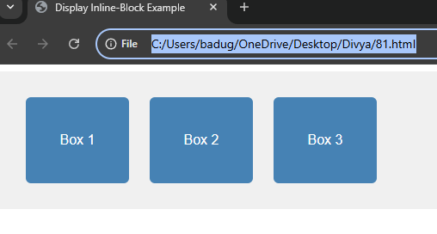

Project-82

Demonstrate the usage of the `display: none` property in CSS

<!DOCTYPE html>

<html lang="en">

<head>

<meta charset="UTF-8">

<title>Display None Example</title>

<style>

.hidden-box {

display: none;

}

.visible-box {

background-color: lightgreen;

padding: 20px;

margin: 10px 0;

border: 1px solid green;

}

</style>

</head>

<body>

<div class="visible-box">I am visible!</div>

<div class="hidden-box">You can't see me because I have display: none.</div>

<div class="visible-box">I am also visible!</div>

</body>

</html>

Output:

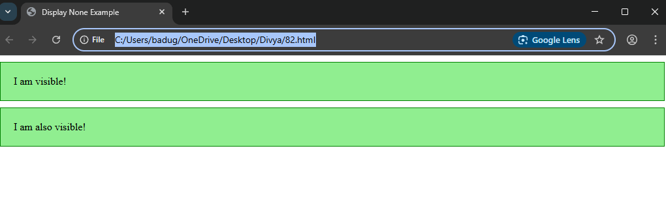

Project-83

Demonstrate the usage of `display: flex` in CSS

<!DOCTYPE html>

<html lang="en">

<head>

<meta charset="UTF-8">

<title>Display Flex Example</title>

<style>

.flex-container {

display: flex;

background-color: #f0f0f0;

padding: 20px;

gap: 20px;

justify-content: center; /* center items horizontally */

align-items: center; /* center items vertically */

height: 200px;

}

.flex-item {

background-color: steelblue;

color: white;

padding: 20px;

border-radius: 8px;

font-family: sans-serif;

text-align: center;

width: 100px;

}

</style>

</head>

<body>

<div class="flex-container">

<div class="flex-item">Item 1</div>

<div class="flex-item">Item 2</div>

<div class="flex-item">Item 3</div>

</div>

</body>

</html>

Output:

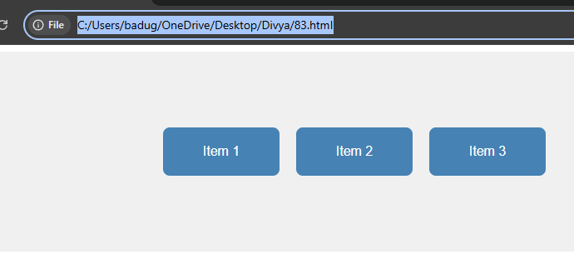

Project-84

Demonstrate the usage of `flex-direction` in CSS

<!DOCTYPE html>

<html lang="en">

<head>

<meta charset="UTF-8">

<title>Flex Direction Example</title>

<style>

.flex-container {

display: flex;

flex-direction: row; /* Try changing to column, row-reverse, etc. */

gap: 20px;

background-color: #f9f9f9;

padding: 20px;

height: 200px;

border: 1px solid #ccc;

}

.flex-item {

background-color: #4CAF50;

color: white;

padding: 20px;

text-align: center;

width: 100px;

border-radius: 6px;

font-family: sans-serif;

}

</style>

</head>

<body>

<h2>flex-direction: row</h2>

<div class="flex-container" style="flex-direction: row;">

<div class="flex-item">1</div>

<div class="flex-item">2</div>

<div class="flex-item">3</div>

</div>

<h2>flex-direction: column</h2>

<div class="flex-container" style="flex-direction: column;">

<div class="flex-item">1</div>

<div class="flex-item">2</div>

<div class="flex-item">3</div>

</div>

</body>

</html>

Output:

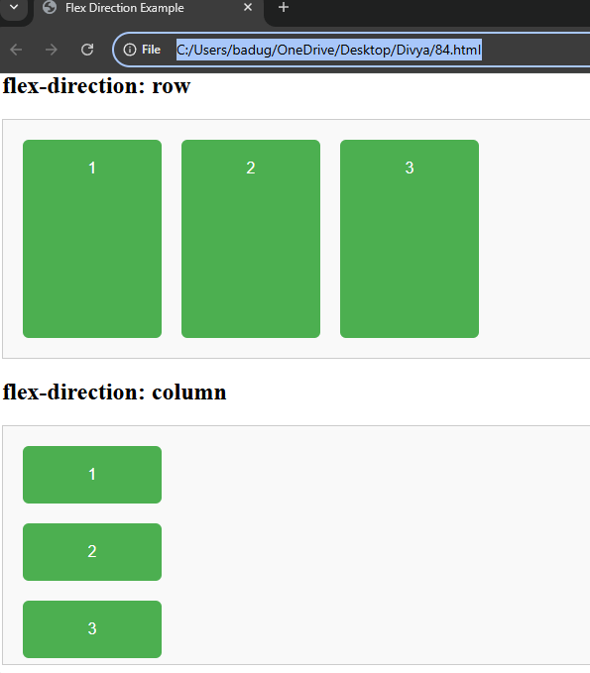

Project-85

Demonstrate the usage of `flex-wrap` in CSS

<!DOCTYPE html>

<html lang="en">

<head>

<meta charset="UTF-8">

<title>Flex Wrap Example</title>

<style>

.flex-container {

display: flex;

flex-wrap: wrap; /* Try changing to nowrap or wrap-reverse */

gap: 10px;

background-color: #f0f0f0;

padding: 20px;

width: 400px;

border: 1px solid #ccc;

}

.flex-item {

background-color: tomato;

color: white;

padding: 20px;

font-size: 1.2em;

text-align: center;

width: 120px;

border-radius: 5px;

font-family: sans-serif;

}

</style>

</head>

<body>

<h2>flex-wrap: wrap</h2>

<div class="flex-container">

<div class="flex-item">1</div>

<div class="flex-item">2</div>

<div class="flex-item">3</div>

<div class="flex-item">4</div>

<div class="flex-item">5</div>

</div>

</body>

</html>

Output:

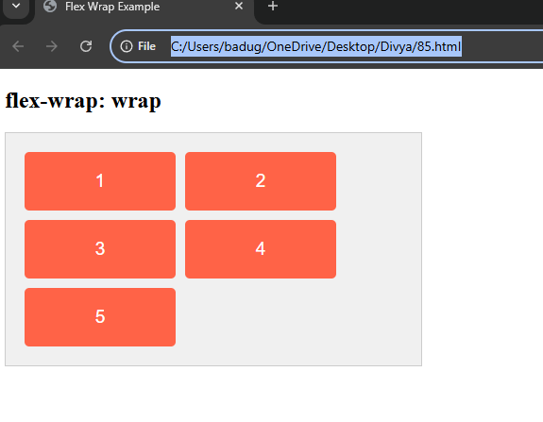

Project-86

Demonstrate the usage of `flex-flow` in CSS

<!DOCTYPE html>

<html lang="en">

<head>

<meta charset="UTF-8">

<title>Flex Flow Example</title>

<style>

.flex-container {

display: flex;

flex-flow: row wrap; /* Combines direction and wrap */

gap: 15px;

background-color: #f9f9f9;

padding: 20px;

width: 400px;

border: 2px solid #ccc;

}

.flex-item {

background-color: dodgerblue;

color: white;

text-align: center;

font-family: sans-serif;

padding: 20px;

width: 120px;

border-radius: 6px;

}

</style>

</head>

<body>

<h2>flex-flow: row wrap</h2>

<div class="flex-container">

<div class="flex-item">Item 1</div>

<div class="flex-item">Item 2</div>

<div class="flex-item">Item 3</div>

<div class="flex-item">Item 4</div>

<div class="flex-item">Item 5</div>

</div>

</body>

</html>

Output:

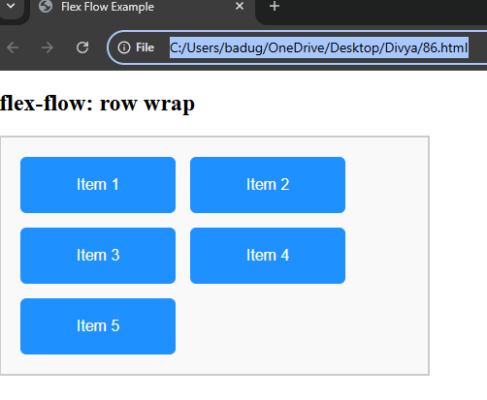

Project-87

Demonstrate the usage of `justify-content` in CSS

<!DOCTYPE html>

<html lang="en">

<head>

<meta charset="UTF-8" />

<title>Justify Content Example</title>

<style>

.flex-container {

display: flex;

background-color: #e0e0e0;

padding: 20px;

margin-bottom: 30px;

border: 1px solid #ccc;

height: 80px;

align-items: center; /* Vertically center items */

gap: 10px;

}

.flex-item {

background-color: #007BFF;

color: white;

padding: 15px 20px;

border-radius: 5px;

font-family: sans-serif;

}

</style>

</head>

<body>

<h2>justify-content: flex-start</h2>

<div class="flex-container" style="justify-content: flex-start;">

<div class="flex-item">Item 1</div>

<div class="flex-item">Item 2</div>

<div class="flex-item">Item 3</div>

</div>

<h2>justify-content: center</h2>

<div class="flex-container" style="justify-content: center;">

<div class="flex-item">Item 1</div>

<div class="flex-item">Item 2</div>

<div class="flex-item">Item 3</div>

</div>

<h2>justify-content: space-between</h2>

<div class="flex-container" style="justify-content: space-between;">

<div class="flex-item">Item 1</div>

<div class="flex-item">Item 2</div>

<div class="flex-item">Item 3</div>

</div>

<h2>justify-content: space-around</h2>

<div class="flex-container" style="justify-content: space-around;">

<div class="flex-item">Item 1</div>

<div class="flex-item">Item 2</div>

<div class="flex-item">Item 3</div>

</div>

<h2>justify-content: space-evenly</h2>

<div class="flex-container" style="justify-content: space-evenly;">

<div class="flex-item">Item 1</div>

<div class="flex-item">Item 2</div>

<div class="flex-item">Item 3</div>

</div>

</body>

</html>

Output:

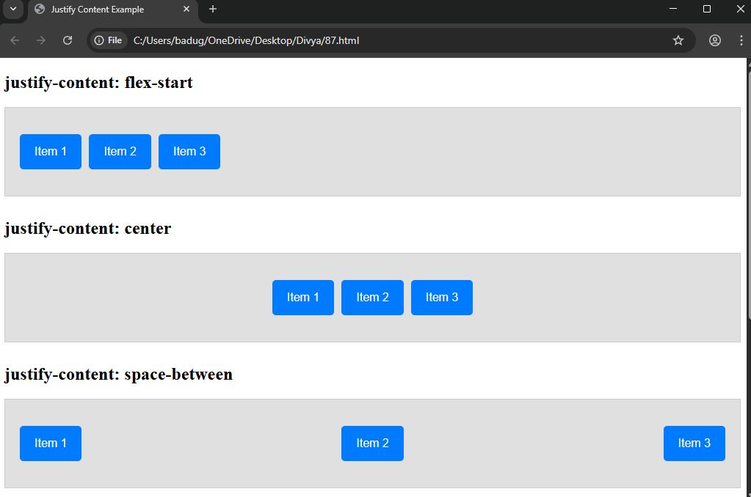

Project-88

Demonstrate the usage of `align-items` in CSS

<!DOCTYPE html>

<html lang="en">

<head>

<meta charset="UTF-8" />

<title>Align Items Example</title>

<style>

.flex-container {

display: flex;

background-color: #f0f0f0;

padding: 20px;

margin-bottom: 30px;

border: 1px solid #ccc;

height: 150px;

gap: 10px;

justify-content: center; /* Center horizontally */

font-family: sans-serif;

}

.flex-item {

background-color: #FF5722;

color: white;

padding: 10px 15px;

border-radius: 5px;

font-size: 1.1em;

width: 80px;

/* Different heights for demonstration */

}

.item1 { height: 40px; }

.item2 { height: 80px; }

.item3 { height: 120px; }

</style>

</head>

<body>

<h2>align-items: stretch (default)</h2>

<div class="flex-container" style="align-items: stretch;">

<div class="flex-item item1">Item 1</div>

<div class="flex-item item2">Item 2</div>

<div class="flex-item item3">Item 3</div>

</div>

<h2>align-items: flex-start</h2>

<div class="flex-container" style="align-items: flex-start;">

<div class="flex-item item1">Item 1</div>

<div class="flex-item item2">Item 2</div>

<div class="flex-item item3">Item 3</div>

</div>

<h2>align-items: center</h2>

<div class="flex-container" style="align-items: center;">

<div class="flex-item item1">Item 1</div>

<div class="flex-item item2">Item 2</div>

<div class="flex-item item3">Item 3</div>

</div>

<h2>align-items: flex-end</h2>

<div class="flex-container" style="align-items: flex-end;">

<div class="flex-item item1">Item 1</div>

<div class="flex-item item2">Item 2</div>

<div class="flex-item item3">Item 3</div>

</div>

<h2>align-items: baseline</h2>

<div class="flex-container" style="align-items: baseline;">

<div class="flex-item item1">Item 1</div>

<div class="flex-item item2">Item 2</div>

<div class="flex-item item3">Item 3</div>

</div>

</body>

</html>

Output:

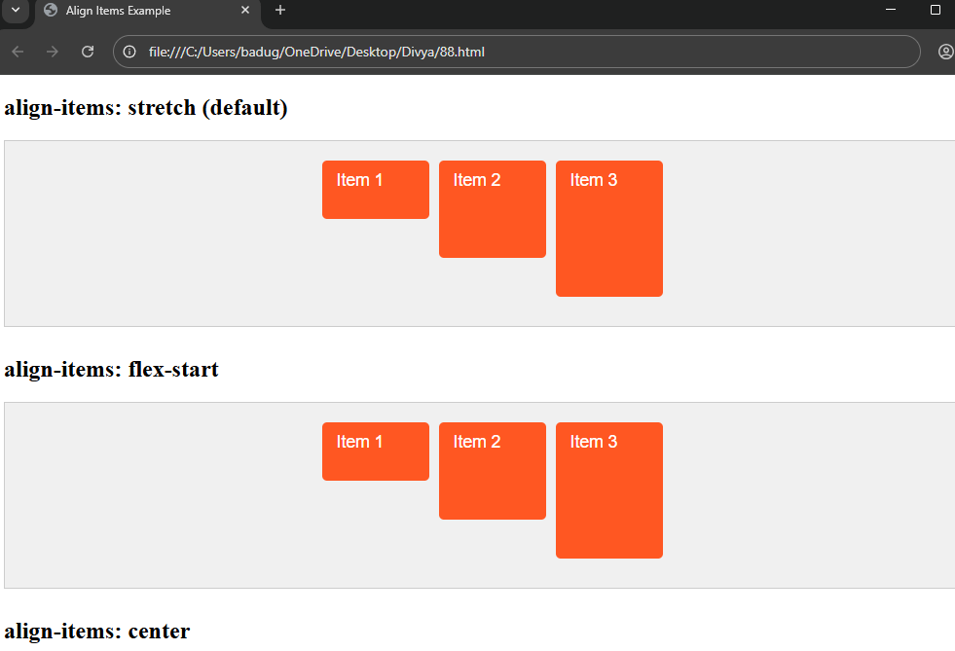

Project-89

Demonstrate the usage of `align-content` in CSS

<!DOCTYPE html>

<html lang="en">

<head>

<meta charset="UTF-8" />

<title>Align Content Example</title>

<style>

.flex-container {

display: flex;

flex-wrap: wrap; /* Enables multiple lines */

height: 250px;

width: 400px;

border: 2px solid #666;

background-color: #f5f5f5;

padding: 10px;

gap: 10px;

font-family: sans-serif;

justify-content: center; /* Center items horizontally */

margin-bottom: 30px;

}

.flex-item {

background-color: #ff6f61;

color: white;

width: 90px;

height: 60px;

display: flex;

justify-content: center;

align-items: center;

border-radius: 5px;

font-weight: bold;

font-size: 1.2em;

}

</style>

</head>

<body>

<h2>align-content: stretch (default)</h2>

<div class="flex-container" style="align-content: stretch;">

<div class="flex-item">1</div>

<div class="flex-item">2</div>

<div class="flex-item">3</div>

<div class="flex-item">4</div>

<div class="flex-item">5</div>

<div class="flex-item">6</div>

</div>

<h2>align-content: flex-start</h2>

<div class="flex-container" style="align-content: flex-start;">

<div class="flex-item">1</div>

<div class="flex-item">2</div>

<div class="flex-item">3</div>

<div class="flex-item">4</div>

<div class="flex-item">5</div>

<div class="flex-item">6</div>

</div>

<h2>align-content: center</h2>

<div class="flex-container" style="align-content: center;">

<div class="flex-item">1</div>

<div class="flex-item">2</div>

<div class="flex-item">3</div>

<div class="flex-item">4</div>

<div class="flex-item">5</div>

<div class="flex-item">6</div>

</div>

<h2>align-content: space-between</h2>

<div class="flex-container" style="align-content: space-between;">

<div class="flex-item">1</div>

<div class="flex-item">2</div>

<div class="flex-item">3</div>

<div class="flex-item">4</div>

<div class="flex-item">5</div>

<div class="flex-item">6</div>

</div>

<h2>align-content: space-around</h2>

<div class="flex-container" style="align-content: space-around;">

<div class="flex-item">1</div>

<div class="flex-item">2</div>

<div class="flex-item">3</div>

<div class="flex-item">4</div>

<div class="flex-item">5</div>

<div class="flex-item">6</div>

</div>

</body>

</html>

Output:

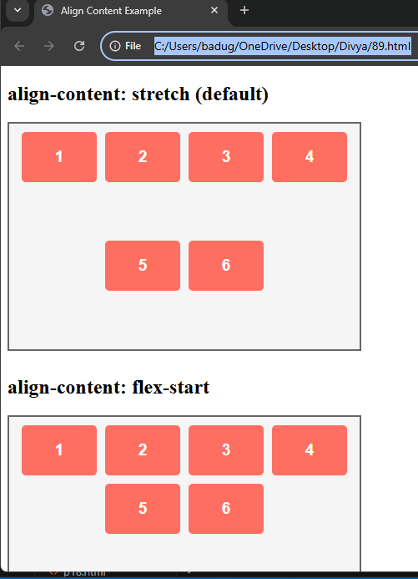

Project-90

Demonstrate the usage of `a:link` in CSS

<!DOCTYPE html>

<html lang="en">

<head>

<meta charset="UTF-8">

<meta name="viewport" content="width=device-width, initial-scale=1.0">

<title>CSS a:link Example</title>

<style>

/* Style for unvisited links */

a:link {

color: blue;

text-decoration: none;

font-weight: bold;

}

/* Style for visited links (optional for demonstration) */

a:visited {

color: purple;

}

/* Style for links on hover */

a:hover {

color: red;

}

/* Style for active links */

a:active {

color: green;

}

</style>

</head>

<body>

<h1>CSS a:link Example</h1>

<p>

This is an example of the <code>a:link</code> pseudo-class in CSS. The following is an unvisited link:

</p>

<a href="https://www.example.com" target="_blank">Visit Example</a>

</body>

</html>

Output:

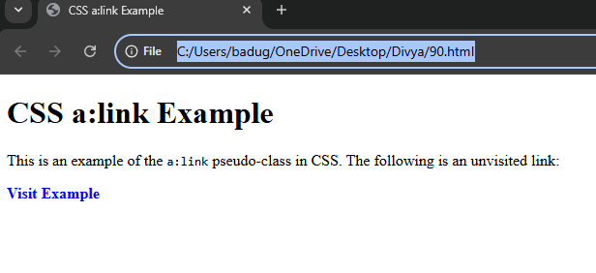

Projrct-91

Demonstrate the usage of `a:visited` in CSS

<!DOCTYPE html>

<html lang="en">

<head>

<meta charset="UTF-8">

<meta name="viewport" content="width=device-width, initial-scale=1.0">

<title>CSS a:visited Example</title>

<style>

/* Style for unvisited links */

a:link {

color: blue;

text-decoration: none;

font-weight: bold;

}

/* Style for visited links */

a:visited {

color: purple;

text-decoration: underline;

}

/* Style for links on hover */

a:hover {

color: red;

}

/* Style for active links */

a:active {

color: green;

}

</style>

</head>

<body>

<h1>CSS a:visited Example</h1>

<p>

This example shows how <code>a:visited</code> works in CSS. You can click on the links to see how the color changes when you visit them.

</p>

<ul>

<li><a href="https://www.example.com" target="_blank">Visit Example 1</a></li>

<li><a href="https://www.example.org" target="_blank">Visit Example 2</a></li>

<li><a href="https://www.example.net" target="_blank">Visit Example 3</a></li>

</ul>

</body>

</html>

Output:

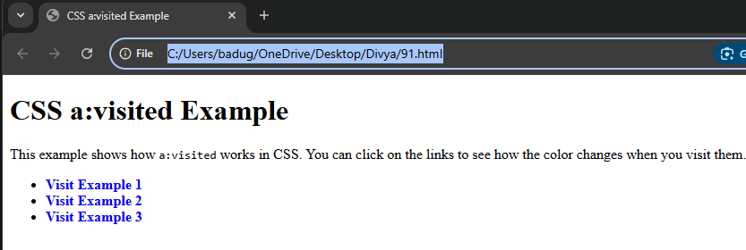

Project-92

Demonstrate the usage of `a:hover` in CSS

<!DOCTYPE html>

<html lang="en">

<head>

<meta charset="UTF-8">

<meta name="viewport" content="width=device-width, initial-scale=1.0">

<title>CSS a:visited Example</title>

<style>

/* Style for unvisited links */

a:link {

color: blue;

text-decoration: none;

font-weight: bold;

}

/* Style for visited links */

a:visited {

color: purple;

text-decoration: underline;

}

/* Style for links on hover */

a:hover {

color: red;

}

/* Style for active links */

a:active {

color: green;

}

</style>

</head>

<body>

<h1>CSS a:visited Example</h1>

<p>

This example shows how <code>a:visited</code> works in CSS. You can click on the links to see how the color changes when you visit them.

</p>

<ul>

<li><a href="https://www.example.com" target="_blank">Visit Example 1</a></li>

<li><a href="https://www.example.org" target="_blank">Visit Example 2</a></li>

<li><a href="https://www.example.net" target="_blank">Visit Example 3</a></li>

</ul>

</body>

</html>

Output:

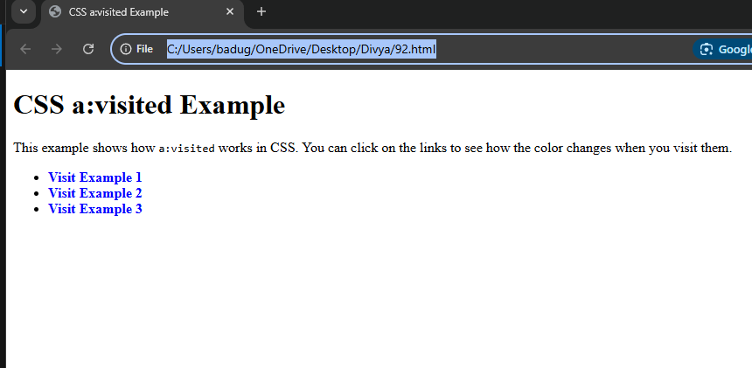

Project-93

Demonstrate the usage of `a:active` in CSS

<!DOCTYPE html>

<html lang="en">

<head>

<meta charset="UTF-8">

<meta name="viewport" content="width=device-width, initial-scale=1.0">

<title>CSS a:active Example</title>

<style>

/* Style for unvisited links */

a:link {

color: blue;

text-decoration: none;

font-weight: bold;

}

/* Style for visited links */

a:visited {

color: purple;

}

/* Style for links on hover */

a:hover {

color: red;

}

/* Style for active links (when clicked) */

a:active {

color: green;

transform: scale(0.95); /* Slightly shrinks the link */

}

</style>

</head>

<body>

<h1>CSS a:active Example</h1>

<p>

This example demonstrates how the <code>a:active</code> pseudo-class works in CSS. Try clicking on the links below to see the effect.

</p>

<ul>

<li><a href="https://www.example.com" target="_blank">Visit Example 1</a></li>

<li><a href="https://www.example.org" target="_blank">Visit Example 2</a></li>

<li><a href="https://www.example.net" target="_blank">Visit Example 3</a></li>

</ul>

</body>

</html>

Output:

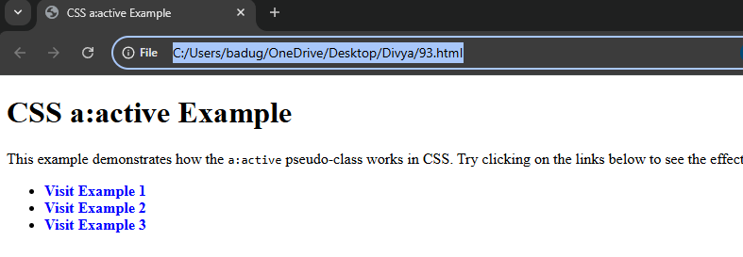

Project-94

Demonstrate the usage of `overflow` in CSS

<!DOCTYPE html>

<html lang="en">

<head>

<meta charset="UTF-8">

<meta name="viewport" content="width=device-width, initial-scale=1.0">

<title>CSS overflow Example</title>

<style>

/* Container with fixed height and width */

.container {

width: 300px;

height: 150px;

border: 2px solid #000;

padding: 10px;

margin: 20px;

overflow: hidden; /* Hide the overflowing content */

}

/* Content inside the container */

.content {

height: 200px;

background-color: lightblue;

}

</style>

</head>

<body>

<h1>CSS Overflow Example</h1>

<div class="container">

<div class="content">

This content is taller than the container. The overflow property hides the excess content.

</div>

</div>

</body>

</html>

Output:

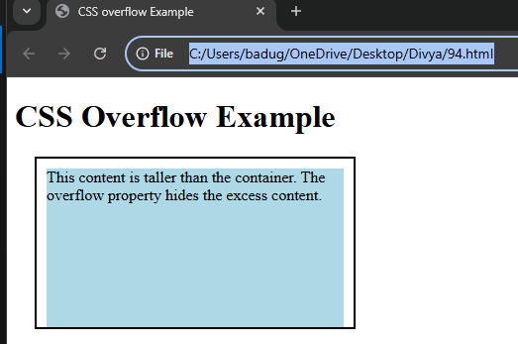

Project-95

Demonstrate the usage of the `float` property in CSS

<!DOCTYPE html>

<html lang="en">

<head>

<meta charset="UTF-8">

<meta name="viewport" content="width=device-width, initial-scale=1.0">

<title>CSS Float Example</title>

<style>

/* Container for the content */

.content {

width: 600px;

margin: 20px auto;

}

/* Float an image to the left with text wrapping around it */

.image-float {

float: left;

margin-right: 20px; /* Space between the image and text */

margin-bottom: 20px; /* Space at the bottom */

}

/* Just to add some style to the text */

p {

line-height: 1.6;

font-size: 18px;

}

</style>

</head>

<body>

<h1>Using float to wrap text around an image</h1>

<div class="content">

<img src="https://via.placeholder.com/150" alt="Placeholder Image" class="image-float">

<p>

This is a paragraph of text that wraps around the floated image. The image is floated to the left, and the text flows around it.

The <code>float</code> property allows the image to be positioned alongside the text. The <code>margin-right</code> property creates space between the image and the text, ensuring they don't touch each other.

This effect can be used to create interesting layouts and designs where text wraps neatly around elements.

</p>

<p>

You can add more content here, and the text will continue to flow around the image. Floating is commonly used in layouts like magazine articles or blog posts where images and text need to coexist in a fluid manner.

</p>

</div>

</body>

</html>

Output:

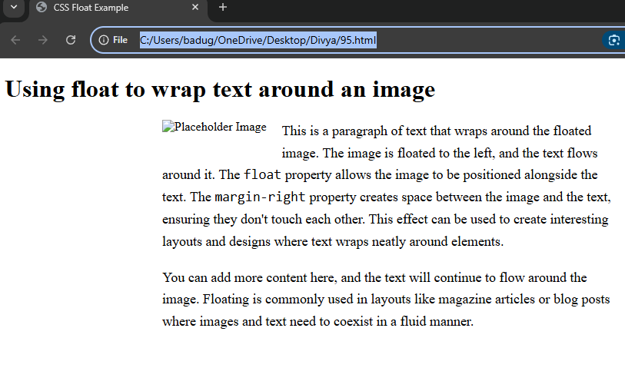

Project-96

Demonstrate the usage of `calc()` in CSS

<!DOCTYPE html>

<html lang="en">

<head>

<meta charset="UTF-8">

<meta name="viewport" content="width=device-width, initial-scale=1.0">

<title>CSS calc() Example</title>

<style>

.container {

width: calc(100% - 40px); /* Full width minus 40px */

padding: 20px;

background-color: lightblue;

box-sizing: border-box; /* Includes padding in the width */

}

.content {

width: calc(50% - 10px); /* 50% of parent width minus 10px */

margin: 10px;

padding: 10px;

background-color: lightcoral;

}

</style>

</head>

<body>

<h1>Using calc() for Dynamic Layout</h1>

<div class="container">

<div class="content">

This content box has a dynamic width calculated with `calc()`. It takes 50% of the parent container's width, minus 10px.

</div>

</div>

</body>

</html>

Output:

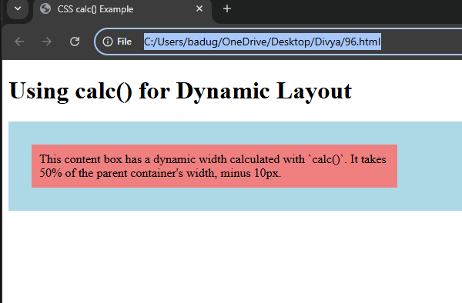

Project-97

Demonstrate the usage of `min()` in CSS

<!DOCTYPE html>

<html lang="en">

<head>

<meta charset="UTF-8">

<meta name="viewport" content="width=device-width, initial-scale=1.0">

<title>CSS min() Example</title>

<style>

.container {

background-color: lightblue;

margin: 20px;

padding: 20px;

width: min(50%, 400px); /* Set width to 50% of parent, but no larger than 400px */

}

</style>

</head>

<body>

<h1>Using min() for Responsive Width</h1>

<div class="container">

This container will be 50% of the parent width, but no larger than 400px.

</div>

</body>

</html>

Output:

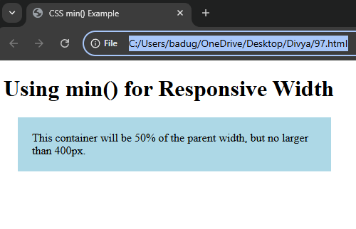

Project-98

Demonstrate the usage of `max()` in CSS

<!DOCTYPE html>

<html lang="en">

<head>

<meta charset="UTF-8">

<meta name="viewport" content="width=device-width, initial-scale=1.0">

<title>CSS max() Example</title>

<style>

.container {

background-color: lightblue;

margin: 20px;

padding: 20px;

width: max(50%, 400px); /* Set width to 50% of parent, but at least 400px */

}

</style>

</head>

<body>

<h1>Using max() for Responsive Width</h1>

<div class="container">

This container will be 50% of the parent width, but will never be smaller than 400px.

</div>

</body>

</html>

Output:

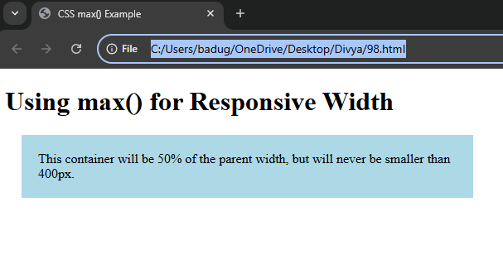

Project-99

Demonstrate the usage of `::first-line` in CSS

<!DOCTYPE html>

<html lang="en">

<head>

<meta charset="UTF-8">

<meta name="viewport" content="width=device-width, initial-scale=1.0">

<title>First Line Styling with ::first-line</title>

<style>

p::first-line {

color: red;

font-weight: bold;

}

</style>

</head>

<body>

<h1>Using ::first-line in CSS</h1>

<p>This is an example paragraph. The first line of this paragraph will be red and bold.</p>

<p>Here is another paragraph. The first line will also be styled differently from the rest of the text.</p>

</body>

</html>

Output:

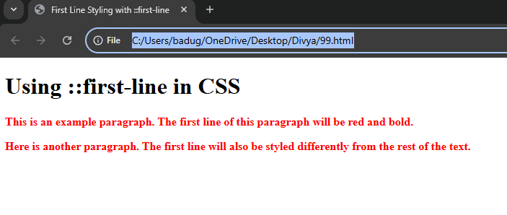

Project-100

Demonstrate the usage of `::first-letter` in CSS

<!DOCTYPE html>

<html lang="en">

<head>

<meta charset="UTF-8">

<meta name="viewport" content="width=device-width, initial-scale=1.0">

<title>First Letter Styling</title>

<style>

p::first-letter {

font-size: 2em;

font-weight: bold;

color: red;

}

</style>

</head>

<body>

<h1>Using ::first-letter in CSS</h1>

<p>This paragraph demonstrates how the first letter can be styled differently from the rest of the text.</p>

<p>Here is another example, where the first letter is larger and bolder than the rest of the paragraph text.</p>

</body>

</html>

Output:

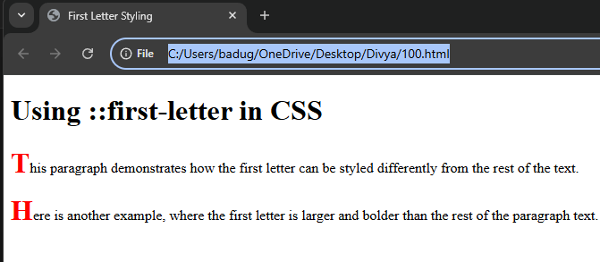

Project-101

Demonstrate the usage of `::before` in CSS

<!DOCTYPE html>

<html lang="en">

<head>

<meta charset="UTF-8">

<meta name="viewport" content="width=device-width, initial-scale=1.0">

<title>Using ::before</title>

<style>

p::before {

content: "Note: ";

font-weight: bold;

color: red;

}

</style>

</head>

<body>

<h1>Using ::before in CSS</h1>

<p>This is a paragraph where we add some text before the actual content using the ::before pseudo-element.</p>

</body>

</html>

Output:

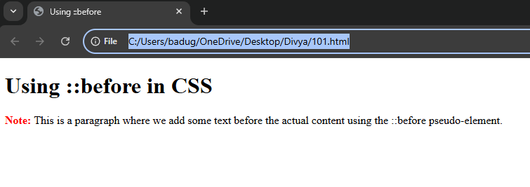

Project-102

Demonstrate the usage of `::after` in CSS

<!DOCTYPE html>

<html lang="en">

<head>

<meta charset="UTF-8">

<meta name="viewport" content="width=device-width, initial-scale=1.0">

<title>Using ::after</title>

<style>

p::after {

content: " Read more...";

color: blue;

font-weight: bold;

cursor: pointer;

}

</style>

</head>

<body>

<h1>Using ::after in CSS</h1>

<p>This is an example paragraph that will have a "Read more" link appended at the end using the ::after pseudo-element.</p>

<p>Here's another paragraph with the same effect added to it. The "Read more" link will appear after the text.</p>

</body>

</html>

Output:

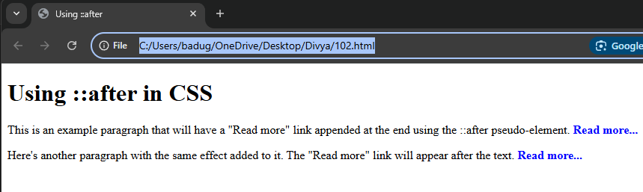

Project-103

Demonstrate the usage of `::selection` in CSS

<!DOCTYPE html>

<html lang="en">

<head>

<meta charset="UTF-8" />

<meta name="viewport" content="width=device-width, initial-scale=1" />

<title>Using ::selection</title>

<style>

/* Style the selected text inside paragraphs */

p::selection {

background-color: #3399ff;

color: white;

}

/* Style the selected text inside headings */

h1::selection {

background-color: #ff6347;

color: white;

}

</style>

</head>

<body>

<h1>Select this heading text</h1>

<p>Select some of this paragraph text to see the custom selection style.</p>

<p>Try selecting different parts of this text to see the effect.</p>

</body>

</html>

Output:

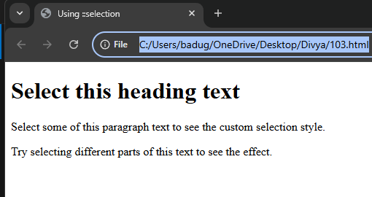

Project-104

Demonstrate the usage of `:nth-child()` in CSS

<!DOCTYPE html>

<html lang="en">

<head>

<meta charset="UTF-8" />

<meta name="viewport" content="width=device-width, initial-scale=1.0" />

<title>:nth-child() Example</title>

<style>

ul li:nth-child(2) {

color: red;

}

</style>

</head>

<body>

<h1>Using :nth-child() in CSS</h1>

<ul>

<li>Item 1</li>

<li>Item 2 (this will be red)</li>

<li>Item 3</li>

</ul>

</body>

</html>

Output:

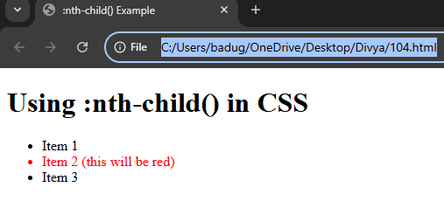

Project-105

Demonstrate the usage of `:target` in CSS

<!DOCTYPE html>

<html lang="en">

<head>

<meta charset="UTF-8" />

<meta name="viewport" content="width=device-width, initial-scale=1.0" />

<title>:target Example</title>

<style>

/* Basic styles for sections */

section {

padding: 20px;

margin: 20px 0;

background-color: #f0f0f0;

transition: background-color 0.3s ease;

}

/* Style for the targeted section */

section:target {

background-color: #ffcc00;

border: 2px solid #333;

box-shadow: 0 0 10px rgba(0, 0, 0, 0.1);

}

/* Links to jump to sections */

nav a {

margin: 10px;

padding: 10px;

text-decoration: none;

color: #007bff;

font-size: 18px;

}

nav a:hover {

background-color: #ddd;

}

</style>

</head>

<body>

<nav>

<a href="#section1">Go to Section 1</a>

<a href="#section2">Go to Section 2</a>

<a href="#section3">Go to Section 3</a>

</nav>

<section id="section1">

<h2>Section 1</h2>

<p>This is the first section. Click the link in the navigation to target this section.</p>

</section>

<section id="section2">

<h2>Section 2</h2>

<p>This is the second section. Click the link in the navigation to target this section.</p>

</section>

<section id="section3">

<h2>Section 3</h2>

<p>This is the third section. Click the link in the navigation to target this section.</p>

</section>

</body>

</html>

Output:

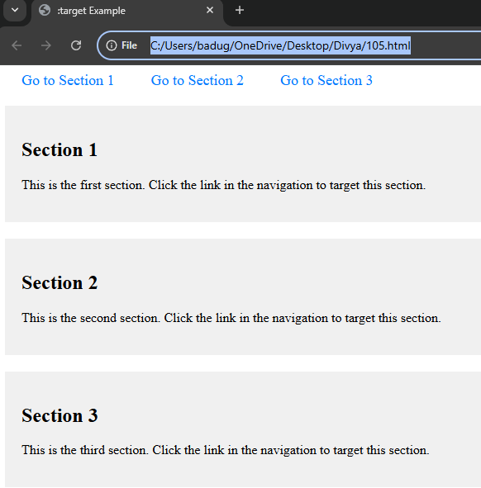

Project-106

Demonstrate the usage of `input[type="text"]` in CSS

<!DOCTYPE html>

<html lang="en">

<head>

<meta charset="UTF-8" />

<meta name="viewport" content="width=device-width, initial-scale=1.0" />

<title>Styling Text Input</title>

<style>

/* Style for all text input fields */

input[type="text"] {

width: 250px;

padding: 10px;

border: 2px solid #007bff;

border-radius: 5px;

font-size: 16px;

transition: border-color 0.3s ease;

}

/* Change border color on focus */

input[type="text"]:focus {

border-color: #ff6347;

outline: none;

}

/* Style for placeholder text */

input[type="text"]::placeholder {

color: #aaa;

font-style: italic;

}

</style>

</head>

<body>

<h1>Styling Text Input</h1>

<form>

<label for="username">Username:</label>

<input type="text" id="username" name="username" placeholder="Enter your username">

</form>

</body>

</html>

Output:

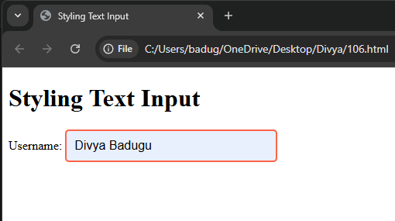

Project-107

Demonstrate the usage of `::placeholder` in CSS

<!DOCTYPE html>

<html lang="en">

<head>

<meta charset="UTF-8" />

<meta name="viewport" content="width=device-width, initial-scale=1.0" />

<title>::placeholder Example</title>

<style>

/* Style for text input placeholder */

input::placeholder {

color: #888;

font-style: italic;

font-size: 16px;

}

/* Style for textarea placeholder */

textarea::placeholder {

color: #999;

font-weight: bold;

font-size: 14px;

}

</style>

</head>

<body>

<h1>Placeholder Styling</h1>

<form>

<label for="username">Username:</label>

<input type="text" id="username" placeholder="Enter your username">

<br><br>

<label for="message">Message:</label>

<textarea id="message" placeholder="Write your message here"></textarea>

</form>

</body>

</html>

Output:

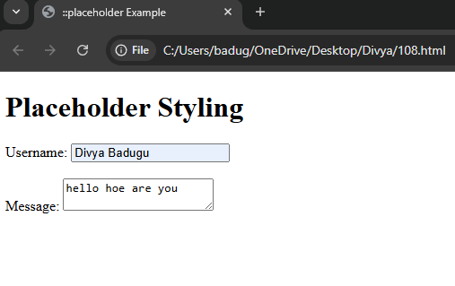

Project=108

Demonstrate the usage of `z-index` in CSS

<!DOCTYPE html>

<html lang="en">

<head>

<meta charset="UTF-8">

<title>z-index Example</title>

<style>

.box {

width: 150px;

height: 150px;

position: absolute;

top: 50px;

left: 50px;

opacity: 0.9;

}

.red {

background-color: red;

z-index: 1;

}

.green {

background-color: green;

top: 80px;

left: 80px;

z-index: 2;

}

.blue {

background-color: blue;

top: 110px;

left: 110px;

z-index: 3;

}

</style>

</head>

<body>

<div class="box red"></div>

<div class="box green"></div>

<div class="box blue"></div>

</body>

</html>

Output:

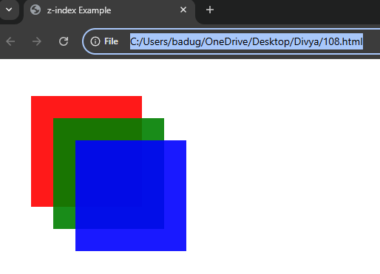

Project-109

Demonstrate the usage of `input[type="range"]` in CSS

<!DOCTYPE html>

<html lang="en">

<head>

<meta charset="UTF-8">

<title>Styled Range Input</title>

<style>

input[type="range"] {

width: 300px;

height: 8px;

background: #ddd;

border-radius: 5px;

outline: none;

margin: 20px 0;

}

input[type="range"]::-webkit-slider-thumb {

appearance: none;

height: 20px;

width: 20px;

background: #007bff;

border-radius: 50%;

cursor: pointer;

margin-top: -6px;

}

input[type="range"]::-moz-range-thumb {

height: 20px;

width: 20px;

background: #007bff;

border-radius: 50%;

cursor: pointer;

}

</style>

</head>

<body>

<h2>Custom Styled Range Slider</h2>

<input type="range" min="0" max="100" value="40">

</body>

</html>

Output:

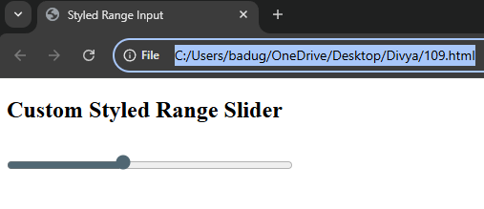

Project-110

Demonstrate the usage of the `` element in CSS

<!DOCTYPE html>

<html lang="en">

<head>

<meta charset="UTF-8">

<title><code> Element Example</title>

<style>

code {

background-color: #f4f4f4;

padding: 2px 6px;

border-radius: 4px;

font-family: Consolas, monospace;

color: #c7254e;

}

</style>

</head>

<body>

<p>To print in JavaScript, use <code>console.log('Hello')</code>.</p>

</body>

</html>

Output:

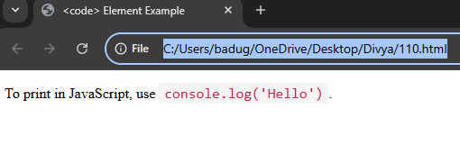

Project-111

Demonstrate the usage of `accent-color` in CSS

<!DOCTYPE html>

<html lang="en">

<head>

<meta charset="UTF-8" />

<meta name="viewport" content="width=device-width, initial-scale=1.0"/>

<title>accent-color Example</title>

<style>

input[type="checkbox"],

input[type="radio"] {

accent-color: #ff5722; /* Deep orange */

width: 18px;

height: 18px;

}

label {

font-size: 18px;

margin-left: 8px;

}

body {

font-family: sans-serif;

padding: 20px;

}

</style>

</head>

<body>

<h2>accent-color Demo</h2>

<div>

<input type="checkbox" id="check1" checked />

<label for="check1">I agree to the terms</label>

</div>

<div>

<input type="radio" id="opt1" name="plan" checked />

<label for="opt1">Basic Plan</label>

</div>

<div>

<input type="radio" id="opt2" name="plan" />

<label for="opt2">Premium Plan</label>

</div>

</body>

</html>

Output:

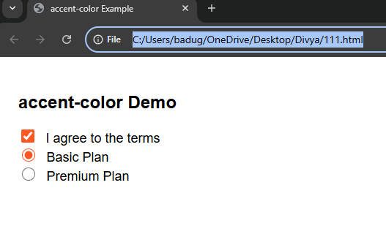

Project-112

Demonstrate a simple CSS animation using `@keyframes`

<!DOCTYPE html>

<html lang="en">

<head>

<meta charset="UTF-8">

<title>Simple CSS Animation</title>

<style>

/* The element to animate */

.box {

width: 100px;

height: 100px;

background-color: steelblue;

position: relative;

animation: moveAndColor 3s infinite alternate ease-in-out;

}

/* Keyframes define what happens in the animation */

@keyframes moveAndColor {

0% {

left: 0;

background-color: steelblue;

}

50% {

background-color: orange;

}

100% {

left: 300px;

background-color: tomato;

}

}

</style>

</head>

<body>

<h2>CSS Animation with @keyframes</h2>

<div class="box"></div>

</body>

</html>

Output:

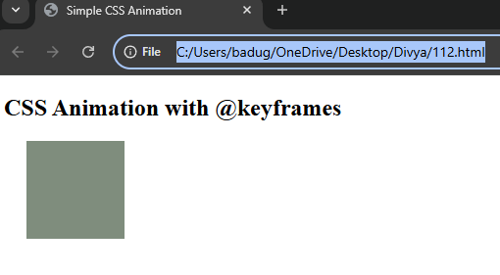

Project-113

Demonstrate the usage of `backdrop-filter` in CSS

<!DOCTYPE html>

<html lang="en">

<head>

<meta charset="UTF-8" />

<meta name="viewport" content="width=device-width, initial-scale=1.0"/>

<title>backdrop-filter Example</title>

<style>

body {

background: url('https://picsum.photos/800/600') no-repeat center center/cover;

height: 100vh;

margin: 0;

display: flex;

align-items: center;

justify-content: center;

}

.glass-box {

width: 300px;

height: 200px;

background-color: rgba(255, 255, 255, 0.2);

border-radius: 15px;

backdrop-filter: blur(10px) brightness(1.2);

-webkit-backdrop-filter: blur(10px) brightness(1.2); /* Safari support */

border: 1px solid rgba(255, 255, 255, 0.4);

padding: 20px;

color: #fff;

text-align: center;

}

</style>

</head>

<body>

<div class="glass-box">

<h2>Frosted Glass</h2>

<p>This uses <code>backdrop-filter</code> to blur the background.</p>

</div>

</body>

</html>

Output:

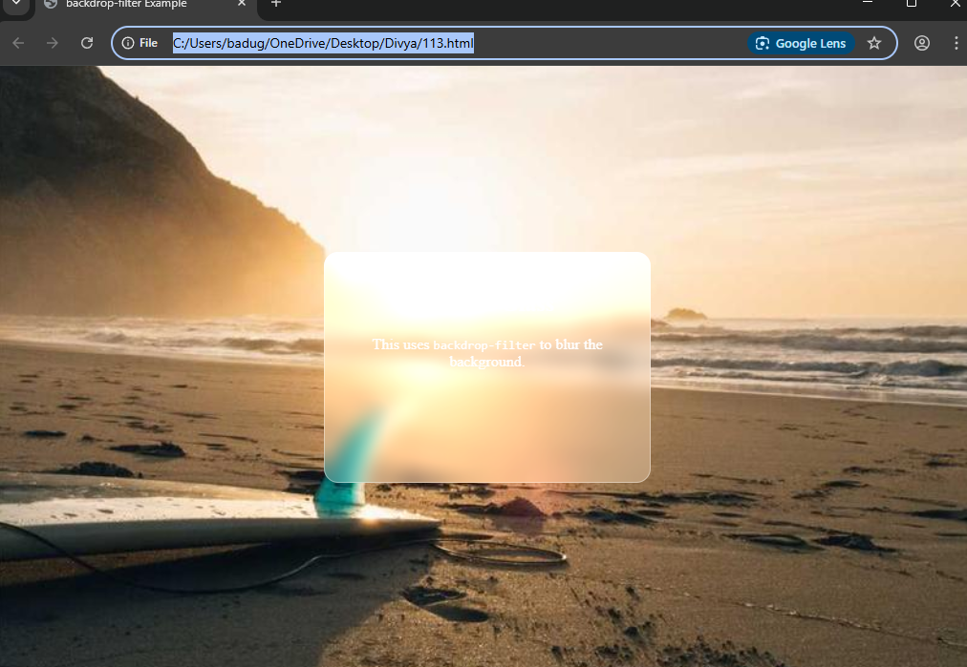

Project-114

Demonstrate the usage of `transform: translate()` in CSS

<!DOCTYPE html>

<html lang="en">

<head>

<meta charset="UTF-8">

<title>transform: translate()</title>

<style>

.box {

width: 100px;

height: 100px;

background-color: coral;

transition: transform 0.3s ease;

}

.box:hover {

transform: translate(50px, 30px);

}

</style>

</head>

<body>

<h2>Hover to Translate</h2>

<div class="box"></div>

</body>

</html>

Output:

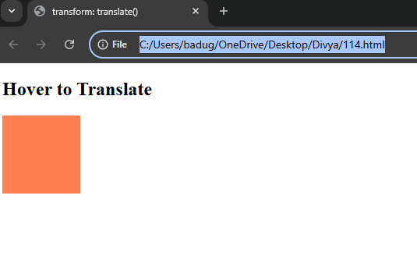

Project-115

Demonstrate the usage of `transform: rotate()` in CSS

<!DOCTYPE html>

<html lang="en">

<head>

<meta charset="UTF-8">

<title>Rotate Example</title>

<style>

.box {

width: 100px;

height: 100px;

background-color: tomato;

transition: transform 0.3s ease;

margin: 50px;

}

.box:hover {

transform: rotate(45deg);

}

</style>

</head>

<body>

<h2>Hover to Rotate</h2>

<div class="box"></div>

</body>

</html>

Output:

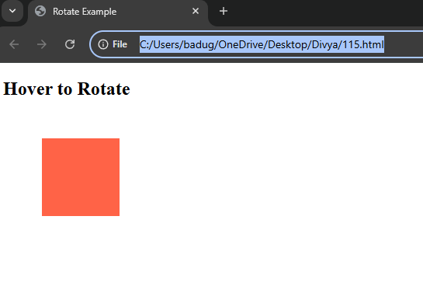

Project-116

Demonstrate the usage of `transform: scale()` in CSS

<!DOCTYPE html>

<html lang="en">

<head>

<meta charset="UTF-8">

<title>Scale Example</title>

<style>

.box {

width: 100px;

height: 100px;

background-color: royalblue;

transition: transform 0.3s ease;

margin: 40px;

}

.box:hover {

transform: scale(1.2);

}

</style>

</head>

<body>

<h2>Hover to Scale</h2>

<div class="box"></div>

</body>

</html>

Output:

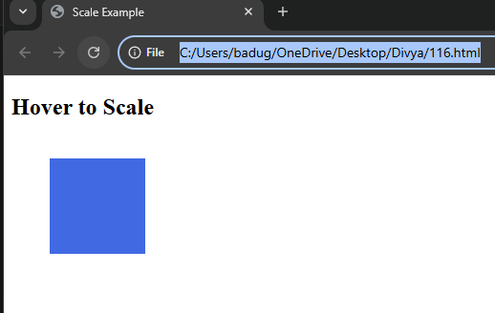

Project-117

Demonstrate the usage of `counter-increment` in CSS

<!DOCTYPE html>

<html lang="en">

<head>

<meta charset="UTF-8">

<title>counter-increment Example</title>

<style>

.steps {

counter-reset: step; /* initialize counter */

list-style: none;

padding: 0;

}

.steps li {

counter-increment: step; /* increment counter */

margin: 10px 0;

position: relative;

padding-left: 30px;

}

.steps li::before {

content: counter(step) ". ";

position: absolute;

left: 0;

color: #007bff;

font-weight: bold;

}

</style>

</head>

<body>

<h2>Installation Steps</h2>

<ul class="steps">

<li>Download the installer</li>

<li>Run the installer</li>

<li>Follow the setup wizard</li>

<li>Launch the application</li>

</ul>

</body>

</html>

Output:

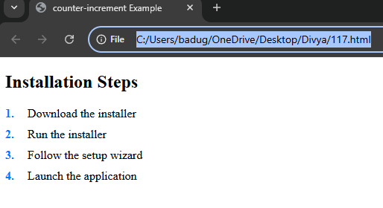

Project-118

Demonstrate the usage of a media query for screen width in CSS

<!DOCTYPE html>

<html lang="en">

<head>

<meta charset="UTF-8" />

<title>Media Query Example</title>

<style>

.responsive-box {

width: 300px;

height: 200px;

background-color: royalblue;

color: white;

display: flex;

align-items: center;

justify-content: center;

font-size: 1.5rem;

margin: 20px auto;

transition: background-color 0.3s ease;

}

/* Media query for smaller screens (e.g., phones) */

@media (max-width: 600px) {

.responsive-box {

background-color: tomato;

font-size: 1rem;

}

}

</style>

</head>

<body>

<h2>Resize the window to see the change</h2>

<div class="responsive-box">Responsive Box</div>

</body>

</html>

Output:

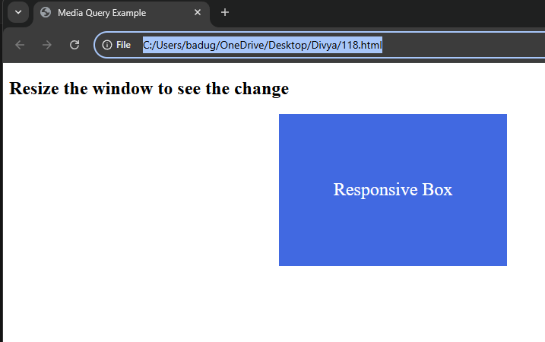

Project-119

Demonstrate media query to change `flex-direction` based on screen size

<!DOCTYPE html>

<html lang="en">

<head>

<meta charset="UTF-8" />

<title>Flex Direction Media Query</title>

<style>

.container {

display: flex;

flex-direction: row; /* default: horizontal layout */

gap: 20px;

padding: 20px;

background-color: #f0f0f0;

}

.box {

background-color: #4caf50;

color: white;

padding: 20px;

flex: 1;

text-align: center;

font-size: 1.2rem;

}

/* On screens 600px or less, stack vertically */

@media (max-width: 600px) {

.container {

flex-direction: column;

}

}

</style>

</head>

<body>

<h2>Responsive Flex Direction</h2>

<div class="container">

<div class="box">Box 1</div>

<div class="box">Box 2</div>

<div class="box">Box 3</div>

</div>

</body>

</html>

Output:

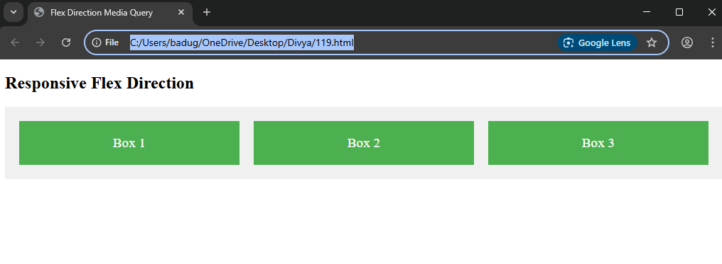

Project-120

Demonstrate media query to toggle visibility based on screen size

<!DOCTYPE html>

<html lang="en">

<head>

<meta charset="UTF-8" />

<title>Toggle Visibility with Media Query</title>

<style>

.mobile-only {

display: none; /* Hidden by default */

background-color: #ffcc00;

padding: 15px;

text-align: center;

font-weight: bold;

margin: 20px;

}

/* Show on screens 600px or less */

@media (max-width: 600px) {

.mobile-only {

display: block;

}

}

</style>

</head>

<body>

<div class="mobile-only">

This message only appears on small screens (≤600px)!

</div>

<p>Resize the window to see the message toggle.</p>

</body>

</html>

Output:

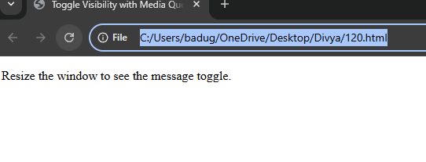

Project-121

Demonstrate the use of `getElementById` to access and modify an element

<!DOCTYPE html>

<html lang="en">

<head>

<meta charset="UTF-8" />

<title>getElementById Example</title>

<style>

#myParagraph {

color: black;

font-size: 18px;

}

</style>

</head>

<body>

<p id="myParagraph">Original paragraph text.</p>

<button onclick="changeContent()">Change Text & Color</button>

<script>

function changeContent() {

// Access the element by its ID

const para = document.getElementById('myParagraph');

// Modify the text content

para.textContent = 'The text has been changed!';

// Modify the style (color)

para.style.color = 'crimson';

}

</script>

</body>

</html>

Output:

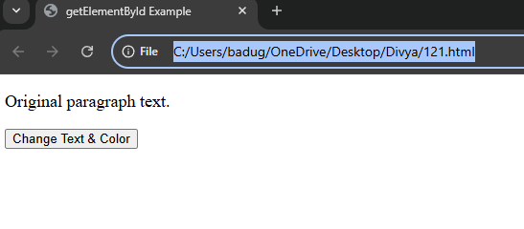

Project-122

Demonstrate the use of `getElementsByClassName` to access multiple elements

<!DOCTYPE html>

<html>

<head>

<title>getElementsByClassName Example</title>

</head>

<body>

<div class="highlight">Item 1</div>

<div class="highlight">Item 2</div>

<div class="highlight">Item 3</div>

<div>Item 4</div>

<script>

// Access all elements with the class "highlight"

let elements = document.getElementsByClassName("highlight");

// Loop through the collection and change the text color

for (let i = 0; i < elements.length; i++) {

elements[i].style.color = "red";

console.log(elements[i].textContent); // Log content to the console

}

</script>

</body>

</html>

Output:

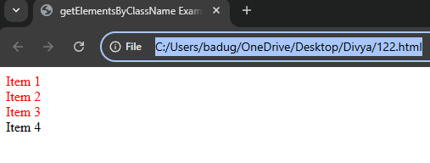

Project-123

Demonstrate how to change content using `textContent` with a button click

<!DOCTYPE html>

<html>

<head>

<title>Change Content Example</title>

</head>

<body>

<p id="message">Original message</p>

<button onclick="changeMessage()">Click Me!</button>

<script>

function changeMessage() {

// Access the paragraph by ID and change its content

let paragraph = document.getElementById("message");

paragraph.textContent = "The message has been changed!";

}

</script>

</body>

</html>

Output:

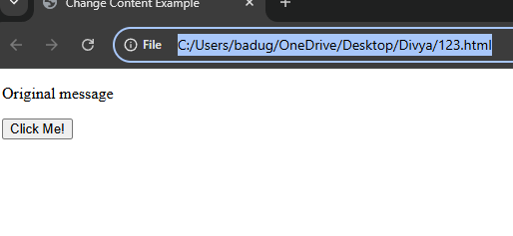

Project-124

Demonstrate how to change content using `innerHTML` with a button click

<!DOCTYPE html>

<html>

<head>

<title>Change Content with innerHTML</title>

</head>

<body>

<div id="content">This is the original content.</div>

<button onclick="changeContent()">Change Content</button>

<script>

function changeContent() {

// Get the element by ID and change its inner HTML

let contentDiv = document.getElementById("content");

contentDiv.innerHTML = "<strong>The content has been updated!</strong>";

}

</script>

</body>

</html>

Output:

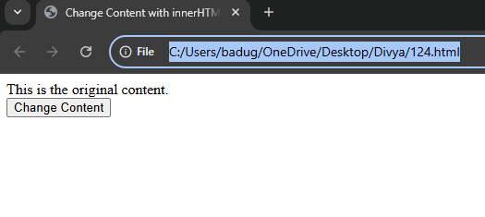

Project-125

Demonstrate how to update visible text using `innerText` with a button

<!DOCTYPE html>

<html>

<head>

<title>Change Text with innerText</title>

</head>

<body>

<h2 id="title">Welcome to the page!</h2>

<button onclick="updateText()">Update Text</button>

<script>

function updateText() {

// Get the element and change its visible text

let heading = document.getElementById("title");

heading.innerText = "Thanks for visiting!";

}

</script>

</body>

</html>

Output:

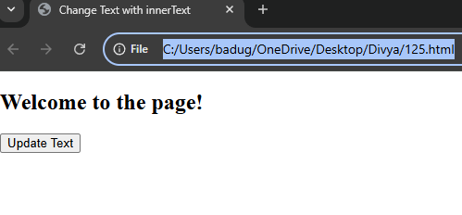

Project-126

Demonstrate how to create an element by clicking a button

<!DOCTYPE html>

<html>

<head>

<title>Create Element Example</title>

</head>

<body>

<div id="container">

<p>Existing content.</p>

</div>

<button onclick="createElement()">Add New Paragraph</button>

<script>

function createElement() {

// Create a new <p> element

let newParagraph = document.createElement("p");

// Set its text content

newParagraph.textContent = "This is a new paragraph added by JavaScript.";

// Append it to the container div

document.getElementById("container").appendChild(newParagraph);

}

</script>

</body>

</html>

Output:

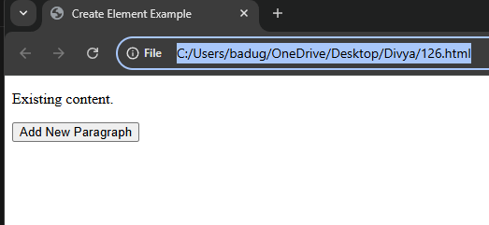

Project-127

Demonstrate how to remove an element from the DOM

<!DOCTYPE html>

<html>

<head>

<title>Remove Element Example</title>

</head>

<body>

<div id="removable">

<p>This paragraph will be removed when you click the button.</p>

</div>

<button onclick="removeElement()">Remove Paragraph</button>

<script>

function removeElement() {

// Get the element to be removed

let element = document.getElementById("removable");

// Remove the element from its parent

element.remove();

}

</script>

</body>

</html>

Output:

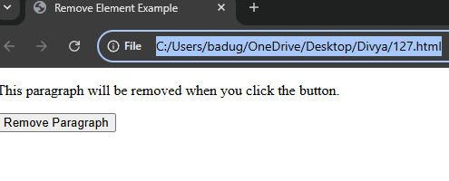

Project-128

Demonstrate how to change the style of an element using JavaScript

<!DOCTYPE html>

<html>

<head>

<title>Change Style Example</title>

</head>

<body>

<p id="text">This text will change style.</p>

<button onclick="changeStyle()">Change Style</button>

<script>

function changeStyle() {

// Get the element

let paragraph = document.getElementById("text");

// Change its style

paragraph.style.color = "white";

paragraph.style.backgroundColor = "blue";

paragraph.style.fontSize = "20px";

paragraph.style.padding = "10px";

}

</script>

</body>

</html>

Output:

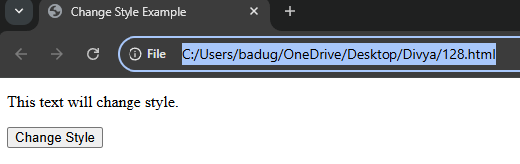

Project-129

Demonstrate how to toggle visibility of an element

<!DOCTYPE html>

<html>

<head>

<title>Toggle Visibility Example</title>

</head>

<body>

<p id="text">This text will be shown or hidden.</p>

<button onclick="toggleVisibility()">Toggle Visibility</button>

<script>

function toggleVisibility() {

// Get the element

let paragraph = document.getElementById("text");

// Check the current display style and toggle it

if (paragraph.style.display === "none") {

paragraph.style.display = "block"; // Show the element

} else {

paragraph.style.display = "none"; // Hide the element

}

}

</script>

</body>

</html>

Output:

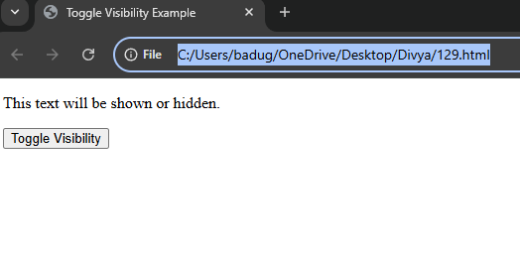

Project-130

Demonstrate how to get the value from an input field

<!DOCTYPE html>

<html>

<head>

<title>Get Input Value Example</title>

</head>

<body>

<label for="nameInput">Enter your name:</label>

<input type="text" id="nameInput" />

<button onclick="showInputValue()">Submit</button>

<p id="output"></p>

<script>

function showInputValue() {

// Get the input field

let input = document.getElementById("nameInput");

// Get the value of the input field

let name = input.value;

// Display the value in the paragraph

document.getElementById("output").textContent = "You entered: " + name;

}

</script>

</body>

</html>

Output:

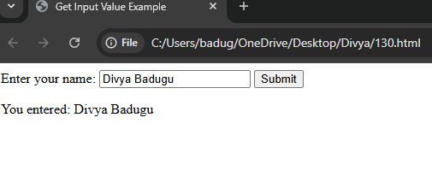

Project-131

Demonstrate how to loop through elements using `getElementsByTagName

<!DOCTYPE html>

<html>

<head>

<title>Loop with getElementsByTagName</title>

</head>

<body>

<h3>Fruits List</h3>

<ul>

<li>Apple</li>

<li>Banana</li>

<li>Orange</li>

<li>Mango</li>

</ul>

<button onclick="highlightItems()">Highlight Items</button>

<script>

function highlightItems() {

// Get all <li> elements

let items = document.getElementsByTagName("li");

// Loop through them and change their style

for (let i = 0; i < items.length; i++) {

items[i].style.color = "green";

items[i].style.fontWeight = "bold";

}

}

</script>

</body>

</html>

Output:

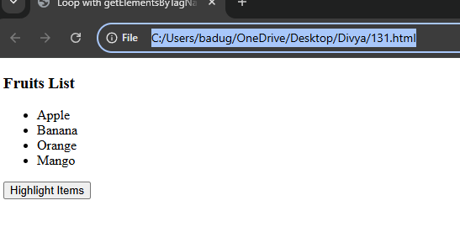

Project-132

Demonstrate an increment and decrement counter

<!DOCTYPE html>

<html>

<head>

<title>Counter Example</title>

<style>

#counter {

font-size: 24px;

margin: 10px;

}

</style>

</head>

<body>

<h2>Counter</h2>

<div id="counter">0</div>

<button onclick="increment()">Increment</button>

<button onclick="decrement()">Decrement</button>

<script>

// Initialize counter value

let count = 0;

function increment() {

count++;

document.getElementById("counter").textContent = count;

}

function decrement() {

count--;

document.getElementById("counter").textContent = count;

}

</script>

</body>

</html>

Output:

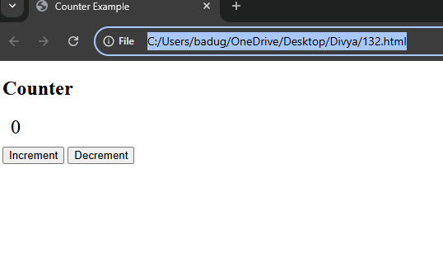

Project-133

Demonstrate the usage of the `push()` method

<!DOCTYPE html>

<html>

<head>

<title>Array push() Example</title>

</head>

<body>

<h3>Fruits:</h3>

<ul id="fruitList"></ul>

<input type="text" id="fruitInput" placeholder="Enter a fruit name" />

<button onclick="addFruit()">Add Fruit</button>

<script>

let fruits = [];

function addFruit() {

let input = document.getElementById("fruitInput");

let fruit = input.value;

if (fruit) {

// Add the fruit to the array

fruits.push(fruit);

// Clear the input

input.value = "";

// Update the list on the page

updateFruitList();

}

}

function updateFruitList() {

let list = document.getElementById("fruitList");

list.innerHTML = ""; // Clear the current list

// Loop through the array and add each fruit to the list

for (let i = 0; i < fruits.length; i++) {

let li = document.createElement("li");

li.textContent = fruits[i];

list.appendChild(li);

}

}

</script>

</body>

</html>

Output:

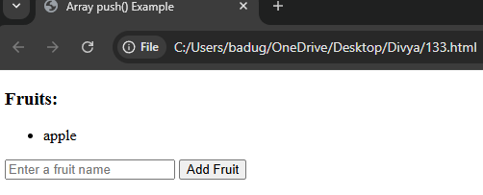

Project-134

Demonstrate the usage of the `pop()` method

<!DOCTYPE html>

<html>

<head>

<title>Array pop() Example</title>

</head>

<body>

<h3>Fruits:</h3>

<ul id="fruitList"></ul>

<button onclick="addFruit()">Add Random Fruit</button>

<button onclick="removeLastFruit()">Remove Last Fruit</button>

<script>

let fruits = [];

function addFruit() {

// Add a random fruit to the list

const sampleFruits = ["Apple", "Banana", "Mango", "Orange", "Peach"];

let randomFruit = sampleFruits[Math.floor(Math.random() * sampleFruits.length)];

fruits.push(randomFruit);

updateFruitList();

}

function removeLastFruit() {

// Remove the last fruit using pop

let removed = fruits.pop();

if (removed !== undefined) {

alert("Removed: " + removed);

} else {

alert("No fruits to remove!");

}

updateFruitList();

}

function updateFruitList() {

let list = document.getElementById("fruitList");

list.innerHTML = "";

for (let i = 0; i < fruits.length; i++) {

let li = document.createElement("li");

li.textContent = fruits[i];

list.appendChild(li);

}

}

</script>

</body>

</html>

Output:

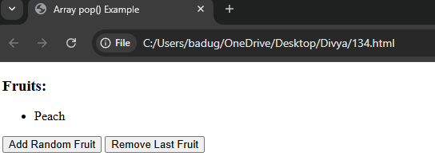

Project-135

Demonstrate the usage of the `map()` method

<!DOCTYPE html>

<html>

<head>

<title>map() Method Example</title>

</head>

<body>

<h3>Original Numbers:</h3>

<p id="original"></p>

<h3>Squared Numbers (Using map):</h3>

<p id="squared"></p>

<button onclick="showMappedValues()">Square Numbers</button>

<script>

let numbers = [2, 4, 6, 8];

function showMappedValues() {

// Display original numbers

document.getElementById("original").textContent = numbers.join(", ");

// Use map to square each number

let squared = numbers.map(num => num * num);

// Display the result

document.getElementById("squared").textContent = squared.join(", ");

}

</script>

</body>

</html>

Output:

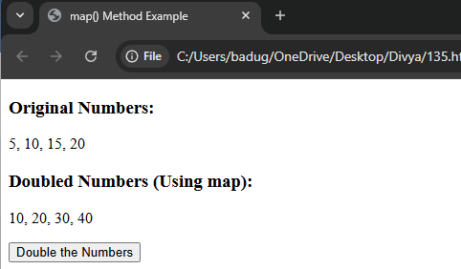

Project-136

Demonstrate the usage of the `filter()` method

<!DOCTYPE html>

<html>

<head>

<title>filter() Method Example</title>

</head>

<body>

<h3>All Ages:</h3>

<p id="original"></p>

<h3>Adults (Age ≥ 18):</h3>

<p id="filtered"></p>

<button onclick="filterAdults()">Show Adults</button>

<script>

let ages = [12, 17, 18, 21, 16, 25, 14];

function filterAdults() {

// Display original ages

document.getElementById("original").textContent = ages.join(", ");

// Filter ages greater than or equal to 18

let adults = ages.filter(age => age >= 18);

// Display filtered result

document.getElementById("filtered").textContent = adults.join(", ");

}

</script>

</body>

</html>

Output:

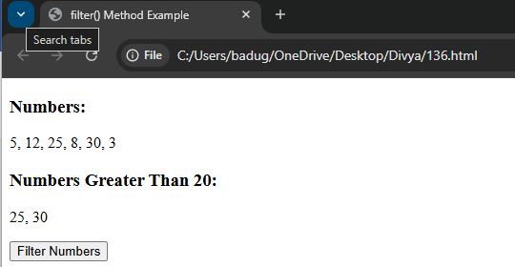

Project-137

Demonstrate the usage of the `reduce()` method

<!DOCTYPE html>

<html>

<head>

<title>reduce() Method Example</title>

</head>

<body>

<h3>Numbers:</h3>

<p id="numbers"></p>

<h3>Total Sum:</h3>

<p id="result"></p>

<button onclick="calculateSum()">Calculate Sum</button>

<script>

let numbers = [5, 10, 15, 20];

function calculateSum() {

// Display the original numbers

document.getElementById("numbers").textContent = numbers.join(", ");

// Use reduce to calculate the sum

let sum = numbers.reduce((acc, curr) => acc + curr, 0);

// Display the result

document.getElementById("result").textContent = sum;

}

</script>

</body>

</html>

Output:

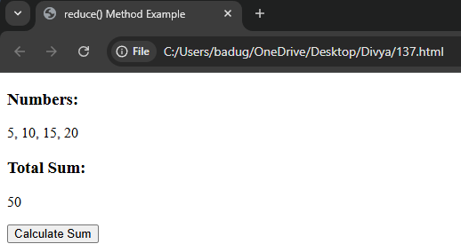

Project-138

Demonstrate the usage of the `forEach()` method

<!DOCTYPE html>

<html>

<head>

<title>forEach() Method Example</title>

</head>

<body>

<h3>Fruit List:</h3>

<ul id="fruitList"></ul>

<button onclick="showFruits()">Show Fruits</button>

<script>

let fruits = ["Apple", "Banana", "Orange", "Grapes"];

function showFruits() {

let list = document.getElementById("fruitList");

list.innerHTML = ""; // Clear previous list

// Loop through each fruit and add to the list

fruits.forEach(function(fruit) {

let li = document.createElement("li");

li.textContent = fruit;

list.appendChild(li);

});

}

</script>

</body>

</html>

Output:

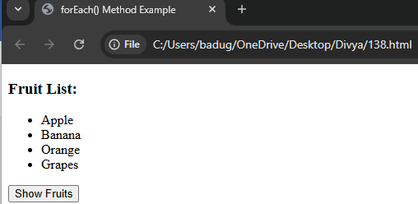

Project-139

Demonstrate the usage of the `slice()` method

<!DOCTYPE html>

<html>

<head>

<title>slice() Method Example</title>

</head>

<body>

<h3>Full List of Numbers:</h3>

<p id="fullList"></p>

<h3>Sliced (Index 2 to 5):</h3>

<p id="slicedList"></p>

<button onclick="sliceArray()">Slice Array</button>

<script>

let numbers = [10, 20, 30, 40, 50, 60, 70];

function sliceArray() {

// Show full array

document.getElementById("fullList").textContent = numbers.join(", ");

// Slice from index 2 to 5 (not including index 5)

let sliced = numbers.slice(2, 5);

// Show sliced array

document.getElementById("slicedList").textContent = sliced.join(", ");

}

</script>

</body>

</html>

Output:

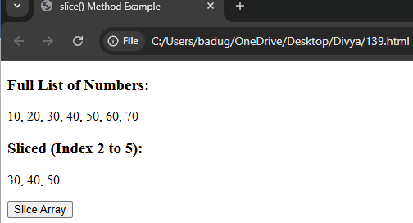

Project-140

Demonstrate the usage of the `splice()` method

<!DOCTYPE html>

<html>

<head>

<title>splice() Method Example</title>

</head>

<body>

<h3>Original Array:</h3>

<p id="original"></p>

<h3>Modified Array (After splice):</h3>

<p id="modified"></p>

<button onclick="useSplice()">Modify Array</button>

<script>

let animals = ["Dog", "Cat", "Elephant", "Lion", "Zebra"];

function useSplice() {

// Show original array

document.getElementById("original").textContent = animals.join(", ");

// Remove 2 elements starting from index 1, insert "Tiger" and "Monkey"

animals.splice(1, 2, "Tiger", "Monkey");

// Show modified array

document.getElementById("modified").textContent = animals.join(", ");

}

</script>

</body>

</html>

Output:

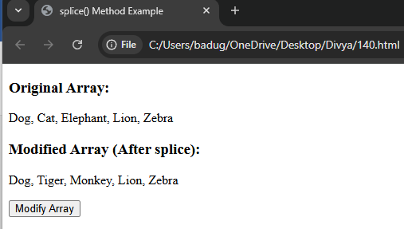

Project-141

Demonstrate the usage of the `includes()` method

<!DOCTYPE html>

<html>

<head>

<title>includes() Method Example</title>

</head>

<body>

<h3>Fruits:</h3>

<p id="fruitList"></p>

<input type="text" id="fruitInput" placeholder="Enter fruit to check" />

<button onclick="checkFruit()">Check if Included</button>

<p id="result"></p>

<script>

let fruits = ["Apple", "Banana", "Mango", "Orange"];

// Display the list

document.getElementById("fruitList").textContent = fruits.join(", ");

function checkFruit() {

let input = document.getElementById("fruitInput").value.trim();

let result = document.getElementById("result");

if (fruits.includes(input)) {

result.textContent = input + " is in the list.";

result.style.color = "green";

} else {

result.textContent = input + " is NOT in the list.";

result.style.color = "red";

}

}

</script>

</body>

</html>

Output:

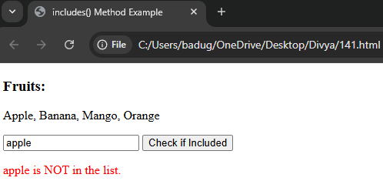

Project-142

Demonstrate the usage of the `find()` method

<!DOCTYPE html>

<html>

<head>

<title>find() Method Example</title>

</head>

<body>

<h3>Users:</h3>

<p id="userList"></p>

<input type="text" id="searchName" placeholder="Enter name to find" />

<button onclick="findUser()">Find User</button>

<p id="result"></p>

<script>

// Sample user data

let users = [

{ id: 1, name: "Alice" },

{ id: 2, name: "Bob" },

{ id: 3, name: "Charlie" }

];

// Show list of user names

document.getElementById("userList").textContent = users.map(u => u.name).join(", ");

function findUser() {

let input = document.getElementById("searchName").value.trim();

let result = document.getElementById("result");

// Use .find() to search for the user

let found = users.find(user => user.name.toLowerCase() === input.toLowerCase());

if (found) {

result.textContent = `User found: ${found.name} (ID: ${found.id})`;

} else {

result.textContent = "User not found.";

}

}

</script>

</body>

</html>

Output:

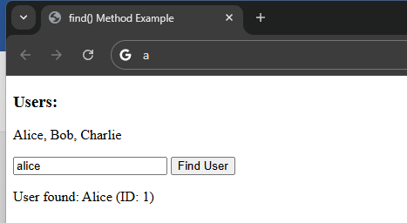

Project-143

Demonstrate the usage of the `sort()` method

<!DOCTYPE html>

<html>

<head>

<title>sort() Method Example</title>

</head>

<body>

<h3>Unsorted Numbers:</h3>

<p id="original"></p>

<h3>Sorted Numbers (Ascending):</h3>

<p id="sorted"></p>

<button onclick="sortNumbers()">Sort Numbers</button>

<script>

let numbers = [30, 5, 20, 10, 100];

function sortNumbers() {

// Show original numbers

document.getElementById("original").textContent = numbers.join(", ");

// Create a copy and sort it (optional if you don't want to modify original)

let sorted = [...numbers].sort((a, b) => a - b);

// Show sorted numbers

document.getElementById("sorted").textContent = sorted.join(", ");

}

</script>

</body>

</html>

Output:

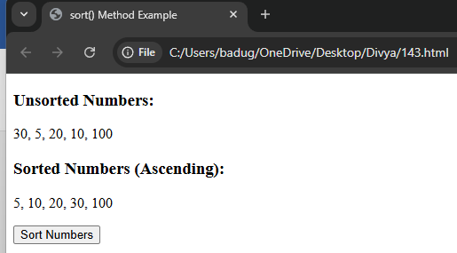

project-144

Demonstrate the usage of the `Spread Operator (...)` in arrays

<!DOCTYPE html>

<html>

<head>

<title>Spread Operator Example</title>

</head>

<body>

<h3>Original Arrays:</h3>

<p id="original"></p>

<h3>Merged Array:</h3>

<p id="merged"></p>

<button onclick="mergeArrays()">Merge Arrays</button>

<script>

let array1 = ["A", "B", "C"];

let array2 = ["D", "E", "F"];

function mergeArrays() {

document.getElementById("original").textContent =

"Array 1: " + array1.join(", ") + " | Array 2: " + array2.join(", ");

// Merge using spread operator

let mergedArray = [...array1, ...array2];

document.getElementById("merged").textContent = mergedArray.join(", ");

}

</script>

</body>

</html>

Output:

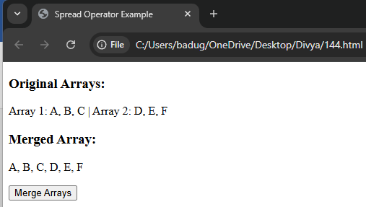

MONGODB:

Project 145:

Demonstrate how to create a database in MongoDB

Description:

The use command is used to create or switch to a database in MongoDB. A new database is created only when data is inserted into it.

Example:

use myDatabase

Project 146:

Demonstrate how to create a collection in MongoDB

Description:

Collections can be created explicitly using db.createCollection(), or implicitly by inserting a document.

Example:

db.createCollection("students")

project 147:  
Demonstrate how to insert a document into a MongoDB collection

Description:

The insertOne() method is used to insert a single document. insertMany() can be used for inserting multiple documents.

Example:

db.students.insertOne({ name: "Sai", course: "BCA", age: 21 })